LIBRARY VISITOR NOISE MONITORING SYSTEM DESIGN WITH WARNING USING LED AND TELEGRAM

Submitted: … ; Revised: … ; Approved: …. ; Available Online: ….

Abstract. The library supports education and is used as a place to learn and gain knowledge. To maximize its use, visitors need comfort by not making noise or upheaval that can disturb other visitors. According to the decision of the Ministry of Environment in 1996, the maximum standard for noise levels in libraries is 55 dB. This research was conducted to design a tool that can monitor the noise that occurs in the library by providing information on room conditions using LED (Light Emitting Diode) lights, LCD (Liquid Crystal Display), and giving notifications to librarians in the form of messages on the Telegram application if the noise exceeds the limit. maximum. The tool is designed using ESP32 as a control, a GY-MAX4466 sensor to detect sound, and the output system uses red, yellow, and green LED (Light Emitting Diode), LCD (Liquid Crystal Display) 16x2, and the Telegram application. The results of this study concluded that the noise monitoring system was running well, with a GY-MAX4466 sensor error rate of 0.4%, and the best R Square value was obtained at a distance of 1 meter from the sound source with an R Square value of 0,7202.

Keywords: ESP32, GY-MAX4466, LCD, LED, Library, Noise, Telegram.

INTRODUCTION
The library functions as a medium for education, research, preservation, information and entertainment, acts as a promoter of literacy culture with the hope of creating conditions for cultural literacy to become a basic need in the daily lives of Indonesian people. If literacy culture is practiced as a way of life, then the Indonesian nation will become an educated society, thirsty for knowledge and ready to become a developed country [1]
In every library there is always a librarian who plays an important role in the management, service and organization of library activities, he is responsible for improving services, implementing programs, promotions, assisting customers in finding information, replacing damaged books and sending them to the bookbinding department, monitoring the use of collections , verifying the correct arrangement of collections on shelves, making statistical reports on activities, maintaining order and cleanliness of the room [2]. To maintain order, the librarian gives freedom to guests to carry out any activities as long as they don't disturb other guests. To increase the comfort of library visitors, a warning is needed to remind the state of the room caused by visitor activity. Of course the warning given shouldn't add to the noise in the room. In addition to warning visitors, it is also important to notify the librarian if room conditions exceed the noise limit values in the library. The minimum number of employees with a large room can cause the room to go unnoticed, requiring notification to provide reports even if the distance between staff and visitors is far. As for several previous noise detection studies, Nurwati's first research was in 2018 concerning noise detection using a microcontroller similar to Arduino Uno, the LM393D sound sensor as a noise detector and a speaker as an alarm if noise is detected [3]. Then in the same year research was also carried out by Theodorus and his friends regarding a noise detection device using an Arduino Uno type microcontroller, a condenser mic sound sensor as a sound detector and a speaker as an alarm if noise is detected [4].
From the problems above, the author intends to design a noise detector for library visitors based on sound pressure parameters using an amplified sound sensor so that it is able to detect not only loud sounds, so the GY-MAX4466 sensor is used. To warn visitors, of course, warning signs are used so as not to cause additional noise, 3 LEDs (light emitting diodes) of different colors are used to clearly indicate when one of them is on. And for librarians, a system has also been created to notify when conditions exceed the limit. For this reason, the messaging application Telegram is used because it can be accessed on many devices so that many librarians can access it.

RESEARCH METHODS

This research was conducted at the Physics Laboratory Center, the Integrated Laboratory Center at UIN Syarif Hidayatullah Jakarta and the Siliwangi University Library, Tasikmalaya City, West Java. The research phase consists of the preparation stage, analyzing the tools and materials needed, then designing the hardware and software, then calibrating and testing the accuracy of the sensor, testing the tool as a whole, analyzing the data and making conclusions.

RESULTS AND DISCUSSION

Hardware Design Results
The hardware design for the library visitor noise monitoring system is designed by making the esp32 microcontroller the brain or control center for all components, including the GY-MAX4466 sensor, LED (Light Emitting Diode), and LCD (Liquid Crystal Display). The results of the hardware design can be seen in Figure 1.
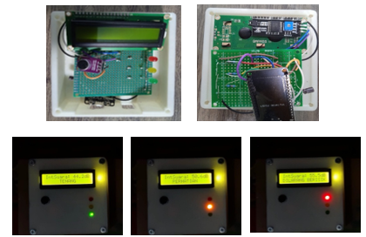
Figure 1. Hardware Design Results

In Figure 1, you can see from the outside that there is a black circle which is the GY-MAX4466 sound sensor which receives sound waves from the surrounding environment. Then there is an LCD screen that displays the results of the esp32 microcontroller process which processes sound wave value data received by the sound sensor so that room conditions and sound intensity can be displayed. Finally, there is a red, yellow and green LED (Ligh Emitting Diode) which functions as a warning sign where the red LED will light up when the surrounding sound intensity is above 55 dB, the yellow LED will light up when the surrounding sound intensity is between 50 dB to 55 dB , and the green LED will light up when the surrounding sound intensity is below 50 dB.
Software Design Results
The design of software for the library visitor noise monitoring system was designed by making the esp32 microcontroller which is a microcontroller with a wifi module as a control center so that it can send noise alerts via the Telegram application. The design uses the Arduino IDE application as a programming medium and the Telegram application to receive warnings regarding room conditions. Here's a picture. 2 is a display of the design results for the Telegram application.
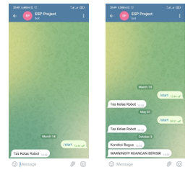

Figure 2. The results of the Telegram Messenger Application Software Design

In Figure 2 it can be seen that at the beginning of the message type "/start" to start a chat on the Telegram bot so that the smartphone can receive a warning message when it is noisy with the sentence "WARNING!!! NOISY ROOM”.

Tool Testing Results
To test the noise monitoring tool for library visitors, several stages were carried out, namely by testing the accuracy of the sensor, then conducting a linear regression test, finally testing the entire system including LCD, LED and the Telegram application.

GY-MAX4466 Sensor Accuracy Test Results
The GY-MAX4466 sensor is a type of sound sensor that functions to identify the sound intensity values around it. Testing the accuracy of the GY-MAX4466 sensor is carried out by taking sound intensity data in a library room measuring approximately 150 m2 and accommodating a maximum of 30 visitors. Retrieval is done by placing the GY-MAX4466 sensor in the middle of the room when the number of people in it is 1 person, 10 people, 20 people and 30 people with data retrieval intervals every one second. At the same time the data is also collected using a factory-made sound level meter, then the results from the GY-MAX4466 sensor are compared with the results of the factory-made device to determine the accuracy value of the GY-MAX4466 sensor by calculating the error value
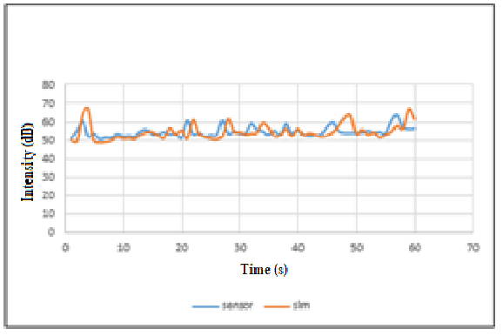

Figure 3. Graph of Comparison of Measurement Results of the GYMAX4466 Sensor with factory sound level meters in the library (20 people)
In Figure 3 it can be seen a graph of the results of sound intensity measurements carried out in the library room in which there was 1 visitor. The blue line shows the measurement results using the GY-MAX4466 sensor and the orange line shows the measurement results using a factory-made sound level meter. The graph shows that the blue and orange lines have almost the same shape of peaks and valleys but there are gaps or differences between the two, but there are also lines that intersect which means that the measurement results with both tools have the same results. So that the error rate is 0.1%.
Linear Regression Test Results
Linear regression test was conducted to determine the direction of the relationship between the dependent variable and the independent variable. In this test, sound measurement is carried out using a sensor with an audio sound source that is getting higher from a level of 10% to 100% at 10% intervals with variations in the distance between the sound source and the GY-MAX4466 sensor as far as 1 meter, 2 meters and3 meters in the room. with an area of about 30 m2.

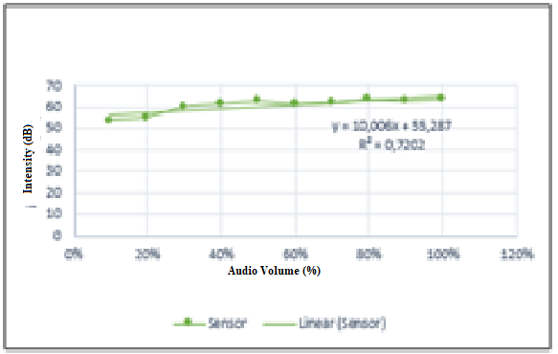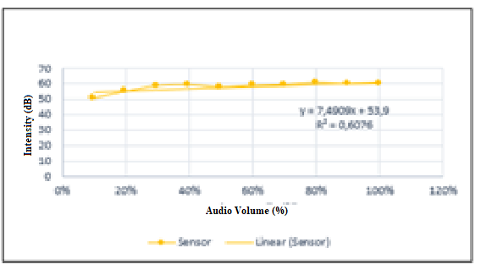
- (b)
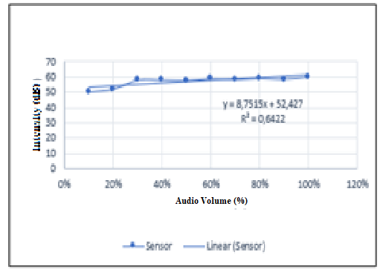
(c)
Figure 4. Graph of the Relationship Between Audio Volume and Sound Intensity at a Distance of (a) 1 Meter, (b) 2 Meters and (c) 3 Meters

Figure 4 shows a graph of the relationship between audio volume and sound intensity. It is then known that the increasing the audio volume, the higher the measured intensity value. At a distance of 1 meter, an R-Square value of 0.7202 is obtained, which means that it is above the value of 0.67, so the results are categorized as strong. At a distance of 2 meters, an R-Square value of 0.6076 is also obtained, which means that between 0.33 and 0.67 the results are categorized as moderate. At a distance of 3 meters, an R-Square value of 0.6422 is also obtained, which means that between 0.33 and 0.67 the results are categorized as moderate [5].It can be concluded that the data obtained at a distance of 1 meter is better than at a distance of 2 meters and 3 meters with the R-Square value closest to number 1, namely at 0.7202.
Overall System Test Results
The final test is testing the entire system which consists of the output LCD, LED and also warning messages that enter the Telegram application. Where when the sensor detects sound intensity below 50 dB, the LCD screen will display a notification "Quiet" with a green LED that lights up. When the sensor detects the sound intensity is between 50 dB to 55 dB, the LCD screen will display the word "Caution" with a yellow LED that lights up, which means visitors are expected to be careful because the sound generated is close to the noise level. When the sensor detects the sound intensity is above 55 dB, the LCD screen will display a warning with the sentence "No noise" and a red LED that lights up as a warning to visitors to stop causing noise, there will also be a message coming through the Telegram application to notify the librarian that noisy room conditions.
The test was carried out in an empty room 6 times with different sound sources, namely, without any sound interference, human voices talking, music from smartphones, the sound of clapping hands, the sound of turning book pages, and the sound of whistling with the distance of the sound source and the instrument. 1 meter away.
Table 1. Test Results for the Whole System
NO | Voice Description | Intensity (dB) | Telegram warning | LCD Detection Results | LED |  |  | Delay  Telegram (s) | Information
 |  |  |  |  | Red | Yellow | Green | Delay  Telegram (s) | Information
1 | No sound disturbance | 44,2 dB | - | Quite | - | - |  | - | Succeed
2 | Human Voice Talking | 50,6 dB | - | Attention | - |  | - | - | Succeed
3 | Smartphone Music Sound | 55,5 dB |  | Do not be noisy |  | - | - | 3 s | Succeed
4 | Applause | 70 dB |  | Do not be noisy |  | - | - | 3 s | Succeed
5 | ​Turning Book Pages | 54,5 dB | - | Attention | - |  | - | - | Succeed
6 | Whistling | 52,5 dB | - | Attention | - |  | - | - | Succeed

In Table 1 it can be seen the results of the first test without any additional sound disturbance, the measured sound intensity value is 44.2 dB, the word "Quiet" is displayed on the LCD screen with a green LED that lights up indicating that the room conditions are calm or conducive. The second test with a human voice speaking, measured a sound intensity value of 50.6 dB, so the word "Caution" is displayed on the LCD screen with a yellow LED that lights up indicating that the room conditions are at a moderate level. The third test was with a music sound source from a smartphone, the measured sound intensity value was 55.5 dB, so the word "Noise Prohibited" is displayed on the LCD screen with a red LED that lights up and the message has successfully entered the Telegram application with the interval between the color change of the LED light and the entry of the message. for 3 seconds indicates that the room condition is noisy. The fourth test is with the sound source of clapping, the measured sound intensity value is 70 dB, the word "No noise" is displayed on the LCD screen with a red LED that lights up as well as the message successfully entering the Telegram application with the time interval between the color change of the LED light and the entry of the message for 3 seconds indicates that the condition of the room is noisy. The fifth test with the book sound source turned upside down, measured a sound intensity value of 54.5 dB, the word "Caution" is displayed on the LCD screen with a yellow LED that lights up indicating that the room condition is at a moderate level. The sixth test with a whistling sound source, measured a sound intensity value of 52.5 dB, so the word "Caution" is displayed on the LCD screen with a yellow LED that lights up indicating that the room conditions are at a moderate level.

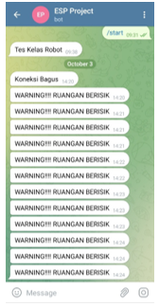
Figure 5. Display of Telegram Overall System Test Results
Figure 5 displays the message that entered the telegram in the form of the sentence "WARNING!!!!" NOISE ROOM” when the sensor detects the sound source of smartphone music and hand clapping.
From all the test results, it can be concluded that the design of the library visitor noise monitoring tool using LED (Light Emitting Diode) as a warning to visitors and messages sent via the Telegram application as notifications to guards can run well as planned.

CONCLUSION

The design of a tool for monitoring the noise of library visitors has been successfully carried out using LED (Light Emitting Diode) as a warning to visitors and messages via the Telegram application as notifications to guards.From the results of the characterization carried out on the GY-MAX4466 sensor, an average error value of 0.4% is obtained. In the linear regression test, the R square value is obtained when the distance between the sound source and the GY-MAX4466 sensor is 1 meter. .6076 and 0.6422.It can be said that all components and systems in this noise monitoring tool are going well as planned. The sensor can identify the environment well, so the warning LED can function properly, also notification messages for the Telegram application can be received properly with an average delay time of receiving messages for 3 seconds.

REFERENCE LIST

[1] | Tunardi, "Memaknai Peran Perpustakaan dan Pustakawan dalam Menumbuhkembangkan Budaya Literasi," Media Pustakawan, vol. 25, no. 3, p. 79, 2018.
[2] | N. J. Azmar, "Peran Pustakawan Dalam Meningkatkan Kualitas Layanan di Perpustakaan," Jurnal Iqra, vol. 9, no. 2, pp. 227-231, 2015.
[3] | Nurwati, "Pendeteksi Tingkat Kebisingan dan Pemberi Peringatan Pada Perpustakaan Berbasis Arduino," in SEMINAR NASIONAL ROYAL (SENAR), Asahan, 2018.
[4] | Kalengkongan, T. S, D. Z, Mamahit and dkk, "Rancang Bangun Alat Deteksi Kebisingan dan Pemberi Peringatan Pada Perpustakaan Berbasis Arduino Uno," Teknik Elektro dan Komputer, vol. 7, no. 2, pp. 183-188, 2018.
[5] | W. Wynne, The Partial Least Square Approach To Structural Equation Modeling, London: Lawrence Erbaum Associates, 1998.

