3D VISUALIZATION OF GEOTHERMAL SYSTEM STRUCTURE BASED ON INVERSION MODEL OF GRAVITY DATA. CASE STUDY: MT. SALAK REGION, WEST JAVA

Submitted: ; Revised: ; Approved: ; Available Online:

Abstract. The geothermal power plant located in Gunung Salak plays a crucial role in increasing the electricity supply transmitted to the Java-Bali region, as the energy demand continues to rise. The objective of this research is to determine the 3D subsurface structure of Gunung Salak, specifically the distribution of the reservoir as the target for geothermal energy using the Gravity method. Gravity data, including gravity disturbance (gd), geoid, and Digital Elevation Model (DEM), were obtained from the ICGEM website with a total of 48740 data each. Based on the results of the residual anomaly map, the low anomalies beneath Gunung Salak have values from -5.15 to -1.88 mGal, which are suspected to be associated with the magma chamber. The high anomalies beneath the manifestations have values from 0.92 to 5.01 mGal, indicating andesitic basalt intrusive rocks believed to be the reservoir rock. Through the 3D inversion modeling of the subsurface structure of the Gunung Salak geothermal system, a clay cap with a density from 2.47 to 2.5 g/cc at depths of 0 to 700 m and andesitic basalt rock as the reservoir with a density from 2.74 to 2.91 g/cc at depths of 700 to 3000 m have been identified.

Keywords: Geothermal, Gravity, Inversion, Mt. Salak, Reservoir

INTRODUCTION

Geothermal is a renewable energy source that shows an increasing role and mix of primary energy supply in Indonesia [1], because it is relatively environmentally friendly for electricity generation compared to other sources such as fuel oil [2]. Geothermal potential in Indonesia is estimated to reach more than 27,000 Mw or the equivalent of 219 million barrels of petroleum [3]. Where almost 40% of the world's geothermal potential is in Indonesia [4] and around 21.7% is in West Java [5].
Geothermal power plants have an important role in the Java-Bali network as they require a large supply of electricity for the local population. The Geothermal Power Plant in Gunung Salak supplies electricity to the surrounding areas, particularly in the Jawa-Bali region, with a capacity of not less than 180 MWe. [6]. The Geothermal Power Plant in Gunung Salak consists of three units with a capacity of 60 MW each. Electrical power from these three units is transmitted to the New Bogor 150 kV transmission network for interconnection with the Java-Madura-Bali system. Part of the generated power is also used for self-consumption [7]. The purpose of this study is to visualize in 3D the subsurface structure of the Mount Salak geothermal area, especially the depth of the reservoir as a geothermal target using the Gravity method.
Geothermal System
Geothermal systems are usually associated with volcanic systems that occur due to the movement of tectonic plates on the earth's surface which causes volcanoes [8]. Geothermal systems are formed as heat transfer from surrounding heat sources which can occur by conduction and convection [9]. This system stores and transports heat generated from geological processes within the Earth's crust.
The geothermal system consists of three main elements: (1) permeable reservoir rock, (2) water that carries heat from the reservoir to the earth's surface, and (3) a heat source. In addition, the essential things needed for the existence of a geothermal system are (1) heat source as the primary source, (2) reservoir that stores and transports hot fluids within the Earth, and (3) cap rock as the covering layer that contains the hot fluids [10]. The presence of reservoirs as geothermal targets can be characterized by the presence of manifestations around geothermal areas in the form of hot springs, mud pools, fumaroles, solfatara, etc.

Georeg Mount Salak
Mount Salak is a Quaternary volcano which is still geologically active and is a potential source of geothermal energy as well as a geological disaster. The volcanism of Mount Salak is directly related to the tectonic processes that occur as a result of the collision of the Eurasian and Indo-Australian plates in southern Java [11].
Based on the 1:100,000 scale geological map, the geological structure in the study area consists of faults, folds, and lineaments. The fault structure consists of shear faults, reverse faults, and normal faults which generally trend north-south, southwest-northeast, and northwest-southeast [12]. The top to the foot of Mount Salak is composed of rock products of Mount Salak in the form of sandy pumice tuff covered by lava deposits, tuffaceous breccias, and andesitic-basalt layered lapilli which are generally very weathered, the uppermost part is composed of andesitic lava [13] [ 14].

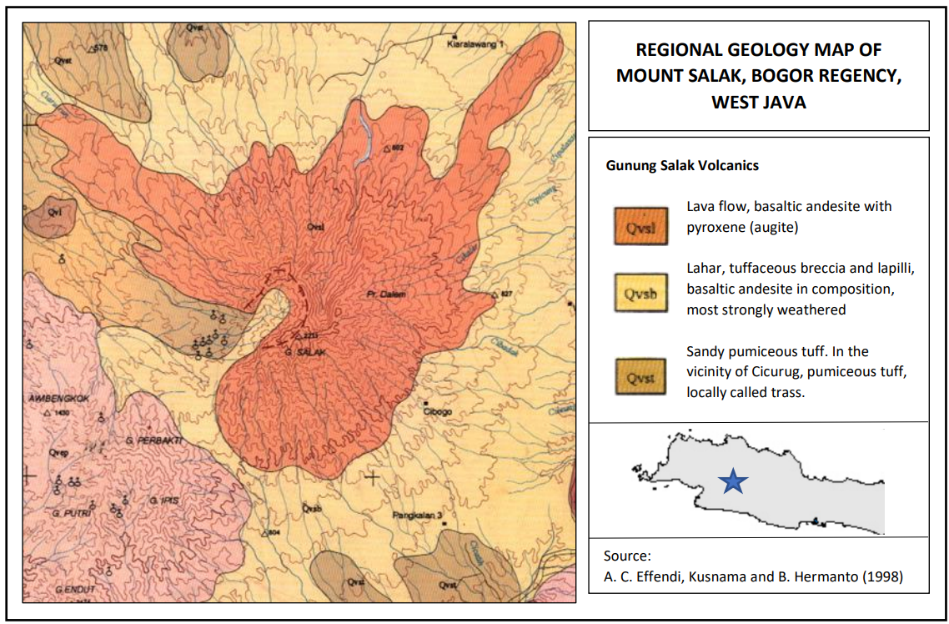
Figure 1. Regional Geology of Research Areas [15]

Gravity Method
The gravity method is a geophysical exploration method that is carried out by measuring the acceleration of gravity below the earth's surface caused by differences in rock density from an area [16].
The method of gravity works based on Newton's Law of Gravity which states that the force acting between two objects with masses of m separated at a distance r will be directly proportional to the multiplication of the masses of the two objects and inversely proportional to the square of the distance from the center of mass of the two objects [17]. The gravitational force can be written in an equation as follows:
$F= G \frac{M.m}{r^{2}}$ (1)
Where F is the weight of the object in units (N), M is the mass of the first object in units (Kg), m is the mass of the second object in units (Kg), r is the distance between the two masses in units (m), and G is a constant gravity with a value 6,67428 $× {10}^{-11 }{Nm}^{2}{Kg}^{-2}$ atau $m^{2 }{Kg}^{-1}{dt}^{2}$ [17].

Gravity Corrections
Gravity correction refers to the steps or procedures applied to improve or minimize the factors that can affect gravity measurement results. In this study, only using Bouguer correction and field correction [18].
The bouguer correction is a variation in the pull of rock masses on the earth's surface that can be calculated from the results of the derivation process [19]. The Bouguer correction can be written as follows:
BC = 0.000419Δhρ (2)
BC is the bouguer correction (mGal), h is the difference between the height of the measurement point and the datum (m), and is the density (kg/m³) [20].
Terrain correction is caused by topographical factors in the measurement point area because there are topographical effects as well as large elevation differences, such as hills and valleys around the measurement station [21].
$TC=G ρ θ [\left(r_{2}- r_{1}\right)+ \sqrt{r_{1}^{2}+ z^{2}}- \sqrt{r_{2}^{2}+ z^{2} }$] (3)
TC is Terrain Correction (mGal), G is universal constant, $ρ$ is density of rock mass (kg/m³), r₁ radius of inner circle (m), r₂ radius of outer circle ( m), z is height of hill or depth of valley (m) [20].

Inversion Modeling
Inverse modeling is a process used to obtain information about subsurface structures based on observation or measurement data collected at the surface. Inverse modeling involves the use of algorithms and mathematical methods to transform observation data into a model or representation that approximates the actual conditions beneath the surface [22]. In general, inversion modeling is based on the following equation:
$m= F^{-1}$ (4)
where F is the operator associated with the model, m is the model calculation data, and d is for the observation data, where the value of the calculation data and the observation data is done by trial and error so that the shape of the curve is the same [21].

RESEARCH METHOD

The research location is on Mount Salak which is located between Bogor Regency and Sukabumi Regency, West Java with predetermined boundaries with an area of ​​587 km2 (Figure 2). Gravity anomaly data in the form of gravity disturbance (gd), geoid, and Digital Elevation Model (DEM) were obtained from the website of the International Center for Global Earth Models (ICGEM) with a total of 48740 data each. The data processing process, from data collection to 3D modeling, can be seen in the flowchart below (Figure 3).

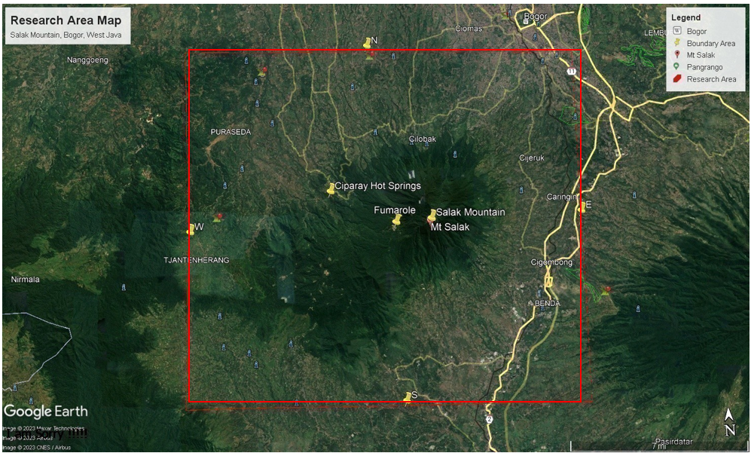
Figure 2. Research Area Map
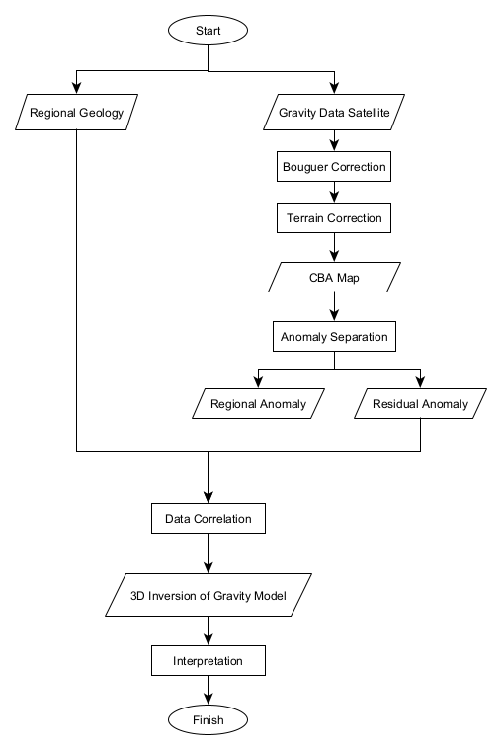
Figure 3. Research Flowchart

RESULTS AND DISCUSSION

Topography
On the topographic map of the research area, it can be observed that the distribution of topographic values ranges from 306.4 to 1448.1 meters. The low-lying topography is found north of Mount Salak, with values ranging from 306.4 to 459 meters. The high-lying topography is located on Mount Salak and in several surrounding manifestations, with values ranging from 694.2 to 1448.1 meters (Figure 4).

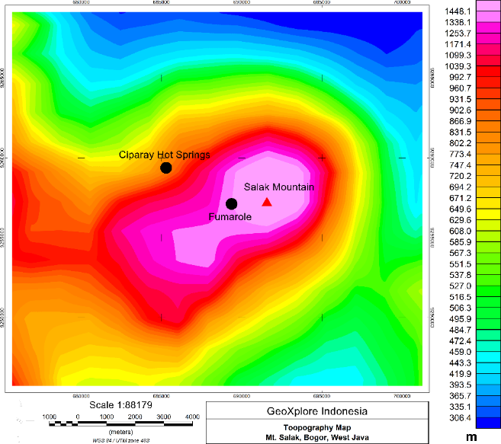
Figure 4. Topography Map

Complete Bouguer Anomaly (CBA)
On the CBA map, it can be observed that the distribution of gravity anomaly values at the research location ranges from 25 to 134.6 mGal. The low anomalies in the central part of the research area have values ranging from 25 to 68.6 mGal, which are believed to be associated with the overlying clay cap layer and alteration zone due to subsurface hydrothermal flow. High anomalies surround Mount Salak with values ranging from 99.6 to 134.6 mGal, which are believed to be associated with the Mount Salak caldera consisting of lava flows and pyroxene-containing basaltic andesite (augite). This CBA map still contains a mixture of shallow residual anomalies and deep regional anomalies, so to eliminate ambiguity in the interpretation, separation of these anomalies needs to be performed (Figure 5).

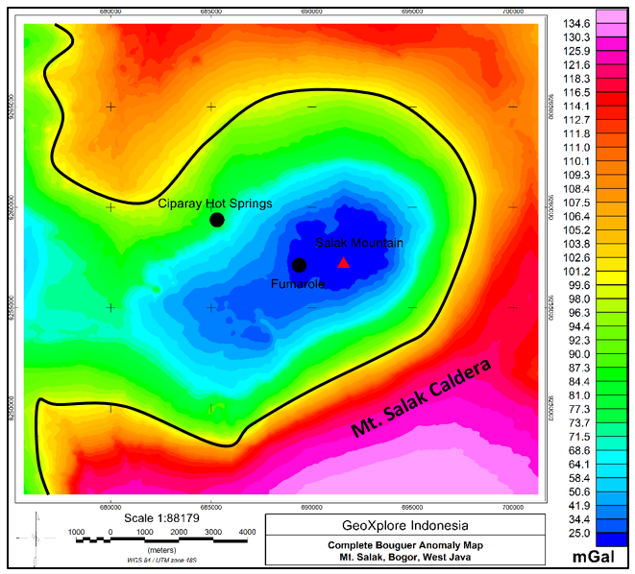
Figure 5. Complete Bouguer Anomaly Map

Regional and Residual Anomaly
On the regional anomaly map in the research area, the distribution of gravity anomaly values ranges from 24.8 to 134.3 mGal. This regional anomaly is caused by the response of deep rocks beneath the Earth's surface and has contour shapes similar to the CBA map, but the contours on this regional anomaly map are smoother (Figure 6a).
On the residual anomaly map, the distribution of gravity anomaly values ranges from -5.15 to 5.01 mGal. The low anomalies located directly beneath and around Mount Salak have values ranging from -5.15 to (-1.88) mGal, which are believed to be associated with the magma chamber of Mount Salak containing fluids and the distribution of the overlying clay cap layer with alteration minerals. The high anomalies located directly beneath and around Mount Salak have values ranging from 0.92 to 5.01 mGal, which are believed to be associated with the Mount Salak caldera composed of Salak volcanic rock formation (Qvsl), consisting of lava flows and pyroxene-containing basaltic andesite (augite). The high anomaly located directly beneath the manifestations (Fumarole and Ciparay Hot Springs) is believed to be an intrusive andesitic basalt rock, which is considered a reservoir rock containing hot fluids as the target of this research (Figure 6b).

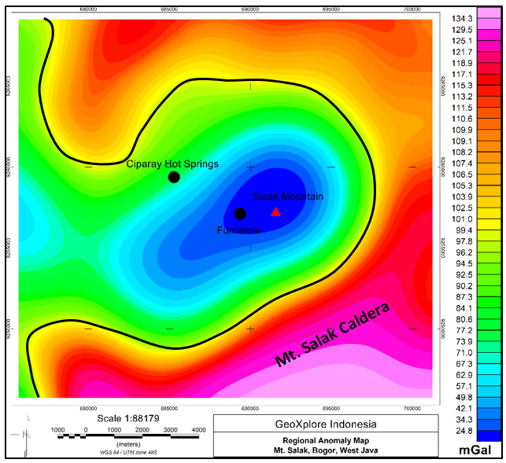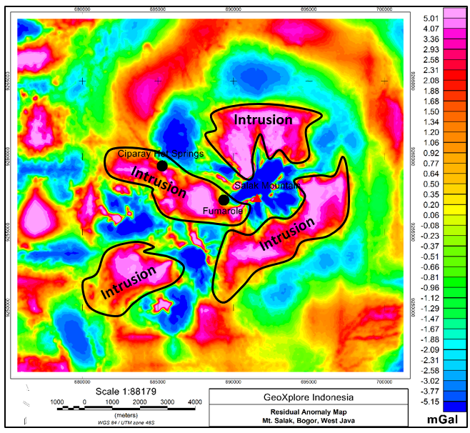
(a) (b)
Figure 6. (a) Regional Anomaly Map, and (b) Residual Anomaly Map

3D Inverse Modeling In this stage, 3D inverse modeling is conducted to depict the subsurface structure of the geothermal system in the Gunung Salak region, West Java, correlated with the regional geological map. In the 3D model image below the surface of Gunung Salak, it can be observed from different perspectives that the clay cap has a density ranging from approximately 2.47 to 2.5 g/cc with a depth of 0 to 700 meters, while the andesitic basalt rock serving as the reservoir has a density ranging from approximately 2.74 to 2.91 g/cc with a depth of 700 to 3000 meters (Figure 7).

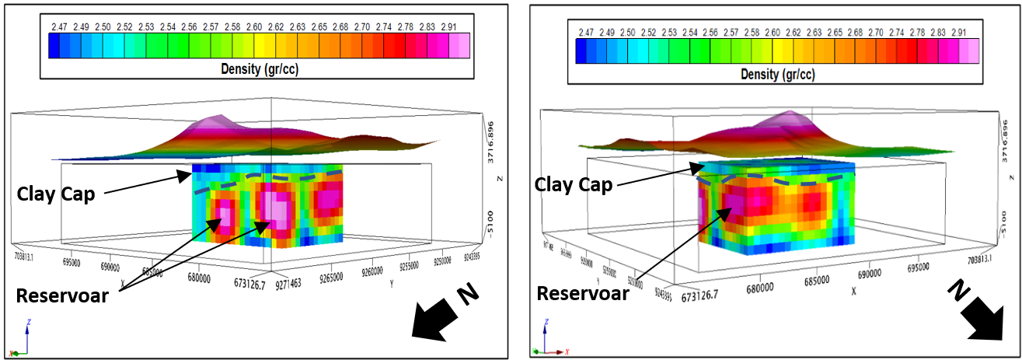
- (b)
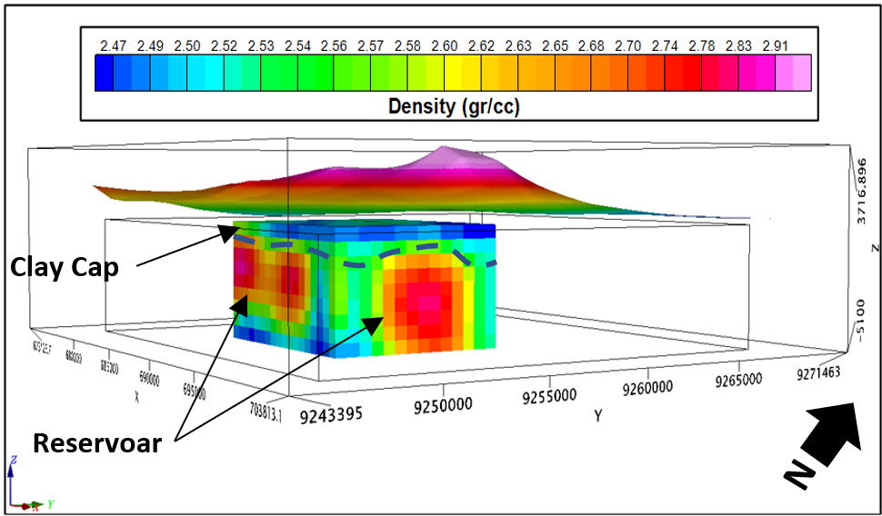
(c)
Figure 7. Model 3D Gravity (a) Northwest View, (b) Northeast View, (c) Southeast View

In this 3D Isosurface model, it is conducted to visualize the shape and structure of the geothermal system in a three-dimensional manner, including the clay cap and reservoir beneath the surface. It is evident that the clay cap forms thin layers, while the reservoir appears as intrusive rock. Additionally, the model allows us to observe the shape of the magma chamber within Gunung Salak, which has a density value ranging from 2.47 to 2.5 g/cc with a depth of 0 to 3000 meters (Figure 8).

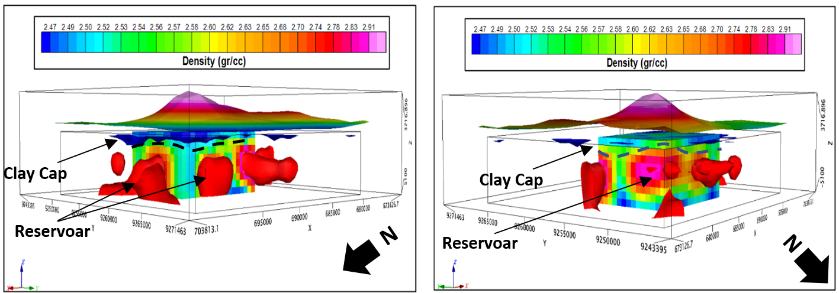
- (b)
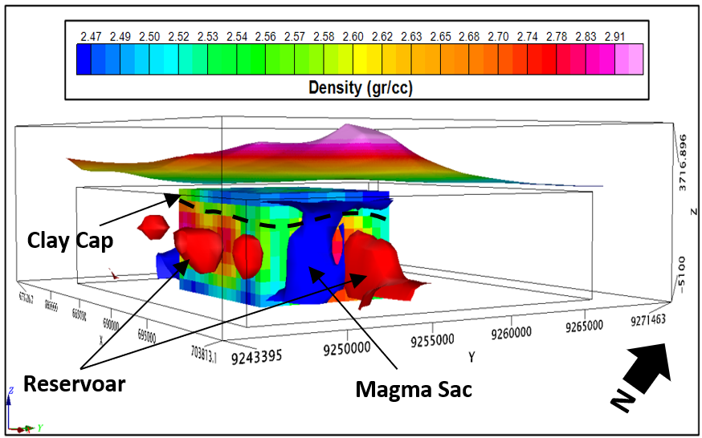
(c)
Figure 8. Model 3D Isosurface (a) Northwest View, (b) Northeast View, (c) Southeast View

CONCLUSION

- Based on the residual anomaly map, the low anomalies located beneath and around Gunung Salak have values ranging from -5.15 to -1.88 mGal, which are suspected to be associated with the magma chamber of Gunung Salak containing fluids and the distribution of the clay cap layer. The high anomalies located directly beneath and around Gunung Salak have values ranging from 0.92 to 5.01 mGal, which are believed to be associated with the caldera of Gunung Salak consisting of lava flows and andesitic basalt with pyroxene content (augite). The high anomalies beneath the manifestations are believed to be andesitic basalt intrusive rocks, which are considered as the reservoir containing hot fluids.
- Based on the results of 3D inverse modeling to depict the subsurface structure of the geothermal system in the Gunung Salak region, West Java, correlated with the regional geological map, there is a clay cap as the overlying rock with a density ranging from 2.47 to 2.5 g/cc at depths of 0 to 700 m. Meanwhile, the andesitic basalt rock serves as the reservoir with a density ranging from 2.74 to 2.91 g/cc at depths of 700 to 3000 m.

REFERENCES

[1] Ermawati. T, and N. D Siwage., 2014. "Policy Analysis of Geothermal Energy Development in Indonesia", Jakarta: Lipi Press.
[2] S. Mirwanda, et al., 2021. “Pemetaan Suhu Permukaan Anomali Panas Bumi Daerah Gunung Ciremai Menggunakan Data Inframerah Termal Landsat 8”. Jurnal Geosains dan Remote Sensing (JGRS), Vol. 2, Number 2, pp. 92-99.
[3] I. R. Dewi., et al., 2022. “Anomali Bouguer Lengkap untuk Mengidentifikasi Sistem Panas Bumi Gunung Pandan Jawa Timur”. Evolusi: Journal of Mathematics and Sciences, Volume 6, Number 1, pp. 48-57.
[4] R. D. Goenawan., et al., 2018. “Studi Potensi Panas Bumi Dan Teknologi Modifikasi Cuaca Alternatif Di Pantai Parang Tritis Yogyakarta”. Seminar Sains dan Teknologi Kelautan, Fakultas Teknik UNHAS Gowa, pp. 2-7.
[5] I. Adhitia dan M. A. Karmadi, 2021. “Studi Potensi Panas Bumi di Wilayah Kabupaten Bogor Ditinjau Dari Geologi Dan Geokimia”. Jurnal Teknik, Vol. 22, No. 1, pp. 27-37.
[6] R. Adiprana, Izzuddin, E. Yuniarto, 2010. “Gunung Salak Geothermal Power Plant Experience of Scaling/Deposit: Analysis, Root Cause and Prevention”. Proceedings World Geothermal Congress 2010 Bali, Indonesia, pp. 1-11.
[7] A. R. Swastika, 2012. “Analisa Monitoring Arus Penggiat Pada Operasi Gererator Di Unit Pembangkit Listrik Tenaga Panas Bumi (PLTP) Gunung Salak”. Depok: Universitas Indonesia.
[8] M. Nafian, N. R. Permana, B. Gunawan, 2022. “Identification of the Subsurface Structure of Geothermal Working Area of the Hamiding Mountain, North Maluku through Land Surface Temperature (LST) Data and Forward Modeling with the Gravity Method”. J. Nat. Scien. & Math. Res, Vol. 8, No. 1, pp. 10-19.
[9] Hermawan, D., Widodo, S., Mulyadi, E., 2012. “Sistem Panas Bumi Daerah Candi Umbul-Telomoyo Berdasarkan Kajian Geologi Dan Geokimia”. Buletin Sumber Daya Geologi, 7(1), pp. 1-6.
[10] A. Firdaus, U. Harmoko, S. Widada., 2014. “Pemodelan Steady State Sistem Panas Bumi Daerah Sumber Air Panas Diwak-Derakan Dengan Menggunakan Software Hydrothrem 2.2”. Youngster Physics Journal, 3(4), pp. 243- 250.
[11] D. Zaenudin M., et al., 2019. “Karakteristik Endapan Vulkanik Sub DAS Cigombong Lereng Timur Gunung Salak”. Bulletin of Scientific Contribution: GEOLOGY, Vol. 17, No. 2, pp. 109 – 120.
[12] S. Mawardi, E. Sukiyah, and I. Haryanto., 2019. “Karakteristik Morfotektonik Daerah Aliran Sungai Cisadane Berdasarkan Analisis Citra Satelit”. Jurnal Geologi dan Sumberdaya Mineral, Vol. 20, No. 3, pp.175 – 186.
[13] B. R. Suganda and V. Isnaniawardhani., 2014. “Karakteristik Geologi Daerah Volkanik Kuarter Kaki Tenggara Gunung Salak”. Bulletin of Scientific Contribution, Vol. 12, No. 2, pp. 99-106.
[14] D. Zaenudin M., et al., 2019. “Stratigrafi Vulkanik Sub DAS Cibadak Implikasinya Terhadap Kegiatan Gunungapi Salak Lereng Timur”. Bulletin of Scientific Contribution: GEOLOGY, Vol. 17, No. 1, pp. 9 – 20.
[15] Effendi, A. C., 1974. “Peta Geologi Lembar Bogor, Jawa”. Direktorat Geologi.
[16] Jamaluddin, et al., 2019. “Pemodelan Geologi Bawah Permukaan Bantar Karet, Jawa Barat Menggunakan Metode Gravitasi”. Jurnal Geocelebes Vol. 3 No. 2, pp. 59 – 65
[17] M. Nafian, B. Gunawan, N. R. Permana., 2021. “2D Forward Modeling Geothermal System Gravity Data in South Solok Region, West Sumatra. Al-Fiziya: Journal of Materials Science, Geophysics, Instrumentation and Theoretical Physics, pp. 36-44.
[18] N. R. Permana, B. Gunawan, M. Nafian., 2022. “Analysis of Subsurface Structure of Sembalun Geothermal Prospect Area, East Lombok with 2D and 3D Gravity Modeling”. Al-Fiziya: Journal of Materials Science, Geophysics, Instrumentation and Theoretical Physics, Vol. 5, No. I, pp. 10 – 22.
[19] Rachmawati, F. A., Haryanto, A. D., Hutabarat, J., Sumaryadi, M., 2019. “Penentuan Sumber Panas Sistem Panas Bumi Gunung Api Talang, Sumatera Barat Berdasarkan Sejarah Panas dan Geokimia Air”. Padjajaran Geoscience Journal. 3 (1), pp. 44-50.
[20] Aji D. M,. 2019. “Analisa Matematis pada Koreksi Bouguer dan Koreksi Medan Data Gravitasi Satelit Topex dalam Penentuan Kondisi Geologi Studi Kasus Sesar Palu Koro, Sulawesi Tengah”. Jurnal Geosaintek, Vol. 5, No. 3, pp. 91-100.
[21] B. Gunawan, A. Anjani, and A. Anjalni, 2022. "Identifikasi Pemodelan 2D dan Suhu Permukaan Daerah Panas Bumi Gunung Gede-Pangrango, Jawa Barat menggunakan Metode Gravitasi", J. of Engineering Environtmental Energy and Science, vol. 1, no. 1, pp. 1-14.
[22] Hartini, 2020. "Pemodelan Inversi Linier Least Square (LS) Pada Anomali Geomagnet Model Dyke," J. Hadron, vol. 2, no. 2, pp. 49-53.

