Prototype of Automatic Tractor Control Navigation System Using ESP 32 Microcontroller

Abu Ammar^{1,†}, Muhammad Yusril ², Prasepvianto Estu Broto ³, Ihsan ⁴, and Iswadi⁵
¹ Physics Study Program, Faculty of Science and Technology, Alauddin State Islamic University Makassar, Jl. H.M. Yasin Limpo No. 36 Samata, Gowa, South Sulawesi, Indonesia.

ur.abuammar99@gmail.com

Abstract. A prototype of an automatic tractor control navigation system using a microcontroller has been designed. This study aims to design a prototype of a tractor control navigation system automatically. The design begins with initializing ESP 32, followed by reading GPS (Ublox Neo M8N) and compass (QMC5883L). After that, waiting for commands from the wifi network, followed by reading waypoints, moving the motor, then the motor will drive the tractor prototype. The tests carried out included GPS and compass testing, control response testing, and waypoint navigation testing. The test results show that the accuracy of the coordinates of the GPS UBlox Neo M8N is 0.04 m from the Android smartphone GPS, the QMC5883L compass test shows the difference between the analog compass and the android smartphone compass by 0.4 degrees and 1.0 degrees. Testing the navigation system using the waypoint method, it was found that it was able to map an area or location with a distance of less than 5 meters in following the waypoint route and provide accurate coordinate information to the server during the trip as a source of map information.

Keywords: ESP 32, Microcontroller, Tractor, Waypoint, Wifi.

INTRODUCTION

Indonesia is an agricultural country, many people in Indonesia work as farmers. One of the problems that arise for farmers is in terms of plowing the fields before farming. In general, farmers use tractors to plow the fields. However, the use of tractors in plowing the fields requires a lot of energy and time in the process. Because the tools owned by farmers are still traditional, it requires a touch of technology that can facilitate farmers in plowing fields, especially on a large scale.
One of the technologies currently being developed is an autonomous system. Autonomous is a mode that refers to GPS coordinate data on an electronic device that can move automatically without using a remote control in its movement.
The system used in the development of autonomous systems is a waypoint navigation system. Waypoints are usually used to remember or store a position point from a place on the map. In this study, a waypoint navigation system is used to correct the position obtained from the GPS. And so that the tractor can move properly, a compass is also needed which can set the direction of the tractor's rotary motion. The data is then processed in the ESP32 microcontroller which is then sent to the DC motor to drive the wheels of the tractor prototype.
This study aims to design a prototype of a tractor control navigation system automatically using a microcontroller. With the prototype of this tractor control navigation system, it is hoped that it will become an innovative technological design that can later help farmers in plowing the fields, namely by using a tractor that can plow the fields automatically.
FORMALISM

Tractor
Tractors are specially designed vehicles used to pull low-speed implements commonly used in agriculture [1]. The tractor used in this research is a type of hand tractor or two-wheeled tractor. A hand tractor or two-wheeled tractor is a machine that is used to cultivate land with a tillage tool mounted on the back of the machine [2].
The main components of a two-wheeled tractor or hand tractor can be grouped into three, namely propulsion, power transmission, and control levers. Generally, hand tractors use a single-cylinder motor as a drive unit with a power output of around 3-12 hp [3]. The power successor is divided into two, namely the frame and transmission. The frame is the seat of the transmission, drive motor, other parts of the tractor. While the transmission is the part that transfers power to other moving devices from the driving motor. There are several types of transmission used, namely belts, pulleys, chains, gears, clutches, and others. Control levers are several levers that are used as control devices when the tractor is running [1].

ESP 32
Tractors are specially designed vehicles that are used to pull implements at low speed which are commonly used in the agricultural field. has been loaded into it [4]. ESP 32 is a microcontroller introduced by Espressif System. ESP 32 is the successor to the previous version, namely ESP8266 [5]. The advantage of ESP 32 compared to other microcontrollers is that ESP 32 is equipped with wifi so it can make it easier to connect to the internet. Wi-fi (Wireless Fidelity) is a medium that is used to communicate or transfer data and programs wirelessly [6]. An internet connection is needed to create an IoT-based application system [7]. IoT is a system where an object in everyday life can communicate with other objects [8].

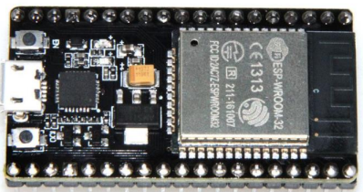

Figure 1. ESP32 [9]

GPS & Compass
GPS is a system that uses satellite technology by receiving signals from several interconnected satellites. GPS can be applied as a navigation service, time (PNT), and position [10]. GPS is widely used in various fields, including mapping surveys, geology, geodesy, geodynamics, geophysics, deformation monitoring, transportation and navigation, forestry, agriculture, and even in sports to recreation [11].
One of the important tools in the navigation system is a compass. The compass functions to determine the direction based on the position of the earth's poles [12]. Digital compasses, especially those found on Android smartphones, are activated by a sensor commonly referred to as a magnetic sensor [13]. The working principle of a digital compass is generally almost the same as an analog compass, namely that both work by detecting magnetic field values around the compass [14].

DC Motor
DC motor or direct current motor is a type of electric actuator that uses a DC voltage source [15]. There are two main parts that are owned by a DC motor, namely the rotor and stator. The rotor is a coil through which electric current flows. The stator is a fixed part of a DC motor that generates a magnetic field [16]. In DC motors, energy changes from electrical energy to mechanical energy (motor) take place through the medium of a magnetic field [15].

Waypoint
A waypoint is a point on the GPS that has been marked in the form of a location point based on the coordinates of the latitude (y) and longitude (x) axes [17]. Waypoint navigation works by making coordinate points for the location that the machine will go through, then from the path that has been formed, the machine can follow it to the coordinate points for the next location that has been determined [18]. The important components needed in this waypoint navigation system are GPS which is used to determine the position and compass which is used to determine direction and can also be used to find the bearing direction of the tractor [19].

RESEARCH METHODS

The instruments used in this study were ESP32, Smartphone/Android, DC Motor, Jumper Cables, BreadBoard, Ublox M8N GPS, QMC5883L Compass, Batteries, and Arduino IDE software. The design begins with initializing the ESP 32 microcontroller, followed by reading the GPS (Ublox Neo M8N) and compass (QMC5883L). After that, waiting for commands from the wifi network (manual or automatic). If the command is automatic, it is followed by reading the waypoint and if the order is manual, then it is continued by reading the command from the operator to move the motor, then the motor will drive the tractor prototype.
To obtain a good result, the stages in this study follow the flowchart as shown in the following figure:
Start

Study of literature

Design of a tractor control navigation system prototype

Hardware assembly and software design

Software configuration of the tractor

Waypoint determination and sensor calibration

Tractor navigation control testing

No
Testing whether the system is already working

Yes
Conclusion

Finished

Figure 2. Research Flowchart

RESULTS AND DISCUSSIONS

Design Results
Hardware design includes combining electronic components, microcontroller, DC motor, compass, and GPS. The results of the hardware design can be seen in Figure 3.
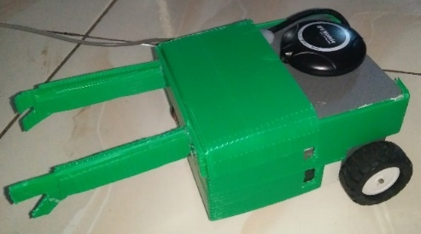
Figure 3. Results of the prototype tractor design
The results of this prototype design consist of several parts, namely, the ESP32 microcontroller, GPS, compass and driving motor (DC motor). The ESP microcontroller is used to store the Arduino IDE program and as a firebase communication liaison device as a data and history store with the controller application via the internet. GPS is used to determine the coordinates that will see the position of the tractor prototype. The compass functions to determine the angle that corresponds to the path to be taken. Finally, the driving motor is used to move the prototype towards a predetermined point or direction.

GPS Test Results
GPS testing is done by comparing the value of the GPS sensor on the device with the reference GPS value. The GPS sensor used in this study is a GPS sensor with the Ublox Neo M8N type. while the reference GPS used in this study is GPS on the oppo A54 android smartphone (GPS GLONASS, GALILEO, BDS). This test is carried out by taking five sample points from different locations. The data obtained is then poured into Table 1. Table 1 contains a comparison of the location point readings (latitude and longitude) between the GPS sensor and the reference GPS. Then from the two data it is calculated what is the difference in the distance between the two location point readings.
Table 1. GPS Sensor Test Results
No | GPS Sensor |  | GPS Reference |  | Difference (Meter)
No | Latitude | Longitude | Latitude | Longitude | Difference (Meter)
1 | -5.370141 | 120.334926 | -5.3701642 | 120.334926 | 0.000025
2 | -5.370153 | 120.334912 | -5.3701576 | 120.334930 | 0.00002
3 | -5.370143 | 120.334893 | -5.5701582 | 120.334927 | 0.2
4 | -5.370136 | 120.334904 | -5.3701657 | 120.334934 | 0.000046
5 | -5.370121 | 120.334883 | -5.3701546 | 120.334921 | 0.000031
Average |  |  |  |  | 0.04

Table 1 shows that the difference between the GPS sensor readings and the reference GPS readings is quite small, except for data number 3. The difference seems to reach 0.2 meters. Nevertheless, the overall difference obtained is still relatively small. This can be seen by the average difference value obtained by 0.04 meters.
Compass Test Results
Compass sensor testing is done by comparing the reference compass reading with the compass sensor reading on the tool. The compass sensor used in this study is a compass sensor with the QMC5883L type. While the reference compass used is an analog compass and a compass sensor on an Android smartphone. Testing is done by taking five data with different compass angles. Furthermore, the data obtained is entered into Table 10.
Table 2. Compass Sensor Test Results.
No | Analog Compass | Android Compass | QMC5883L Compass | Difference with Analog Compass | Difference with Android Smartphone Compass | % Error with Analog Compass | % Error with Compass  Android smartphones
1 | 0 | 0 | 0 | 0 | 0 | 0 | 0
2 | 30 | 31 | 30.2 | 0.2 | 0.8 | 0.67 | 2.58
3 | 60 | 60 | 60.3 | 0.3 | 0.3 | 0.50 | 0.50
4 | 90 | 90 | 90.1 | 0.1 | 0.1 | 0.11 | 0.11
5 | 120 | 119 | 120.3 | 0.3 | 1.3 | 0.25 | 1.09
6 | 150 | 152 | 150.5 | 0.5 | 1.5 | 0.33 | 0.99
7 | 180 | 180 | 180.7 | 0.7 | 0.7 | 0.39 | 0.39
8 | 210 | 211 | 210.9 | 0.9 | 0.1 | 0.43 | 0.05
9 | 240 | 241 | 240.3 | 0.3 | 0.7 | 0.13 | 0.29
10 | 270 | 268 | 270.5 | 0.5 | 2.5 | 0.19 | 0.93
11 | 300 | 303 | 301 | 1.0 | 2.0 | 0.33 | 0.66
12 | 330 | 332 | 330.1 | 0.1 | 1.9 | 0.03 | 0.57
Average |  |  |  | 0.4 | 1.0 | 0.3 | 0.7

Table 2 shows that the error for each angle between the reference compass reading value and the compass sensor reading value has a small percentage error. This can be seen by the average error value obtained, which is equal to 0.3% using a manual compass as a reference and 0.7% using a cellphone compass as a reference. Although there are several angles that have quite large errors, such as at angle 30 with an error of 2.8%, and at angle 120 with an error of 1.09%. This can be caused because at these angles there are metal objects and disturbing magnetic fields around the compass sensor so that it can affect the reading results.
Table 2 also shows that the difference between the compass sensor reading value and the reference compass reading value is quite small for the two reference compasses. This can be seen by the difference in value which is not up to one degree using an analog compass reference. Although the reference compass using a cellphone compass has quite a large difference, such as at angles of 120, 150, 270, 300, and 330. The difference seems to reach 1 to 2 degrees. Nevertheless, the overall difference obtained is still relatively small. This can be seen by the average difference value obtained by 0.4 degrees for the analog compass reference and 1 degree for the smartphone compass reference.

Control Response Test Results
Control response testing is carried out to find out how long it takes for the tractor to adjust its angle towards a predetermined target angle. Control response testing is done by determining the starting angle of the tractor (the angle must be different or even opposite to the destination angle). Then it is calculated how long it takes the tractor to adjust its angle so that the angle matches the target angle.

Table 3. Control Response Test Results
Sudut Traktor | Sudut Tujuan | Waktu (s)
0 | 270 | 13
90 | 270 | 10
180 | 270 | 5
270 | 270 | 3
360 | 270 | 14

Table 3 contains how long it takes for the tractor's direction to adjust to the destination direction. The tractor angle is the direction angle of the tractor at the start, while the destination angle is the direction angle of the destination point that the tractor will go through. The time is obtained from how long it takes the tractor to adjust its angular direction.
Based on Table 3, it can be seen that the shortest time needed for the tractor to adjust its direction is when the starting angle of the tractor is 270 degrees, which is 3 seconds. The longest time it takes the tractor to adjust its direction is when the starting angle of the tractor is 360, which is 14 seconds.

Waypoint Navigation Test Results
Waypoint testing is carried out to find out how accurate the prototype tractor is in navigating to a predetermined waypoint.
Table 4 List of Waypoints
 | Latitude | Longitude
Waypoint 1 | -5.203794 | 119.495729
Waypoint 2 | -5.203787 | 119.495639
Waypoint 3 | -5.203728 | 119.495645
Waypoint 4 | -5.203685 | 119.495666
Waypoint 5 | -5.203692 | 119.495738
The plot results for the application based on the waypoints in Table 4 are as follows:

3
2
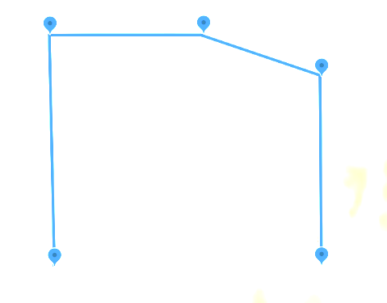
5
1
4
Figure 4. Waypoint Coordinate Plot

After the waypoint is entered, the tractor prototype will move and send the movement coordinates. The coordinates of the movement of the tractor can be seen in Table 5 below.
Table 5. Tractor Prototype Travel Coordinate Data
No. | Latitude | Longitude | No. | Latitude | Longitude
1 | -5.203794 | 119.495718 | 15 | -5.203738 | 119.495647
2 | -5.203796 | 119.495707 | 16 | -5.203732 | 119.495648
3 | -5.203797 | 119.495697 | 17 | -5.203721 | 119.495645
4 | -5.203794 | 119.495686 | 18 | -5.203705 | 119.495649
5 | -5.203790 | 119.495669 | 19 | -5.203698 | 119.495652
6 | -5.203787 | 119.495662 | 20 | -5.203691 | 119.495657
7 | -5.203784 | 119.495652 | 21 | -5.203686 | 119.495664
8 | -5.203788 | 119.495642 | 22 | -5.203680 | 119.495667
9 | -5.203791 | 119.495633 | 23 | -5.203678 | 119.495678
10 | -5.203781 | 119.495632 | 24 | -5.203682 | 119.495688
11 | -5.203773 | 119.495633 | 25 | -5.203685 | 119.495697
12 | -5.203765 | 119.495637 | 26 | -5.203689 | 119.495705
13 | -5.203757 | 119.495642 | 27 | -5.203692 | 119.495722
14 | -5.203747 | 119.495645 | 28 | -5.203691 | 119.495731
3
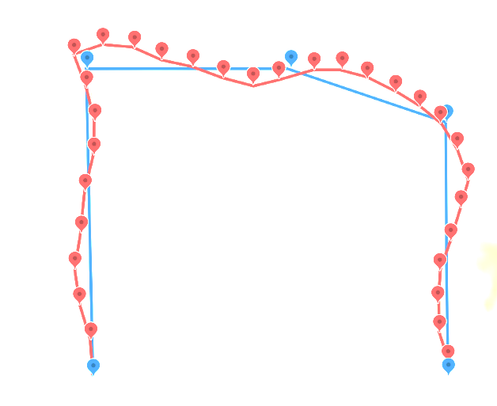
1
5
4
2
Figure 5. Tractor Prototype Path Plot Data
The trip data and waypoint data are then plotted as shown in Figure 5 to show the paths that have been passed by the tractor prototype with the paths that should have been traversed. The red line shows the travel line, while the blue line shows the waypoint line. At several points there was a deviation between the path that should have been and the path passed by the prototype tractor. This could be due to the deviation of the compass sensor. Then the number of satellites that lock GPS is also very influential. The more the number of satellites locked, the higher the accuracy of the GPS.

CONCLUSIONS

The conclusion of this study is that a navigation system has been obtained using the waypoint method to make paths traversed by the prototype tractor with the help of GPS sensors and a compass. From the tests carried out, it shows the accuracy of the GPS coordinates of the UBlox Neo M8N with a difference of 0.04 m from the reference GPS, the QMC5833L compass test shows a difference from the reference compass of 0.4 degrees, and from the waypoint navigation test it can already map an area or location with a distance deviation less than 5 meters to follow the waypoint route and provide accurate coordinate information to the server during the trip as a source of map information.

REFERENCES

[1] Wibowo, N. “Traktor Pertanian”. Pusat Pengembangan Dan Pemberdayaan Pendidik Dan Tenaga Kependidikan Pertanian, 2017.
[2] Nurmayanti, I., Nova, M. A., and Norita, L. “Mesin Traktor dan Alat Tradisional Pengolah Tanah”. Universitas Muhammadiyah Gresik, 2017.
[3] Kementrian Pertanian. “Modul Traktor Roda Dua (Hand Traktor)”. Badan Penyuluhan dan Pengembangan SDM Pertanian, 2015.
[4] Musaddiq, M. “Rancang Bangun Alat Pengusir Kalelawar Menggunakan Mikrokontroler Berbasis Android (Doctoral dissertation”. Universitas Islam Negeri Alauddin Makassar, 2021.
[5] Muliadi, M., Imran, A., and Rasul, M. “Pengembangan tempat sampah pintar menggunakan esp32”. Jurnal Media Elektrik, vol. 17, no. 2, pp. 73-79, 2020.
[6] Karim, R., Sumendap, S. S., and Koagouw, F. V. I. A. “Pentingnya Penggunaan Jaringan Wi-Fi Dalam Memenuhi Kebutuhan Informasi Pemustaka Pada Kantor Perpustakaan Dan Kearsipan Daerah Kota Tidore Kepulauan”. Acta Diurna Komunikasi, 2016.
[7] Hermana, R., Setyoadi, Y., and Aza, M. F. “Kaji Eksprimental Pembandingan Ketelitian Mesin CNC Milling Dengan Kontrol SMC Dan Mesin CNC Milling Dengan Kontrol ESP32 Wifi”. Majalah Ilmiah Gema Maritim, vol, 24, no. 2, pp. 105-113, 2021.
[8] Syamsuddin, M., Imansyah, F., Marpaung, J., and Yacoub, R. R. “Analisis Kinerja Komunikasi Modul Transciver Esp32 Pada Frekuensi 2, 4 GHz yang Akan di Terapkan pada Jaringan IoT”. Jurnal Teknik Elektro Universitas Tanjungpura, vol. 1, no. 1, 2022.
[9] Adelianthi, N. “Pendeteksi Kebakaran Hutan Menggunakan komunikasi LoRa (Long Range) Wireless Network”. Doctoral dissertation, Universitas Islam Negeri Alauddin Makassar, 2019.
[10] Rohman, Q. A. H. H., and Salahuddin, N. S. “Rancang Bangun Prototipe Mobil Penjelajah Dengan Kendali Jarak Jauh Melalui Jaringan Wi-Fi Berbasis Antarmuka Web”. Teknika, vol. 7, no. 1, pp. 1-7, 2018.
[11] Pramono, H. S. “Pembacaan posisi koordinat dengan GPS sebagai pengendali palang pintu rel kereta api secara otomatis untuk penambahan aplikasi modul praktik mikrokontroler”. Jurnal Pendidikan Teknologi dan Kejuruan, vol. 20, no. 2, 2011.
[12] Arief, F. F., Muchlas, M., and Sutikno, T. “Kompas Digital Dengan Output Suara Berbasis Mikrokontroler AT89S52”. TELKOMNIKA (Telecommunication Computing Electronics and Control), vol. 61, no. 1, pp. 1-6, 2008.
[13] Musthafa, A. R. “Sistem Navigasi Indoor Menggunakan Sinyal Wi-fi dan Kompas Digital Berbasis Integrasi dengan Smartphone untuk Studi Kasus pada Gedung Bertingkat”. Doctoral dissertation, Institut Teknologi Sepuluh Nopember Surabaya, 2016.
[14] Triwibowo, Aries. “Penerapan Navigasi Kompas Android Pada Robot Sepak Bola Beroda Berbasis Arduino”. Universitas Negeri Semarang, 2016.
[15] Setiawan, D. “Sistem Kontrol Motor Dc Menggunakan Pwm Arduino Berbasis Android System”. SITEKIN: Jurnal Sains, Teknologi dan Industri, vol. 15, no. 1, pp. 7-14, 2017.
[16] Anggoro, B., and Munadi, D. “Desain Pemodelan Kinematik dan Dinamik Humanoid Robot”. Doctoral dissertation Diponegoro University, 2013.
[17] Rachmawati, P., and Asyam, M. H. “Sistem Kontrol Pesawat Tanpa Awak Untuk Menentukan Waypoint Berbasis Ardupilot”. Quantum Teknika: Jurnal Teknik Mesin Terapan, vol. 2, no. 2, pp. 80-86, 2021.
[18] Saputra, F. R., and Rivai, M. “Autonomous surface vehicle sebagai alat pemantau lingkungan menggunakan metode navigasi waypoint”. Jurnal Teknik ITS, vol. 7, no.1, pp. A76-A81, 2018.
[19] Fikri, A. R., Anam, K., and Cahyadi, W. “Rancang Bangun Sistem Navigasi Robot Beroda Pemandu Disabilitas Netra Menggunakan Metode Waypoint”. Jurnal Rekayasa Elektrika, vol. 16, no. 3, 2020.

