Testing the Bending Strength of Carbon Fiber Composites using the vacuum infusion and vacuum bagging method

on the UAV Skywalker 1900 Fuselage Material

¹Chandra Febriyanto, ²Ferry Setiawan, ³Ikbal Rizki Putra, ⁴Dimas Aditya Mahendra

¹²³⁴Aerospace Engineering, College of Aerospace Technology
Jl. Parangtritis No.KM.4,5, Druwo, Bangunharjo, Sewon, Bantul, Daerah Istimewa Yogyakarta 55143
²ferry.setiawan@sttkd.ac.id

Abstract. The purpose of this study was to determine the bending strength of carbon fiber composite materials with lycal epoxy resin on the Skywalker 1900 UAV. Composites will be made for test specimens with carbon fiber combined with lycal resin using vacuum infusion printing and vacuum bagging methods. From these two methods a sample of specimens will be made for testing using a bending test using the three point bending method to determine the bending strength value of the fuselage material. As for another test, namely microphotos, the process of observing this microstructure can find out how the shape, size, and distribution of second phase particles have an important role in knowing the properties of the material itself. The results of the test specimens were compared between vacuum infusion printing and vacuum bagging and then the best value was sought between the two methods. The results were obtained after testing where the two methods of printing and micro-photos obtained the best results in vacuum bagging. In the vacuum bagging process, the highest value was found in specimen b2 with a bending stress value of 1201.90Mpa and the lowest yield was found in specimen i1 with a bending stress value of 1017.74Mpa. Then the micro photo test can be seen in the vacuum bagging printing process, the penetration of the resin in bagging to the fiber is better.

Keywords : UAV, Composite, Carbon fiber, Vacuum infusion, Vacuum bagging, Bending test.

INTRODUCTION

The utilization of Unmanned Aerial Vehicle (UAV) technology has grown rapidly. UAVs, commonly known as drones, are pilotless aircraft that can be operated remotely from a computer system or other vehicles on land, sea, or even in the air. Drones have various applications, including mapping. Drone technology has been instrumental in territory mapping in Indonesia, an archipelagic nation [1].
Composite is a material made from two or more components, and each composite possesses unique mechanical characteristics based on the materials used to create it. Depending on the type of binding material and the reinforcing material, the mechanical strength characteristics of the composite can vary. Various types of fiber materials are used as reinforcement in fiber-reinforced composites (reinforcing materials) [2].
Carbon fibers are used in UAV fuselages to reduce weight while maintaining material strength. Materials with at least 90% carbon by weight are known as carbon fibers. Graphite fibers with a carbon content exceeding 95% are the most commonly used type of carbon fiber. Applications that require strength, rigidity, lightweight, and fatigue resistance are suitable for carbon fibers [3].
Several methods, including vacuum bagging, spray-up, hand layup, pressure bagging, infusion, continuous pultrusion, and injection molding, are used to manufacture composite materials. This technique involves vacuum infusion and vacuum bagging to create composites, which is a relatively straightforward process. The manufacture of composite materials using vacuum infusion involves the pressing of matrix, fiber, and other layers into the mold while utilizing an airtight bag, resulting in the layers merging into a composite material [4].
Vacuum bagging is one of the most commonly used methods, along with hand lay-up. This method is an improvement over the manual hand lay-up method, as it not only involves lamination but also vacuum steps to eliminate excess resin and trapped air from the lamination [5][6].

RESEARCH METHODS

In this study using the method of vacuum infusion and vacuum bagging.
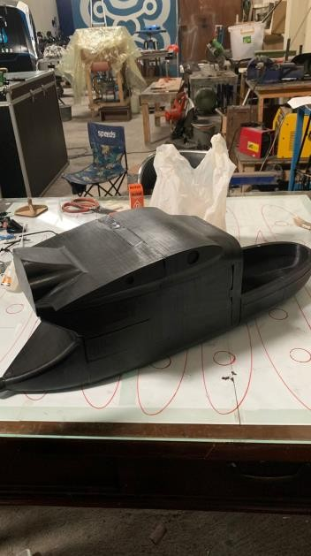

Figure 1. Shows The UAV Fuselage For Which Test Specimens Will Be Produced
In Figure 1, the researchers create a specimen using the vacuum-assisted resin infusion and vacuum bagging processes. In the vacuum-assisted resin infusion process, dry fibers are placed between the fixmold and a plastic bag. Then, resin is injected after the space inside the plastic bag is put under low pressure, and the process continues until the entire fiber is impregnated with resin. On the other hand, in the vacuum bagging process, dry fibers are placed between the fixmold, and resin is manually applied evenly using a brush onto the fiber surface [7][8].
The specimen manufacturing process utilizes the vacuum infusion method.
The process of composite manufacturing begins with the determination and preparation of carbon fibers to be used. Carbon fibers are purchased online with dimensions of 1.5x0.5 meters. After obtaining the carbon fibers, they are cut and shaped according to the size of the vacuum infusion specimen mold.
The mold used is made of glass and has a box-shaped dimension of 40x35 cm. The mold is then cut on the edges to facilitate the airflow for the in and out. Before placing the fibers, the mold is coated with wax mold release to prevent the resin from sticking to the mold. Next, the fibers are arranged in 2 layers. Peel ply is then applied over the carbon fibers, followed by the installation of flow media. Hoses are connected to the in and out parts and covered with plastic bags sealed with dodol adhesive to ensure no air leakage occurs during the infusion process.
The resin and catalyst are mixed in a 3:1 ratio (catalyst to resin by weight) and manually stirred for approximately 5 minutes to ensure a uniform mixture. The resin is poured into a glass container, and the vacuum infusion machine is activated. The in-hose is inserted into the glass container to allow the resin to flow into the mold. Once the resin flows through the hose, it is sealed with dodol adhesive to prevent air from entering the mold, ensuring a smooth vacuum process.
The next step is to wait for approximately 6 hours for the composite to cure. After the specified time has passed, the vacuum machine is turned off. The composite is then left to rest for 18 hours before removing the plastic bag and extracting the composite from the mold. Once removed from the mold, the composite undergoes material forming to meet ASTM testing size requirements using milling machines and sandpaper before being subjected to bending tests.The formed specimens are now ready for bending tests, completing the manufacturing process of the composites [9].
The process of specimen fabrication utilizes the vacuum bagging method.
This research involves several sequential stages. The initial step is to determine and prepare the carbon fibers to be used for the composite. Carbon fibers are purchased online with dimensions of 1.5x0.5 meters. After obtaining the carbon fibers, they are cut and shaped according to the size of the vacuum bagging specimen mold. The mold used is made of glass and has a box-shaped dimension of 40x35 cm. It is then cut in the middle to allow air to exit during the process. Before placing the fibers, the mold is coated with wax mold release to prevent the resin from sticking to it.The next process involves arranging the fibers in a single layer. The resin and catalyst are mixed in a 3:1 ratio (based on resin weight) and manually stirred for approximately 5 minutes to ensure a homogeneous mixture. This mixture is then evenly applied to the previously arranged carbon fibers. The carbon fibers are then re-arranged in another single layer, and the resin-catalyst mixture is again evenly applied.
To strengthen the composite structure, a breder cloth is placed over the carbon fibers. Hoses are attached to the middle part of the mold to allow air to be removed, and then the mold is covered with a plastic bag sealed with dodol adhesive to prevent air leakage into the mold.Next, the composite is left to cure for approximately 6 hours. After the curing period, the vacuum machine is turned off, and the composite is left to rest for 18 hours before removing the plastic bag and extracting the composite from the mold.Once successfully removed from the mold, the composite undergoes material forming to meet ASTM testing size requirements using milling machines and sandpaper as preparation for testing. The formed specimens are then ready to be tested in bending tests
In the final stage, data from all tests are collected and recorded for further analysis and discussion in this research. All these stages are carried out to achieve accurate and reliable results in this composite study [10][11].

RESULTS AND DISCUSSION
A. Research Result
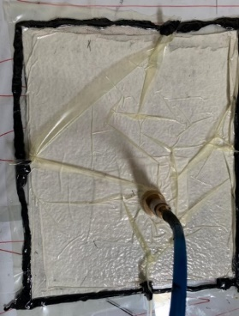
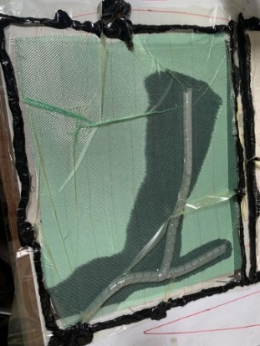
In this section, the results of data processing are displayed on the results of the tests that have been carried out. The data from this study were sourced from bending tests and micro-photos using 6 specimens. For data analysis, it takes the average value of each variation used.

a) b)
Figure 2. a) Vacuum Infusion b) Vacuum Bagging Processes

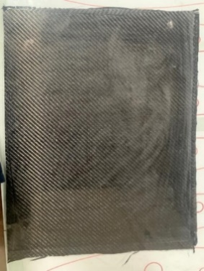
After the vacuuming process for 6 hours and then left for 18 hours, the results are as follows

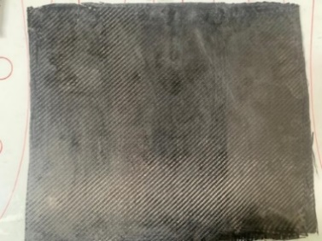

a) b)
Figure 3. The Results a) The Vacuum Infusion b) Vacuum Bagging Processes

Then proceed with cutting the specimen using a CNC router to get precise sizes according to ASTM D790

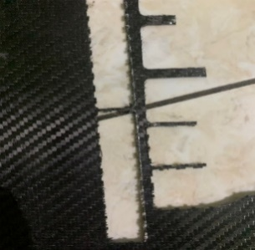
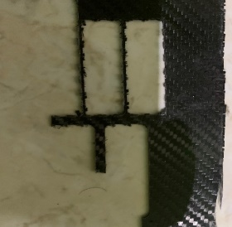

a) b)
Figure 4. Results Of Cutting Using CNC Router a). Vacuum Infusion Cutting Results b) Vacuum Bagging Cutting Results

Bending Test
After the results of cutting composite materials using a CNC router and according to ASTM D790-17 for bending strength testing

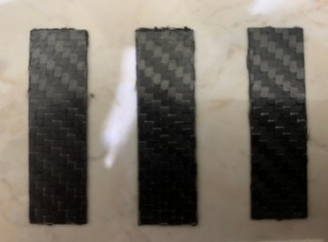
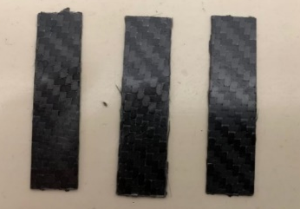
a) b)
Figure 5. Specimens of the vacuum infusion and vacuum bagging method a).specimen vacuum infusion method b) specimen vacuum bagging method

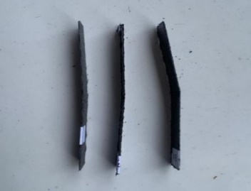
Photos of the bending test results can be seen as below;
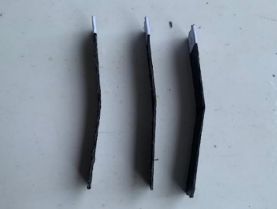
a) b)
Figure 6. Documentation of the results of a) Vacuum infusion bending test results b) Vacuum bagging bending test results

Table 1. Shows the comparison of the vacuum infusion and vacuum bagging methods.
Variation | Bending Strength (MPA) | Bending Strength Average  (MPA)
Vacuum Infusion method | 1017,74 | 1110,25
Vacuum Infusion method | 1182,56 | 1110,25
Vacuum Infusion method | 1130,43 | 1110,25
Vacuum Bagging Methode | 1079,00 | 1159,75
Vacuum Bagging Methode | 1201,90 | 1159,75
Vacuum Bagging Methode | 1198,37 | 1159,75

From the table above we make a graph of the average bending strength can be seen in Figure 7 as follows
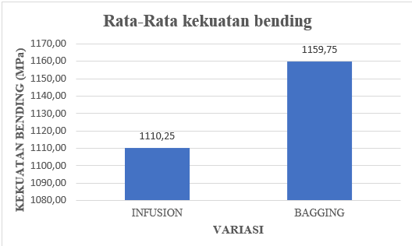
Figure 7. Bending strength bar diagram
The graph shows the average results of the carbon fiber bending test using the vacuum infusion and vacuum bagging methods. In carbon fiber using the vacuum infusion method, the average bending strength results are obtained with a value of 1110.25 MPa. In carbon fiber using the vacuum bagging method, the average bending strength is obtained with a value of 1159.75 MPa. In this bending test, the increase in bending strength from the vacuum infusion to vacuum bagging method reached 0.045%.
a).Spesimen Metode Vacuum Infusion
The graph represents the bending test results of carbon fiber using the vacuum infusion method with 3 specimens. The highest bending stress was achieved at 1182.56 MPa in specimen 2, while the lowest bending stress was recorded at 1017.74 MPa in specimen 1.
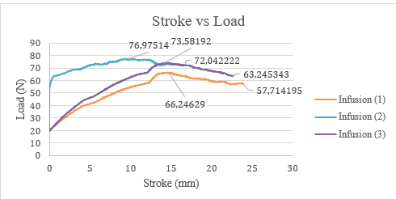
Figure 8. Load vs stroke Chart of The Vacuum infusion Methode
b).Spesimen metode vacuum bagging
The graph shows the results of the bending test of carbon fiber using the vacuum bagging method with 3 specimens. The highest bending stress was achieved at 1201.90 MPa in specimen 2, while the lowest bending stress was recorded at 1079.00 MPa in specimen 1.
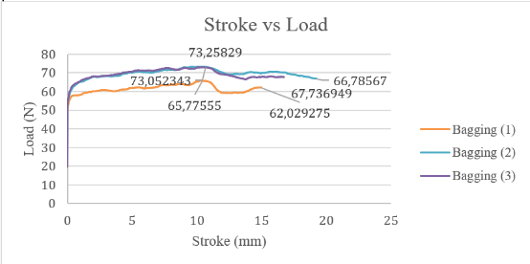
Figure 9. Load vs. Stroke Chart of the Vacuum Bagging Method
Micro Photo
In the bending strength testing, the best variation was achieved using the vacuum bagging method. This is because during the manual resin application, it was evenly distributed using a brush. On the other hand, the vacuum infusion method showed imperfect resin penetration into the fibers due to poor application, specifically caused by uneven resin distribution through the spiral hoses, primarily positioned in the middle. The vacuum bagging method produced better results with fewer voids. This can be observed from the micrograph of the specimens at 70x magnification shown below.

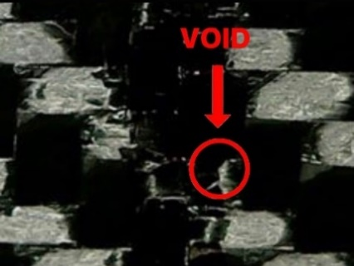
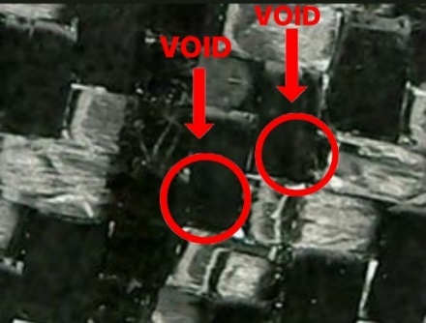
a) b)
Figure 9. a). Micro vacuum infusion photo results b). Photographs of micro vacuum bagging

From Figure 9. above it can be seen that the vacuum infusion method has more voids and the vacuum bagging method has fewer voids. This is caused during the manufacturing process

Density Calculation
$$ρ=\frac{m}{v} (1)$$
information :
$ρ$= density $(gr/cm^{3})$
$m$= object mass ($kg$ atau $gr)$
$v$= object volume ${(kg/m}^{3} atau gr/cm^{3})$
$l$= specimen width $(cm)$
$t$= specimen height $(cm)$
$p$= specimen length $(cm)$

a).Specific Gravity of Specimens using Vacuum Infusion Method
Giveni :
$t$= 0,62$mm$ = 0,062$cm$
$p$= 70$mm$ = 7$cm$
$l$= 12,7$mm$ = 1,27$cm$
$v$= 7 x 0,062 x 1,27 = 0,55118$cm^{3}$
$m$= 0,62$g$
Inquired : ρ= … ?
Answer : ρ= $\frac{m}{v}$
$ρ$= $\frac{0,62}{0,55118}$
ρ= 1,12485939 $\frac{gr}{{cm}^{3}}$

b).Specific Gravity of Specimens using Vacuum Infusion Method
Giveni :
$t$= 0,60$mm$ = 0,060$cm$
$p$= 70$mm$ = 7$cm$
$l$= 12,7$mm$ = 1,27 $cm$
$v$= 7 x 0,060 x 1,27 = 0,5334$cm^{3}$
$m$= 0,58$g$
Inquired : ρ= … ?
Answer : ρ= $\frac{m}{v}$
$ρ$= $\frac{0,58}{0,5334}$
ρ= 1,08736408 gr/${cm}^{3}$

B. discussion of results

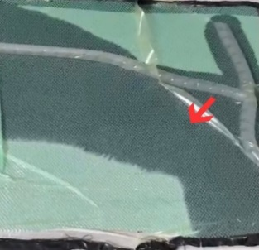
The discussion of the results of the bending test and microphotographs shows that the best method to be used in the manufacture of composite materials for the UAV Skywalker 1900 fuselage is the vacuum bagging method, because the highest results are from the results of making specimens in the form of samples and then bending tests in accordance with ASTM D790, the best results are obtained. by vacuum bagging. In the micro photo, it can be seen that the best penetration between resin and fiber is obtained by the vacuum bagging method. The vacuum infusion process did not go well due to the uneven application of theresin, this can be seen in the image below.

Figure 10. Application Of Resin Vacuum Infusion

In Figure 10 it can be seen that the application of resin tends to flow downward, so that at the top it is not evenly distributed when applying resin to the fiber. For the manufacture of the vacuum infusion method, place the spiral hose on the side like the letter U so that it is evenly distributed in the infusion method.

CONCLUSION

The bending strength testing results of the specimens indicate that the vacuum infusion method achieved the highest bending strength at 1182.56 MPa, while the lowest bending strength reached 1017.74 MPa. On the other hand, the bending strength testing with the vacuum bagging method reached the highest bending strength at 1201.90 MPa, and the lowest bending strength was recorded at 1079.00 MPa.
Based on the results and discussions, the best method for manufacturing carbon fiber composite materials for the UAV Skywalker 1900 fuselage is the vacuum bagging method. This method provides higher bending strength compared to the vacuum infusion method. The use of vacuum infusion encountered challenges in resin penetration into the fibers, mainly due to uneven resin application through spiral hoses, particularly caused by the position of the spiral hoses in the middle, resembling the letter T.Thus, the vacuum bagging method is considered more effective, producing composites with better mechanical properties for UAV fuselage applications. These results offer essential insights for improvement and development in the composite material manufacturing process based on the desired needs and technical requirements.

SUGGESTION

For future researchers, it is recommended to focus on developing materials that are lighter yet maintain high bending strength. Carbon fiber composite materials have the potential to be used in various applications, including UAV fuselages. By optimizing the ratio of weight to bending strength, composite materials will become more efficient and deliver better performance in their applications.
Additionally, for improvements in the vacuum infusion method, the next researchers can consider placing the spiral hoses on the sides, forming a U shape. With this improved placement, resin distribution into the fibers will be more even during the infusion process. This will help enhance resin penetration into the fibers and reduce the possibility of structural weaknesses caused by uneven resin distribution in the previous method. Consequently, the use of vacuum infusion can be optimized to achieve better results in manufacturing carbon fiber composite materials

REFERENCES

- Negara, Made Abdi, I. G. Y. W. serta I. W. K. E. P. (2021). Perbandingan Hasil Pemotretan Foto Udara Memakai Drone Industrial dengan Drone Basic. Jurnal ENMAP (Environment & Mapping), 2(2), 29–36.
- Siagian, E. M. (2017). Sifat Komposit Berpenguat Serat Buah Pinang. Sifat Komposit, 3(Fiber Composite), 1–98.
- Wibawa, L. A. N. (2019). Pengaruh Pemilihan Material Terhadap Kekuatan Rangka Main Landing Gear Untuk Pesawat Uav: Effect of Material Selection on the Strength of the Main Landing Gear Frame for Uav Aircraf. Jurnal Teknologi serta Terapan Bisnis, 2(1), 48–52.
- F.Hazhari, et al. (2022). PENGARUH KEKUATAN TARIK serta KEKUATAN BENDING KOMPOSIT HYBRID serta NON HYBRID MEMAKAI METODE VACUUM BAGGING.
- Azissyukhron, M., & Hidayat, S. (2020). Perbandingan Kekuatan Material Hasil Metode Hand Lay-up serta Metode Vacuum Bag Pada Material Sandwich Composite. Prosiding Industrial Research Workshop and National Seminar, 9, 1–5.
- Agung Prakoso & Fauzan Amarullah (2020). Analisa kekuatan struktur serta ketika membuat fuselage UAV dengan Metode Vacuum Bagging.
- Ferry Setiawan, Muhammad Fauzaan Firmansyah dkk (2023). MANUFACTURE OF UAV SKYWALKER 1900 FLYING VEHICLES MADE OF COMPOSITES. Al-Fiziya: Journal of Materials Science, Geophysics, Instrumentation and Theoretical Physics
- D. A. Ramadhan (2022). CARA MANUFAKTUR PESAWAT TANPA AWAK (UAV) JENIS FIXED WINGDENGAN MEMAKAI MATERIAL STYROFOAM serta MATERIAL COMPOSIT FIBER CLOTH.
- Dinur, R. (2019). Cara Ketika membuat Produk Komposit Sandwich Vacuum Infusion.
- Lufti, F. (2018). Ketika membuat Model Papan Selancar Komposit Vacuum Bagging.
- Fakhrin, H. (2019). Pemanfaatan Serat Tebu Seperti Penguat Pada Komposit Dengan Matriks Polyester Untuk Ketika membuat Papan Skateboard. Tugas Akhir, Universitas Muhammadiyah Sumatera Utara, 1–74.

