THE EFFECT OF NICKEL ELECTROPLATING TIME ON ALUMINUM 2024 TO ITS MECHANICAL PROPERTY
Hidayah fajria¹ , Ferry Setiawan^{2,†}, Dhimas Wicaksono³
¹Aerospace Engineering, College of Aerospace Technology, University?
2…….
3……..
†ferry.setiawan@sttkd.ac.id

Abstract. The purpose of this research on nickel electroplating on aluminum was to determine the effect of time on the mechanical properties in the form of the hardness value of the specimen. The SEM-EDX test was carried out on the specimen with the highest hardness test value to determine the microstructure and elemental composition of the coating. The materials used in this study were nickel as a coating and aluminum 2024 as a coated material. Fixed variables used in this study include voltage (25 V), electrode distance (20 cm), water (2400 ml), salt (40gr), vinegar (1600 ml), aluminum 2024, and nickel. The independent variable is the variation of coating time, namely 10, 15, and 20 minutes. The results of this study showed that the highest hardness value was found in specimens with 10 minutes of immersion time with a value of 198.31 HV and the lowest hardness value was obtained by sample with 20 minutes of immersion time with a value of 132.81 HV. After the SEM-EDX test, it was found that the microstructure of the layer was containing pitting (defects) and highest element found in the layer was Nickel with a mass of 84.07% and an atomic number of 55.29%.

Keywords: aluminium 2024, nickel elctroplating, hardness analysis, elemental analysis

INTRODUCTION
Electroplating is a process used to manipulate the properties of a substrate by coating it with another metal. The results obtained in the electroplating process are influenced by many variables, including the solution used, the temperature of the solution, the duration of the plating, the voltage between the two electrodes, the condition of the electrodes used, and so on. Electroplating is made by passing an electric current through a solution between metals or other conductive materials. Two metal plates are the anode and cathode connected to the positive and negative terminals of the direct current (DC) source. The metal connected to the positive pole is called the anode and the metal connected to the negative pole is called the cathode. When a voltage source is used in the electrolyte, the positive pole emits ions that move in solution (electrolyte) towards the cathode and are referred to as cations. The negative pole also gives off ions, moving towards the anode and is referred to as anion. The scheme of electroplating mechanism is shown in Fig. 1.

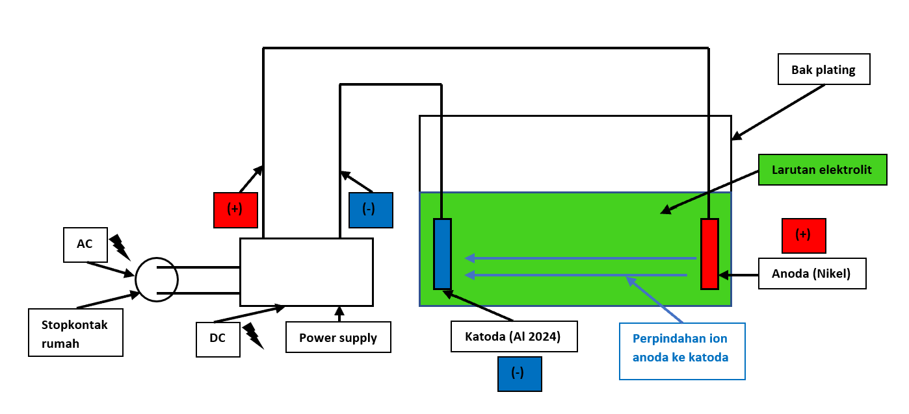
Figure 1 Electroplating mechanism scheme

Aluminum alloy 2024 is one of the metal alloys which is mostly utilized by aircraft manufacturers as a material for aircraft components due to its excellent mechanical property which has a high strength to weight ratio. Apart from airplanes, aluminum 2024 is also often used as a material for making motorcycle components. The element content of alumunium 2024 is shown in Table 1.

Tabel. 1 Aluminium 2024 element content
Element | Persentage (%)
Aluminium | 90.7-94.7
Chromium | 0.1
Copper | 3.8-4.9
Ferrit | 0.5
Magnesium | 1.2-1.8
Mangan | 0.3-0.9

The Vickers Hardness Test is to determine the resistance of the material associated with a smaller indenter, so that the results are more detail compared to using other hardness testing methods. The Vickers value is obtained using the formula 1 and 2:

$D=\frac{(d1+d2)}{2}$ Formula 1
$$HV=\frac{1.854F}{D²} Formula 2$$

where:
D : Mean diagonal tracking (mm),
d1 : Side diagonal tracking 1 (mm),
d2 : side diagonal tracking 2 (mm),
HV : Hardness Vickers value (kgf/mm2), and
F : Maximum force (Newton).

Scanning Electron Microscope (SEM) is an electron microscope designed to directly observe the surface of solid objects. SEM has a magnification of 10 – 3,000,000 times. Due to its combination of high magnification, large depth of field, good resolution, the SEM test is widely used to determine the composition and crystallographic information of a material surface.

This research was carried out by making electroplating tools. After carrying out the manufacturing process, all tools were calibrated both in the system and measuring instruments. After making sure everything is in good condition, the next step is to carry out the nickel-plating process on the aluminum base material and carry out hardness testing and SEM testing. Figure 2 shows the instruments used during the test:

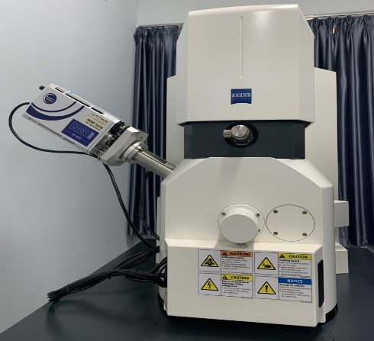
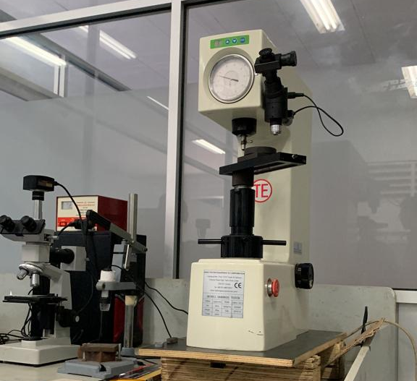

(a) (b)
Gambar. 2 (a) Hardness testing instrument, (b) SEM-EDX instrument

RESULT AND DISCUSSION
The data from this study came from hardness tests on 3 electroplated specimens and SEM tests on specimens with the highest hardness values.
- Hardness analysis
Figure 3 shows the hardness Vickers values of samples with variation of nickel electroplating time.

Figure 3 The Hardness result of samples with nickel electroplating time variations of 10, 15 and 20 minutes.

Figure 3 shows the results of the average hardness value of each time variation. The sample with an immersion time of 10 minutes has the highest hardness Vickers value of of 198.31 HV. Otherwise, the sample with longest immersion time (20 minutes) has the lowest hardness Vickers value of 132.81HV.
- SEM-EDX Analysis
SEM test was carried out with a magnification of 1000 times. The microstructure of the electroplated layer obtained on the specimen with an immersion time of 10 minutes was obtained by Figure 4.
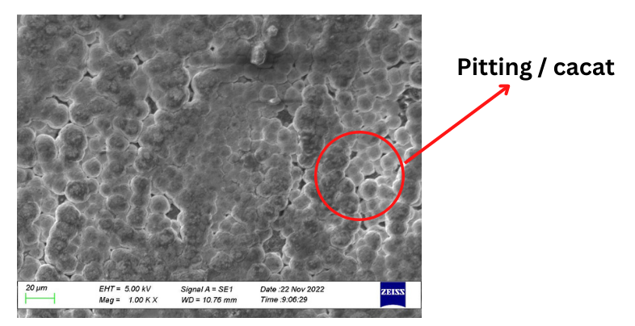
Figure 4 SEM image of sample with immersion time of 10 minutes

From the SEM result, it can be observed that the nickel was successfully coated to the Alumunium 2024. Nickel particles that stick to aluminum form bubbles that are layered and interrelated. However, there are also unrelated bubbles that form cavities in each of them. After carrying out the EDX test on the layer, it can be observed that it is these cavities that allow oxygen and carbon to be trapped in the layer. This can be caused by reactions that occur during the coating process.
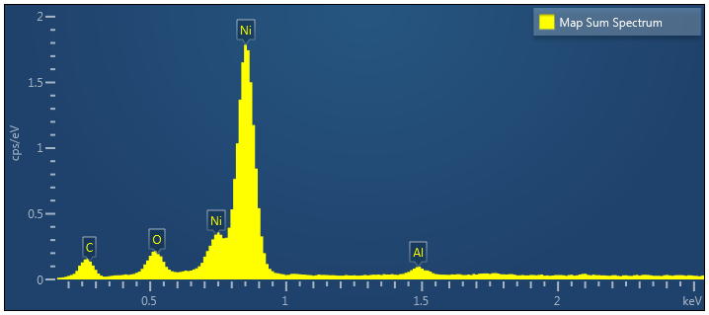

Figure 5 Elemental analysis result of sample with immersion time of 10 minutes

Figure 5 and Table 2 show the elemental analysis of sample with immersion time of 10 minutes. The largest element contained in the sample is nickel element with a composition of 84.07 wight % 55.29 atomic %.

Table 2. Elemental analysis of sample with immersion time of 10 minutes
Element | Weight % | Atomic %
Ni | 84.07 | 55.29
O | 4.86 | 11.73
C | 9.60 | 30.87
Al | 1.47 | 2.11

CONCLUSION
The nickel electroplating to alumunium 2024 was successfully performed with the immersion time variations of 10, 15 and 20 minutes. Hardness analysis result states that the immersion time variation affect the hardness property of samples. The shorter immersion time of 10 minutes shows the higher hardness value of 198.31 HV compared to the sample with the longer immersion time of 20 minutes which has the lower hardness value of 132.81 HV. The hardness value decreases along with the increasing immersion time due to the emergence of pitting (defects) on the electroplated layer. SEM image of 10 minutes immersion sample shows that the microstructure of the specimen layer is hollow and there are some impurities attached to it. The cavities and impurities are identified as oxygen and carbon analyzed from the EDX result. With the presence of pitting (defects), it causes the decrease of hardness value of the specimen and easily produce the brittle nickel coating on the specimen.

REFERENCES
- Amin. 2019. “Optimasi Kekuatan Tarik Proses Electroplating Ss400.”
- Andinata, Febryan. 2012. “161-Article Text (Manuscript) in DOC or DOCX Format-215-1-10-20161114.”
- Caesarti, Astri Widya. 2018. “PENGARUH AGING DAN CLADDING PADA PADUAN ALUMINIUM 2024 TERHADAP SIFAT MEKANIK, KONDUKTIVITAS LISTRIK DAN KETAHANAN KOROSI UNTUK APLIKASI SKIN WING PESAWAT.” Bitkom Research 63(2): 1–3.
- Diah Andayani, Ratih, Rita Djunaidi, Siti Zahara, and Herlangga Yakub. “ANALISA PENGARUH JARAK KATODA DAN ANODA DALAM PROSES ELEKTROPLATING ALUMINIUM TERHADAP DAYA LEKAT.” www.teknika-ftiba.info.
- Djunaidi, Rita, Siti Zahara, and Herlangga Yakub. 2019. “ANALISA PENGARUH JARAK KATODA DAN ANODA DALAM PROSES ELEKTROPLATING ALUMINIUM TERHADAP LAJU KOROSI.” Jurnal Ilmiah "TEKNIKA 4(2). www.teknika-ftiba.info.
- Endah Palupi, Aisyah. PENGARUH TEMPERATUR DAN WAKTU PROSES ELEKTROPLATING TERHADAP.
- Farikhin, Fahrizal. 2016. “Analisa Scanning Electron Microscope Komposit Polyester Dengan Filler Karbon Aktif.” Publikasi Ilmiah.: 1–16.
- Jamaludin. 2014. Pengaruh Ketebalan Elektroplating Menggunakan Nikel Dan Krom Pada Aluminium Alloy 2024 Terhadap Laju Korosi.
- Machfuroh, Talifatim, Yayi Febdia Pradani, and Wildanul Ghufron. 2021. “Pengaruh Jarak Dan Waktu Electroplating Terhadap Laju Deposit Dan Korosi Aluminium Alloy.” Jurnal Pendidikan Teknik Mesin Undiksha 9(1): 71–79.
- Miftakh, Yusuf. 2018. “ANALISIS PENGARUH ELECTROPLATING PADA ALUMINIUM ALLOY 2024 MENGGUNAKAN NIKEL DAN KROM TERHADAP LAJU KOROSI DENGAN METODE POLARISASI LINEAR.” Seminar Nasional Inovasi Teknologi Penerbangan (SNITP) Tahun.
- Niam, M Y, H Purwanto, and S M B Respati. “Pengaruh Waktu Pelapisan Elektro ….”
- Paridawati. 2013. “Analisa Besar Pengaruh Tegangan Listrik Terhadap Ketebalan Pelapisan Chrome Pada Pelat Baja Dengan Proses Electroplating.”
- Pratama, galang anugrah. “ANALISIS PENGARUH WAKTU PELAPISAN NIKEL PADA MATERIAL ALUMINIUM SERI 2024 TERHADAP KEKUATAN TARIK DAN KEKERASAN DENGAN METODE Galang Anugrah Pratama , 2 Sehono , 3 Ferry Setiawan Dirgantara , STTKD Yogyakarta Pendahuluan Salah Satu Logam Yang Memiliki Sif.” 8(1): 1–8.
- Sari, Baqu et al. 2020. “RANCANG BANGUN CONVEYOR AUTO ELECTROPLATING BERBASIS ARDUINO MEGA.” Jurnal POLEKTRO: Jurnal Power Elektronik 9(1). https://www.liputan6.com/regional/read/2884873/tekad-tegal-.
- Setiawan, Ferry. 2022. “JOURNAL OF MECHANICAL ENGINEERING , Pengaruh Variasi Waktu Proses Hot Dipping Alumunizing Coating Stainless Steel 304 Terhadap Karakteristik Material Dan Konduktivitas Termal The Effect of Time Variations in the Hot Dipping Alumunizing Coating Stainless S.” 6(01): 32–47.
- Setiawan, Reza, Ferry Setiawan, and Sttkd Yogyakarta. 2022. “ANALISIS WAKTU PELAPISAN NIKEL PADA ALUMINIUM ALLOY 2024 TERHADAP SIFAT MEKANIS DENGAN MENGGUNAKAN Pendahuluan Perkembangan Pada Bidang Material Terutama Pada Logam Semakin Banyak Dilakukan . Salah Satu Inovasi Yang Dilakukan Adalah Proses Elektroplating.” 8(1): 1–8.
- Sujatno, Agus, Rohmad Salam, Bandriyana Bandriyana, and Arbi Dimyati. 2017. “STUDI SCANNING ELECTRON MICROSCOPY (SEM) UNTUK KARAKTERISASI PROSES OXIDASI PADUAN ZIRKONIUM.” Jurnal Forum Nuklir 9(1): 44.
- Topayung, Daud. 2020. PENGARUH ARUS LISTRIK DAN WAKTU PROSES TERHADAP KETEBALAN DAN MASSA LAPISAN YANG TERBENTUK PADA PROSES ELEKTROPLATING PELAT BAJA EFFECT OF ELECTRIC CURRENT AND PROCESS TIME THE THICKNESS AND MASS LAYER FORMED ON ELECTROPLATING PROCESS STEEL PLATES.
- Walikram, Dzulkifli. “ANALISIS PENGARUH WAKTU TERHADAP KEKUATAN TARIK DAN KEKERASAN Ferry Setiawan , 2 Dzulkifli Walikram Pendahuluan Pada Era Globalisasi Saat Ini Terdapat Banyak Perkembangan Teknologi Yang Terjadi Salah Satunya Adalah Dalam Bidang Material Atau Bahan , Pada.” 8(1): 1–11.
- Wibowo. 2017. “STUDI EKSPERIMENTAL PENGENDALIAN LAJU KOROSI FATIK PADA ALUMINIUM 2024-T3 DI LINGKUNGAN AIR LAUT MELALUI PENAMBAHAN INHIBITOR KALIUM KROMAT (K2CrO4).” 17.
- Wicaksono, Dhimas et al. 2020. “Pengaruh Kandungan Ti Pada Struktur Mikro Dan Sifat Mekanik.” 991: 24–29.

