Analysis of Landslide Potential Using Resistivity, Geology and Climatology Values in Samangki Village, Simbang District, Maros Regency
Ahmad Haan ¹, Ayusari Wahyuni ², Muh. Said L ³, Rahmaniah ⁴
¹²³⁴Jurusan Fisika, Universitas Islam Negeri Alauddin Makassar, Makassar, Indonesia
ahmadalileah@gmail.com

Abstrak. Telah dilakukan penelitian yang bertujuan untuk mengetahui analisis potensi longsor menggunakan nilai resistivitas, geologi dan klimatologi di Desa Samangki, Kecamatan Simbang, Kabupaten Maros. Penelitian ini menggunakan metode resistivitas konfigurasi wenner pada tiga lintasan dengan panjang masing-masing lintasan 120 meter pada jarak spasi antar elektroda sebesar 10 meter. Hasil interpretasi diperoleh nilai resistivitas pada lintasan pertama antara 61,1 – 972 Ω.m, pada lintasan kedua sebesar 58,2 - 666 Ω.m, dan pada lintasan terkahir nilai resistivitas kisaran 60,1 - 1105 Ω.m, yang menandakan keberadaaan batu gamping sisipan batu pasir serta akuifer yang tersebar pada masing-masing lintasan. Kemudian dipadukan dengan data sekunder berupa peta curah hujan, peta kemiringan lereng, peta pengunaan lahan, peta geologi, dan peta jenis tanah. Hasil analisis kemudian menunjukan daerah lokasi penelitian ini berada pada daerah rawan longsor sesuai data primer atau data lapangan dan data sekunder dari kelima parameter tersebut diatas.

Kata Kunci: Geolistrik, Konfigurasi Wenner, Resistivitas

Abstract. Research has been carried out that aims to determine the analysis of landslide potential using resistivity, geology, and climatology values in Samangki Village, Simbang District, Maros Regency.This study uses the resistivity method of the wenner configuration on three tracks of 120 meters at a distance between the electrodes of 10 meters. Interpretation results obtained resistivity values on the first track between 61,1-972 Ω.m, on the second trajectory of 58,2 - 666 Ω.m, and on the last track the resistivity value of the range 60,1 - 1105 Ω.m, which indicates the presence of limestone inserts sandstone and aquiver scattered on each track. Then combined with secondary data in the form of rainfall maps, geological maps and soil type maps. The results of the analysis then show that the location of this research is in an area prone to landslides according to primary data or field data and secondary data from the five parameters mentioned above.

Keywords: Geoelectric, Wenner Configuration, Resistivity

INTRODUCTION

Indonesia is a country that cannot be separated from natural disasters such as landslides, volcanic eruptions, earthquakes, and floods. Moreover, one that often happens in Indonesia is landslides. A landslide is one of the natural geological disasters that can cause huge losses ranging from material losses such as roads, settlements, agricultural land, bridges, irrigation canals, and other infrastructure to causing fatalities.
Maros Regency is geographically located between 119ᵒ30'00''-120ᵒ0'0'' East Longitude and 4ᵒ50'0''-5ᵒ10'0'' South Latitude. The geological conditions of Maros Regency, especially Simbang District, consist of hilly areas with volcanic rock, intrusive rock, igneous rock, and sedimentary rock as their constituent rocks. In this range, the average rainfall for Maros Regency is high, with such geological conditions and rainfall that Samangki Village, Simbang District, Maros Regency is very vulnerable to landslides (RP12-JM, 2014).
In addition to geological conditions and rainfall, the slope of the slope is a factor that also influences the occurrence of landslides. BMKG Maros data states that Maros Regency, with a slope of > 40% with a percentage of 30%, is located in the east. With this slope, Maros Regency, especially in the east, which is the location of this research, is very prone to landslides. For example, in January 2021, there was a landslide on the Maros-Bone flyover, which is not far from the research area, which caused the disconnection of Maros-Bone road access which had an impact on various factors. This motivates the author to conduct this research to minimize unwanted things in the future.
The concept of geology states that soil is a weathered layer of the earth's crust. Soil is the result of the transformation of mineral and organic substances on the surface of the earth's land, and soil is formed under the influence of environmental factors that work for a very long time. Soil is a heterogeneous and diverse component of soil mixing, namely the solid phase (mineral materials and organic matter), the liquid phase (soil moisture and groundwater), and the gaseous phase (soil air) (Susanto, 2005).
The function of the soil is to distribute food to plants through the roots so they can grow and develop and channel the things plants need to grow, namely substances that accelerate plants, such as vitamins, hormones, acids, etc. Another function is as a place to live for living things below the surface of the soil and provide primary and secondary needs for living things below the surface of the soil. In addition to having a positive impact, on the one hand, it also harms plants, including pests and diseases, both directly and indirectly (Herry, 2016).
Soil also has a classification and morphology, which are part of the pedology. As for the morphological, chemical, physical, and biological properties of the soil, from these properties, the soil is grouped into certain classes and characteristics so that it can be used to describe the soil itself. The results of the classification, then through observation, will produce the final result, namely in the form of a map of the land distribution according to the classification (Rayes, 2017).

METHOD

The tools and materials used in this study were a set of geoelectric tools, geological data for the Simbang sub-district, slope data for the Simbang sub-district, rainfall data for the Sambang sub-district, soil type data and land use data for the Sambang sub-district.
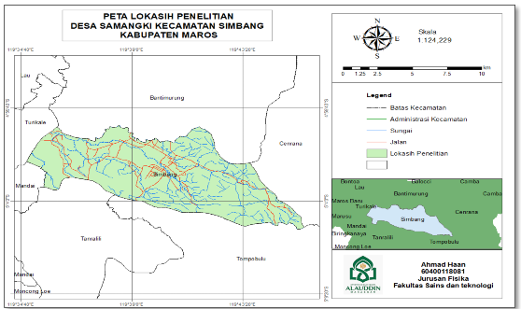
Figure. 1 research sites
The research method was carried out using the resistivity method and the climatological method, while the data between the two methods are as follows:
- Resistivity Method
Using the Wenner configuration Resistivity Data
- Climatological Method
- Geological data of the study area
- Slope data
- Rainfall data
- Land use data and
- Soil type data

RESULTS AND DISCUSSIONS

- Resistivity Data Processing
- First Track
On track 1 it is carried out at coordinate points at South Latitude 08 ˚03'14.0" and West Longitude 119 ˚43'24.4" with an altitude > 1000 meters above sea level. On this track a stretch of 120 m is used with the smallest spacing of 10 m, with a Wenner configuration, on this track there is a low resistivity zone at a distance (x) 25 m to 40 m with a resistivity value of 61.1<ρ<135 Ωm, which indicates the presence of layers of clay, sand and gravel, which indicates the presence of groundwater as a fluid to fill the rock pores. The following is table 4.1 to show more clearly the first track interpretation data:

Table 1: The resistivity value obtained in the first pass
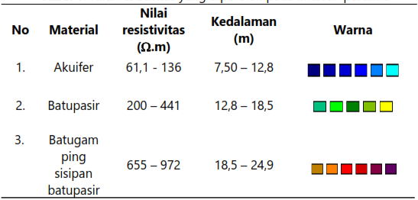

The results of the 2-D cross-section inversion using Res2dinv software can be seen in the following figure:
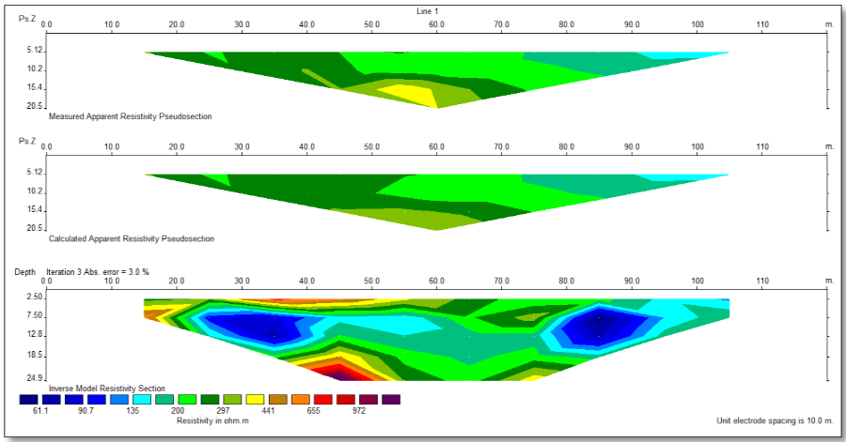
Figure. 8 Resistivity cross-section on track-1

Also, there is a high resistivity zone with a range of resistivity values between 441<ρ<972 Ωm, which indicates the existence of a granitic layer with sand inserts located at a distance of 50 m with a thinning stretch to the east. Maros, the intensity of rainfall at this location is relatively high on this track, while the topographic cross-section on track 1 is as follows:
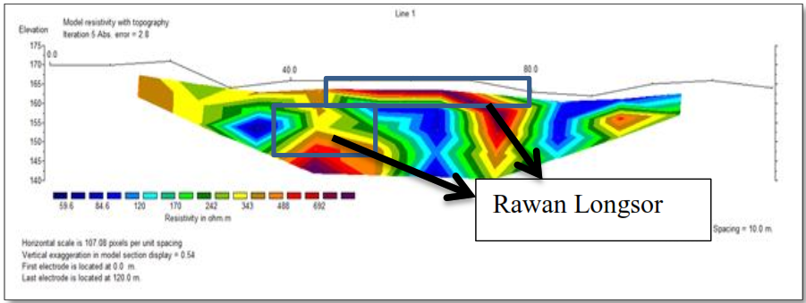
Figure. 9 Topographic cross-section on track-1

Based on the figure in 4.3, the first cross-section has a resistivity value of 61.5 - 972 Ωm, while the red color in the cross-section above is found at a depth of 18.5 - 24.9 m with a length of 40 - 50 m. It is suspected that there is inset limestone and sandstone with a value resistivity between 655 - 972 Ωm, so from the results of the cross-sectional analysis above, this location is suspected of having the potential for landslides. Limestone itself is a sedimentary rock composed chiefly of calcium which comes from the remains of marine organisms such as shells, sea slugs, and dead coral.
- Second Track
As with the first track, on the second track, there is a high resistivity zone with a resistivity value range between 398<ρ<666 Ωm, which indicates the presence of a granitic layer with sand inserts located at a distance of 50-85 m with a thinning stretch towards east. The following table 4.2 shows more clearly the second path interpretation data:

Table 2: The resistivity value obtained in the second pass
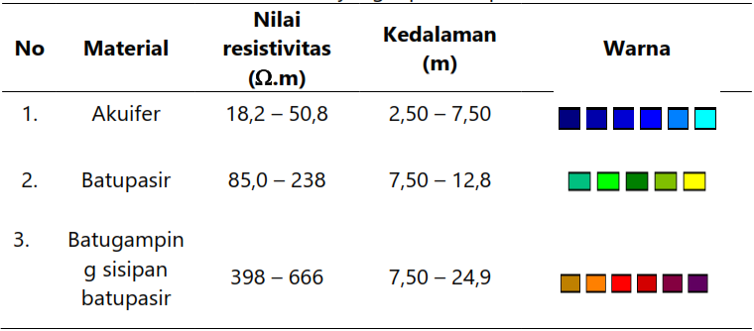

The results of the 2-D cross-section inversion using Res2dinv software can be seen in the following figure:
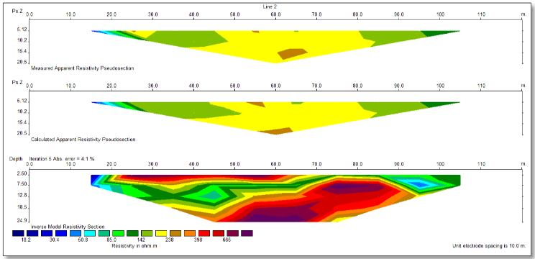
Figure. 10 The resistivity section on track-2

In addition, there is also a low resistivity zone at a distance of (x) 10 m to 20 m with a resistivity value of 18.2<ρ<50.8 Ωm, which indicates the presence of layers of clay, sand, and gravel, which indicates the presence of groundwater as a filling fluid. The rock pores, while the topographic cross-section on track 2 is as follows:
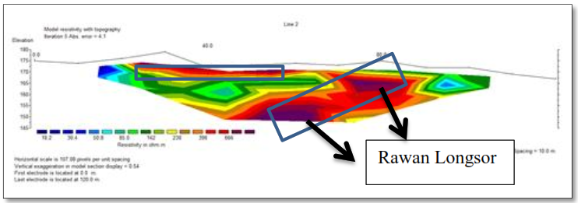
Figure. 11 Topographic cross section on track-2

Based on the figure in 4.4, the second section has a resistivity value of 18.2 - 666 Ωm, while the red color in the section above is found at a depth of 7.50 - 24.9 m with a length of 50 - 90 m. It is suspected that there are inset limestone and sandstone with a value resistivity between 238 - 666 Ωm, so from the results of the cross-sectional analysis above, this location is suspected of having the potential for landslides.
- Third Track
The third track is different from the previous track on the first and second track because, on this track, there is only a low resistivity zone at a distance of (x) 25 m to 80 m. It is also present at a distance of 90 m to 110 m, with a resistivity value of 60,1<ρ<138 Ωm, which indicates the presence of clay layers. The following is table 4.3 to shows more clearly the interpretation of the third trajectory data:

Table 3: The resistivity value obtained in the third pass
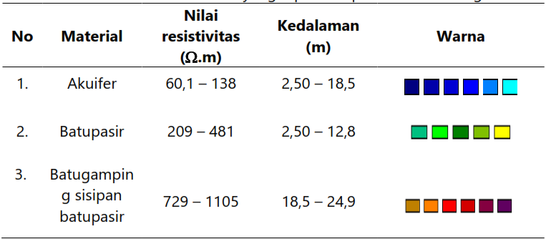

The results of the 2-D cross-section inversion using Res2dinv software can be seen in the following figure:
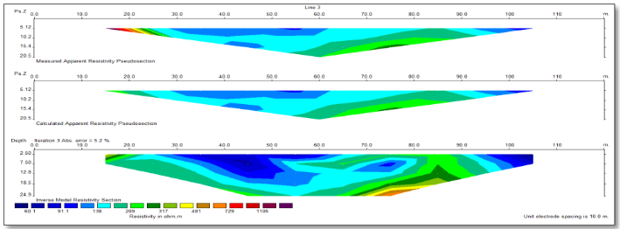
Figure. 12 The resistivity section on track-3

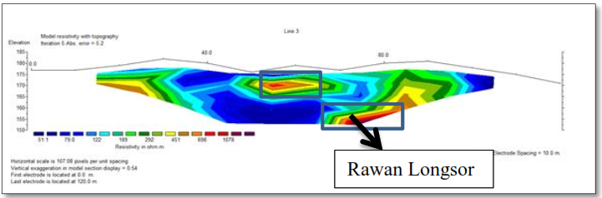
Figure. 13 Topographic cross-section on track-3

Based on the figure in 4.6, the third section has a resistivity value of 51.1 - 1078 Ωm, while the red color in the section above is found at a depth of 18.5 - 24.9 m with a length of 70 - 80 m. It is suspected that there are inset limestone and sandstone with a value the resistivity between 481 - 1105 Ωm, so from the results of the cross-sectional analysis above, this location is suspected of having the potential for landslides because limestone itself is a rock that easily allows water to pass so that the water that escapes easily carries the material in its path and causes landslides.
- Geology
- Geological Conditions
The geological map was obtained from the Maros Regency SHP, which was narrowed down to Simbang District. The data was processed in Arcgis so that a geological map could be obtained, which was used to determine the types of rocks in Simbang District.
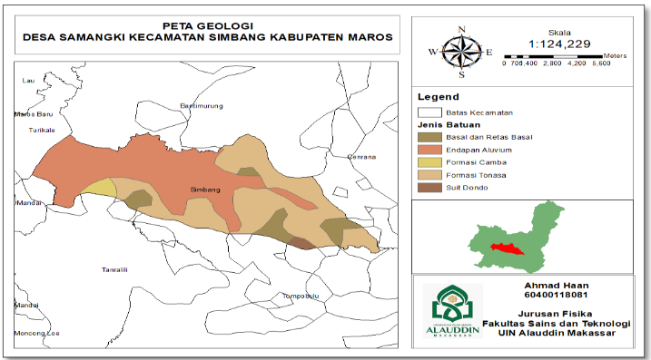
Figure. 14 Geological Map of Sambang District

Based on the attributes of the geological map 5.6 above, there are four types of constituent rocks found in Simbang District, namely basalt rock with a distribution area of 10%, alluvium sedimentary rocks with a distribution area of 50%, camba formation rocks with a percentage of 5%, and tonnage formations with a percentage of 35%.
Based on the data above, the geological structure that makes up the area is sedimentary rock types of limestone and shale. Where these rock types have the potential to cause ground movement because these rocks easily allow water to pass through. Moreover, if the soil or rocks above easily allow water to pass, coupled with the area having a slope, the water will be retained and cause the formation of slip planes which trigger landslides.
- Slope
The slope map was obtained using the 2021 SHP data. The National Demographic Data used is the National Demographic Data for the province of South Sulawesi, which is then narrowed down to Samangki Village, Simbang District, Maros Regency, then processed in Arcgis.

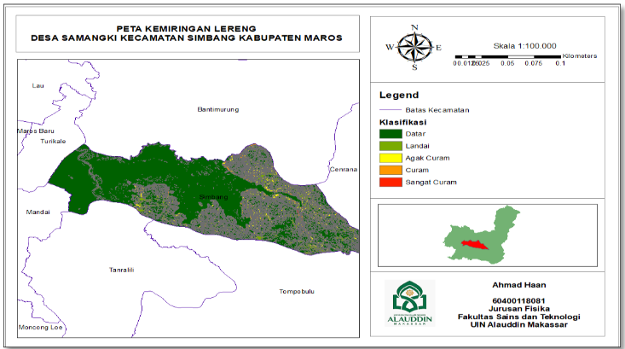
Figure. 15 Slope Map
Based on the attribute results from map 5.5 in Samangki village, Simbang District, Maros Regency, where for a slope of 0 - 8% with a distribution area of 4%, for a slope of 8 - 15%, it has a distribution area of 11%, for a slope of 15 - 25% it has a distribution area namely 25%, for a slope of 25 – 45% it has a distribution area of 20%. The slope map aims to see the general level of the slope of the land, which as a reference, determines the potential for landslides.
- Type of soil
The soil type map was obtained from the Maros Regency SHP data, which was narrowed down to Simbang District. The data obtained were then processed in Arcgis.

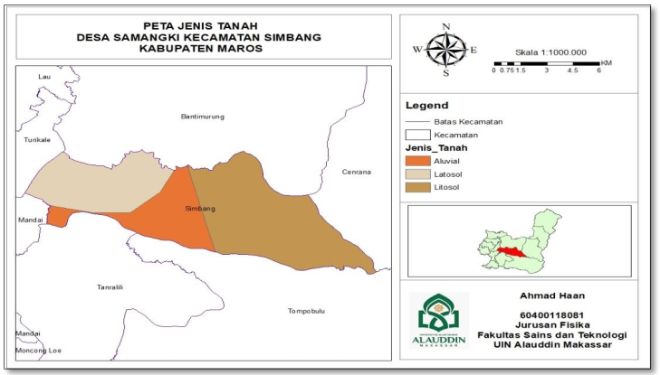
Figure. 16 Map of Soil Types of Simbang District

Based on the results of the data on attribute map 5.7 of the soil types above, it can be obtained that the most extensive soil types in Samanki Village are litosol soils with a distribution of 50%, Alluvial soil types with a distribution area of 20%, and Latosol soil types with a land area of 30%. Where litosol type soil is a type of soil formed from the weathering process of igneous rocks and sediments, litosol soil is characteristic of coarse grains in the form of gravel. In contrast, this type of soil is clay, sand, and silt are very young soil types to allow water to pass through. If this type of soil is above certain rocks or watertight with a particular slope, it can form a slip plane with the potential for landslides.
- Land Use
The land use map was obtained from the results of an overlay between the SHP of land use in the province of South Sulawesi and the administrative SHP of the Maros Regency.
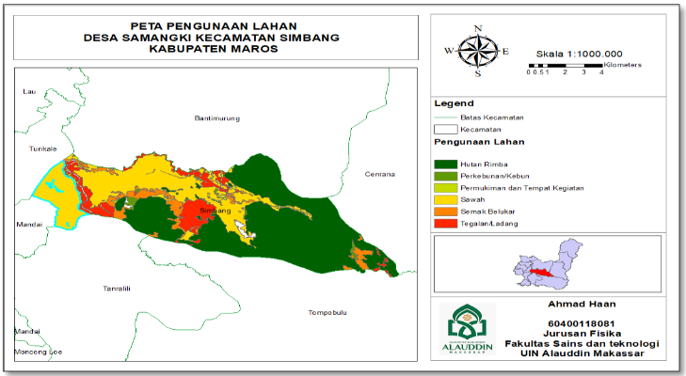
Figure. 17 Land Use Map of Simbang District

Then the two data were cut to produce a land use map for Maros Regency. To determine the level of vulnerability to landslides, a land use map is needed as supporting data. Landslides are prone to occur in areas with open land, rice fields, and cultivation and areas with stagnant water and steep slopes. So to make a landslide risk zone map, land use data is needed. This land use data is a reference to find out how prone the area is to landslides by taking into account the parameters mentioned above.

- Climatology
Rainfall data were obtained from the BMKG Maros Station for the last five years, from 2017 to 2021. The data sent from the BMKG contained three stations, but this research was located in Maros Regency, so researchers used Maros Regency stations in this thesis. The results obtained are under the theory, where the characteristics of rainfall that trigger landslides have been used to establish a relationship between rain and soil in various parts of the world, including shallow landslides. Rainfall parameters include previous rainfall, intensity, and duration (Hasnawir, 2011).
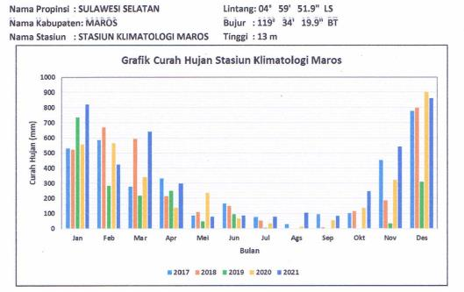
Figure. 18 Graph of Maros Regency rainfall for 2017-2021

Based on the graph above, relatively moderate to high rainfall can have the potential for landslides because it is seen from the type of soil and rock in the study area where the type of soil/rock in the area has high porosity or soil/rock that easily allows water to pass through. These properties cause the soil/rock to gain weight if there is continuous rain, and it is exacerbated by the steep slope conditions, which result in easy landslides.
Based on data from the Maros BMKG station in 2017-2021, Samangki Village, Simbang sub-district, Maros Regency average rainfall is 54 mm each month with 114 rainy days in 2021. The highest rainfall is in December of 900 mm, with a Rain duration is 12 days.

- Landslide Vulnerability Map
Based on the overlay of the four landslide parameters, a map of the landslide hazard level is obtained using the fuzzy logic method with 4 class classification levels of vulnerability: not prone, low prone, moderate, and high prone. Based on the map of the level of vulnerability to landslides, it can be seen that there is one village that occupies the most significant area with a high vulnerability to landslides, namely Samangki Village, which is the location of this research. Based on the results of the analysis, this is influenced by the six parameters that cause landslides, such as the slope of the slope in the area is very steep, namely > 45%, plus the altitude at ± 1000 meters above sea level, the type of soil in the research location that allows water to pass easily, or easily Landslides occur and the types of rock found at the study site are also very sensitive to erosion (easily landslides).
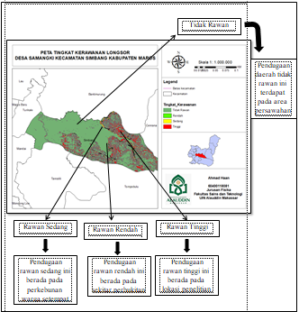
Figure. 19 Map of the landslide vulnerability level of Samangki District

The level of vulnerability of landslides in Simbang sub-district is divided into four classes: non-prone, low, moderate, and high. The classification above shows that the research location area is at a high level of vulnerability marked with red color.
This is due to the nature of the rock/soil, which needs to be well consolidated, high erodibility, and high porosity and permeability followed by high intensity of rainfall at that location with a rainfall rate of 2000-25000 mm/year. According to the Regulation of the Minister of Public Works concerning Guideline 56 on the Utilization of Spatial Areas prone to landslides (2007), high rainfall is rainfall with an annual rainfall intensity of more than 2,500 mm. So areas with rainfall distribution of more than 2,500 mm/year need to be watched out for because the area is prone to landslides and also depends on other physical conditions, as well as land use that is not suitable in the area, such as increased loads that exceed the soil's carrying capacity or shear strength land. This excessive load can be in the form of building loads or trees that are too thick and densely planted on slopes steeper than 40 degrees, and land clearing by residents for plantations and settlements is increasingly being carried out. Judging from the contoured topographical conditions, the community cleared the land not according to its function.

CONCLUSIONS

Based on resistivity, geological and climatological data processing that has been carried out in Samangki Village, Simbang District, Maros Regency, it can be concluded as follows:
- Based on the results of the interpretation of the resistivity data for lines 1, 2, and 3, the resistivity values are from 500 Ωm to 1050 Ωm which are suspected of containing inset limestone and sandstone. These rocks are included in tonnage formation rocks. Plus, the slope is at a slope of > 25%, and Rainfall according to the BMKG Maros Regency in 2017-2021, average Rainfall is 54 mm with 114 days in 2021, so this location has excellent potential for ground movement or landslides.
- Based on the landslide-prone map in Samangki Village, Simbang District, Maros Regency, it is divided into four landslide-prone classes, namely, not prone to 86%, moderate to 2%. Prone by 3% and very vulnerable by 9%, and of the four landslide-prone classes above, the research location is at a very vulnerable point with a percentage of 9%, as shown in map 5.9 above.

REFERENCES

Alfian, Nawir, Dkk. 2018, Analisis Akuifer Air Tanah Kota Makassar, Makassar: Fakultas Teknologi Industri UMI.
Andhini, Putri, Aulifa. 2018. Analisis Resiko Dalam Upaya Penangulangan Bencana Tanah Longsor Di Kabupaten Gowa. Makassar: Jurusan Teknik Geofisika FMIPA UNHAS.
BPS Kota Makassar. 2021. Kota Makassar Dalam Angka 2021. Makassar: Badan Pusat Statistik Kota Makassar.
Hanif, Dkk. 2015. Kerawanan Bencana Tanah Longsor Kabupaten Ponorogo. Surakarta: Jurusan Teknik Sipil Universitas Sebelas Maret Surakarta.
Irmayanti. 2020. Aplikasih Sistem Informasi Geografi (SIG) Dan Metode Geolistrik Dalam Pembuatan Peta Rawan Longsor Di Kecamatan Alla Kabupaten Enrekang. Makassar: Jurusan Fisika Fakultas Sains Dan Teknologi.
Isnaini, Rizkyah. 2019. Analisis Wilayah Tanah Longsor Di Wilayah Jawa Tengah. Surabaya: Universitas Airlangga Surabaya.
Kementerian ESDM. 2018. Gerakan Tanah. Bandung: Kementerian Energi Dan Sumber Daya Mineral Badan Geologi.
Muttaqin, Mu’ammar. 2020. Identifikasih Pengaruh Air Tanah Terhadap Tingkat Kerawanan Longsor Dengan Metode Geolistrik Konfigurasi Schlumberger. Medan: Jurusan Teknik Sipil Universitas Sumatera Utara.
Nusaiba, F. 2018. Identifikasi Letak Dan Sebaran Akuifer Dengan Metode Geolistrik Resistivitas. Malang: Jurusan Fisika Fakultas Sains Dan Teknologi UIN Maulana Malik Ibrahim Malang.
Nurfalaq, Aryadi Dkk. 2018. Identifikasih Aquifer Daerah Pallantikan Kabupaten Jeneponto Dengan Metode Geolistrik. Jeneponto: Jurusan Fisika Universitas Cokroaminoto Palopo.

