UNDERWATER ROBOT DESIGN

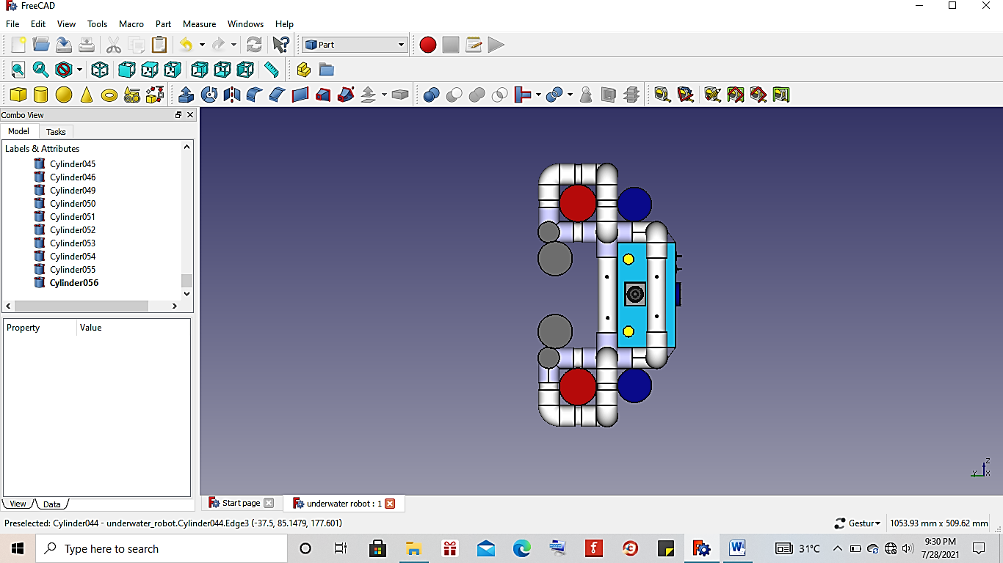
1
1
3
4
3
Figure. 1 Front View Robot
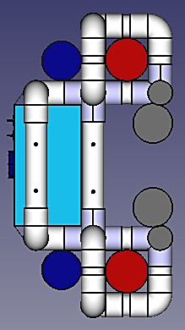
8
3
9
3
10
Figure. 2 Back View Robot
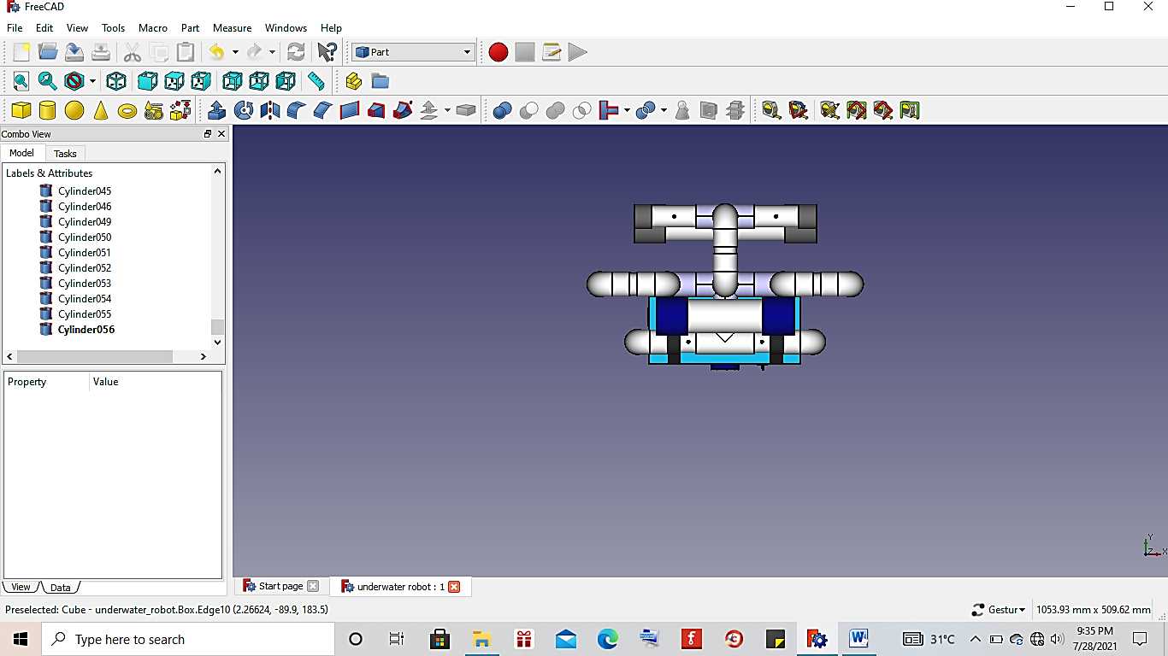
Figure. 3 Side View Robot
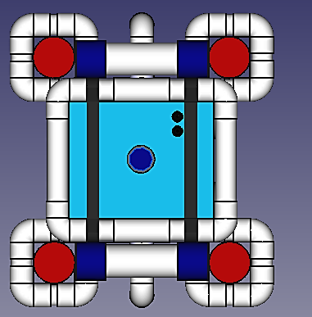
6
2
7
2
2
5
2
Figure. 4 Top View Robot

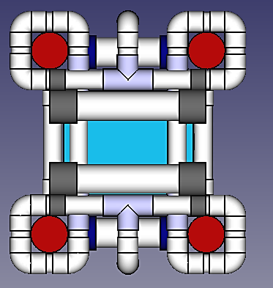
2
2
2
2
Figure. 5 Bottom View Robot
Description:
- Lamp 1 and lamp 2 as lighting.
- Motor 1, motor 2, motor 3, and motor 4 as mover for the robot to move up and down in the water.
- Motor 5 and motor 6 as mover for the robot to move forward, backward and turn.
- Camera as picture and video taker.
- MS5802 pressure sensor as robot depth position controller.
- Switch ON/OFF as a breaker and a connector for electric current on the robot.
- Belt as a safety control box so it doesn’t lift up when it’s put in the water.
- Control box as a place to store robot components.
- Hole as place for water to enter the robot’s PVC frame.
- Ballast as robot mass increase.

