Computational Model of Boride Diffusion Layer on the
Low Carbon Steel

Sutrisno
Department of Physics, State Islamic University Syarif Hidayatullah Jakarta
Jl. Juanda 95, Ciputat, Tangerang, Banten, indonesia
E-mail : sutrisno@uinjkt.ac.id

Abastract: In this paper, a computation model was used to analysis the growth kinetic of two boride layers FeB and Fe₂B on the surface of low carbon steel. St41 one of the low carbon steel was used as the basic sample and given the treatment by adding the powder pack boriding in the temperature of 700, 800, and 900⁰C for the 8 hours of treatment time. To perform the morphology and dimension of the boride layers used the optical microscope. The computation model based on the diffusion equation from the Fick’s Law and solved under the certain assumptions with the parabolic growth of iron boride. For this study, a numerical method was created to determine the iron borides layer thickness as a function of process parameters (temperature and time).By using the parabolic growth constant it can be determined the diffusion coefficient for the phase of FeB, Fe₂B, and diffusion zone. Based on the diffusion coefficient it can be predicted the depth and thickness of borided layer on the surface of St41 low carbon steel.

Keywords : powder pack boriding, Fick’s Law, parabolic growth constant, diffusion coefficient, FeB/Fe₂B layer.

INTRODUCTION
Boronizing is a surface hardening process that thermo chemical lasted. In this process occurs the dynamics change of heat [1], which can produce phase transformation on the basic sample [2]. The phase change can be determined by XRD analysis method [3]. Boronizing can be applied to hard the surface of ferrous and non ferrous metals. To determine the phases in the sample, it was observed using an optical microscope metallographic [4]. In general, the process of boronizing performed by heating treatment at a temperature between 700 ° C up to 1000^{O}C for 1 to 12 hours at a metal surface that has been cleaned [5]. In the process of boronizing occurs the contact between the metal surface as a sample base with hardener media in the form of paste, solid powder, liquid, and gas [6]. These contacts are intertition diffusion process, namely the inclusion of boron atoms (B) into the sidelines between the atoms of iron (Fe) [7]. Boronizing results obtained in the form of a layer of iron boride (FeB, Fe2B) with hardness between 1500-2000 HV and the depth of the layer can reach 300 μm from the surface of the sample base [6].
Mechanical properties of the iron boride layer can be determined through testing [8] while the growth process of the formation of iron boride layer on the surface of the sample can be computed using the numerical diffusion equation [9]. Research on the growth mechanism of thermo chemical iron borides have been conducted using a sample of 99.9% pure iron with a temperature of 850 ° C for 15 hours but the results still in qualitative form [10]. The next study for AISI 4140 steel as the samples heated at temperatures varying 1123, 1173, 1223K and treatment time 2, 4, 6 and 8 hours. This boronizing done with molten bath technique consisting of 65% borax, 15% boric acid, and 20% ferro-silicon produce boron growth constant of 3.10⁻⁹ to 2.10⁻⁸ cm⁻²s⁻¹ [11]. Growth kinetic of Fe₂B layer with various thickness of boron paste on AISI 1045 steel samples have produced the activation energy from 288.62 kJ for FeB layer and 253.402 kJ for the Fe₂B layer [12]. Growth diffusion model based on Fick's second law for a two layers of iron boride FeB and Fe₂B [13] and also on AISI H13 samples with powder pack boriding technique has been reported by researcher [14].
The next developments use computer simulation through the growth phase of iron boride paste boriding process. This model can be developed for application on another iron sample, because the results of simulations match with the experimental data [15]. Study of layer formed diffusion on the iron-based boride Cr has been done. Samples H13 steel and AISI 304 heated at temperatures of 1073 and 1223 for 3, 5, and 7 hours. This boronizing used bath salt slurry technique consisting of borax, boric acid, ferrosilicon and produce the activation energy of 253.35 and 244.37 kJ mol-1 [16]. The method of fuzzy logic, dimensional analysis and artificial neural network has been applied to measure the growth of boride layers on AISI 1045 steel samples with paste boriding technique. This boriding process is performed at a temperature of 1193 - 1273K for 2, 4, 6 hours and produce a feasible method to apply in industry with automation systems [17, 18, 19]. Besides the method of growth computation on boride layers mentioned above, there are other methods that use mass balance equations assuming a linear concentration profile at the boundary between the layers. The method has been applied to samples of AISI 1045 steel, M2, class 30 gray cast iron (ASTM A48), and gray cast iron. Boronizing process was done using paste boriding technique and powder-pack heated at temperatures of 1173, 1223, and 1273K for 2, 4, 6, 8 hours [20,21,22].

RESEARCH METHODS
A computation model to determine the diffusion coefficient based on the case of a solvent saturated with solute B. The chemical potential B of surrounding conditions are such that they are capable of forming one or more phases on the surface of steel samples St41. At the stage of equilibrium components A and B form FeB phase, Fe₂B and diffusion zones. The concentration profile of the growth of two or more with linear phase, and it is assumed that the boron concentration constant during the layers growth process. Thermodynamic equilibrium is achieved at all times during the boriding process . Therefore, according the concentration profile for the three phases below (figure 1), it can be used the following computation model [20] :
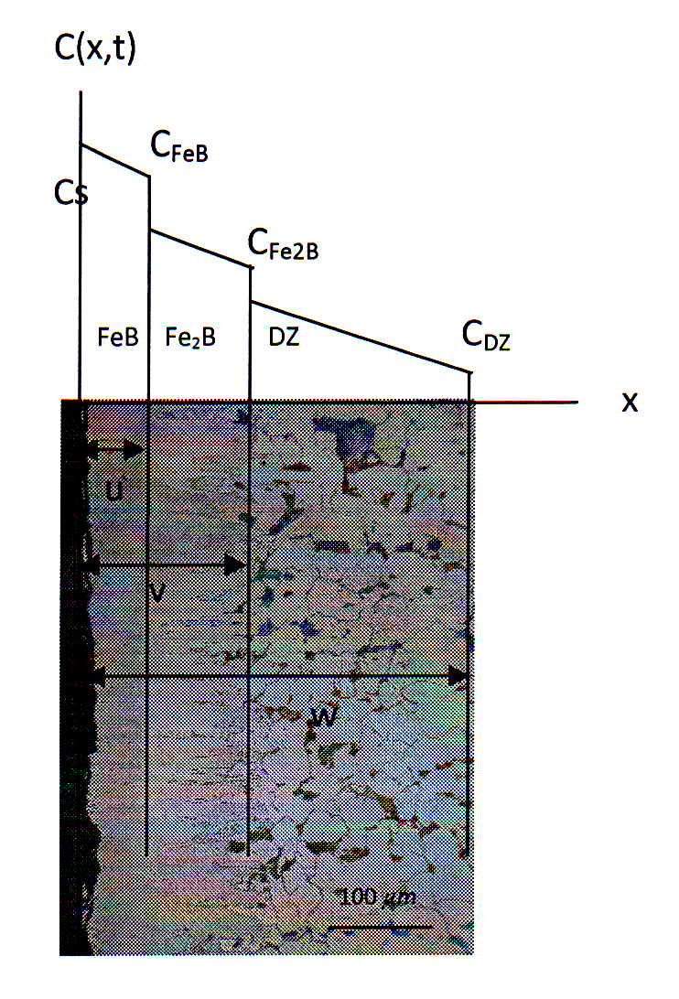
Figure 1. Boron concentration profile for three phases FeB, Fe₂B, and diffusion zone.

for :
0< x < u ; $C_{1}(x,t)=\frac{C_{\text{Fe}B}−C_{s}}{u}x+C_{s}$ (1)
u < x < v ; $C_{2}(x,t)=\frac{C_{{\text{Fe}}_{2}B}−C_{{\text{Fe}}_{B}}}{v−u}(x−u)+C_{\text{FeB}}$ (2)
v < x <w ; $C_{3}(x,t)=\frac{C_{\text{DZ}}−C_{{\text{Fe}2}_{B}}}{w−v}(x−v)+C_{\text{Fe}2B}$ (3)
where : u = k₁ √t ; v = k₂ √t ; w = k₃ √t (4)
C (x, t) is the concentration as a function of x and t, C₁ (x, t) boron concentration between the surface and the first interface, C₂ (x, t) boron concentration between the first and the second interface, C₃ (x, t) boron concentration in the diffusion zone, C_{DZ} concentration in the diffusion zone, C_{FeB} concentration at the FeB interface, C_{Fe2B} concentration at the Fe₂B interface, and Cs concentration at the surface.
In addition, the variable t is the heating time, k1 parabolic growth constant of the FeB interface, k2 parabolic growth constant of the Fe₂B interface, k3 parabolic growth constant of the diffusion zone, u parabolic growth function on the FeB interface, v parabolic growth function on the Fe₂B interface, w parabolic growth function on the diffusion zone, and x distance from the surface of the steel.
$(−C_{s}+C_{\text{FeB}})\frac{\text{du}}{\text{dt}}=D_{\text{FeB}}\frac{{\text{dC}}_{1}}{\text{dx}}−D_{\text{Fe}2B}\frac{{\text{dC}}_{2}}{\text{dx}}$ (5)
$(−C_{\text{FeB}}+C_{\text{Fe}2B})\frac{\text{dv}}{\text{dt}}=D_{\text{Fe}2B}\frac{{\text{dC}}_{2}}{\text{dx}}−D_{\text{DZ}}\frac{{\text{dC}}_{3}}{\text{dx}}$ (6)
$(−C_{\text{DZ}}+C_{\text{Fe}2B})\frac{\text{dw}}{\text{dt}}=D_{\text{DZ}}\frac{{\text{dC}}_{2}}{\text{dx}}$ (7)
Where D diffusion coefficient of the solvent over the substrate, Do pre-exponential factor (m² sec⁻¹), D_{Dz} diffusion coefficient of boron at the diffusion zone, D_{FeB} diffusion coefficient of boron at the FeB interface, and D_{Fe2B} diffusion coefficient of boron at the Fe₂B interface. Assuming that the conditions of the interface follows the parabolic growth law and by using a function of the concentration (5), (6) and (7) following simultaneous equations can be obtained:
$\frac{1}{2}(C_{\text{FeB}}−C_{S})k_{1}=D_{\text{FeB}}\frac{(C_{\text{FeB}}−C_{S}}{k_{1}}−D_{\text{Fe}2B}\frac{(C_{\text{Fe}2B}−C_{\text{FeB}})}{k_{2}−k_{1}}$ (8)
$\frac{1}{2}(C_{\text{Fe}2B}−C_{\text{FeB}})k_{2}=D_{\text{Fe}2B}\frac{(C_{\text{Fe}2B}−C_{\text{FeB}})}{k_{2}−k_{1}}−D_{\text{DZ}}\frac{(C_{\text{DZ}}−C_{\text{Fe}2B})}{k_{3}−k_{2}}$ (9)
$\frac{1}{2}(C_{\text{DZ}}−C_{\text{Fe}2B})k_{3}=D_{\text{DZ}}\frac{(C_{\text{DZ}}−C_{\text{Fe}2B})}{k_{3}−k_{2}}$ (10)
This system of equations can be solved to determine the mobility of boron in the layer FeB, Fe₂B and diffusion zones with Newton-Raphson numerical method (20). Mobility is indicated by the boron diffusion coefficient value for each layer that is D_{FeB} , D_{Fe2B} , and D_{DZ}.
Samples used in this study is cylindrical shape of St41 low carbon steel with a diameter of 3 cm and 1 cm high. The chemical composition of this samples are: 0.20wt% C, 0.40wt% Si, 0.80 - 1.40wt% Mn , 0.025wt% P, 0.015wt% S, 0.012wt% N, 0.30wt% Cu, 0.020wt%Nb, 0.03wt% Ti, 0.020w% Al, 0.30wt% Cr, 0.08w%Mo, 0.30w% Ni, and 0.02wt% Vi respectively. The samples were covered into the powder pack boriding agent that consist of 5wt% B₄C, 5wt% KBF4, and 90wt% SiC. Afterwards, the samples were heated in the furnace with temperature of 700^{O}C, 800^{O}C, 900^{O}C and 8 hours treatment time. After heated sample was cooled to room temperature. To show the morphology of iron boride, layer thickness, and diffusion zones, the sample was done a cross-sectional cutting and observed using optical microscopy. To determine the layer thickness, minimum 15 measurements were done on boride layers and diffusion zone at different points on the sample. To ensure the phases of iron borides in boride layer on the surface of samples used XRD analysis with Cu and Mo radiation and wave length between 0.6 and l.9 A°.

RESULTS AND DISCUSSION
The morphology and growth of boride layer on St41 low carbon steel with a treatment time of 8 hours and temperature of 700^{O}C, 800^{O}C, and 900^{O}C are shown in figure 2. The layer thickness was defined as the average value of the long boride teeth [20]. On the St41 low carbon steel for all temperature treatment was formed two boride layers FeB and Fe₂B. It can be seen on the pattern of XRD data (see figure 3). The change of iron boride growth fronts is determined by the thickness of the powder pack boron. It modifies the surface concentration of the sample and reaches the critical values of concentration for the formation of borided phases[20]. The difference between boron potentials used at constant time and temperature generate the more compact and continuous layers as the thickness of the powder pack boron increases[20].

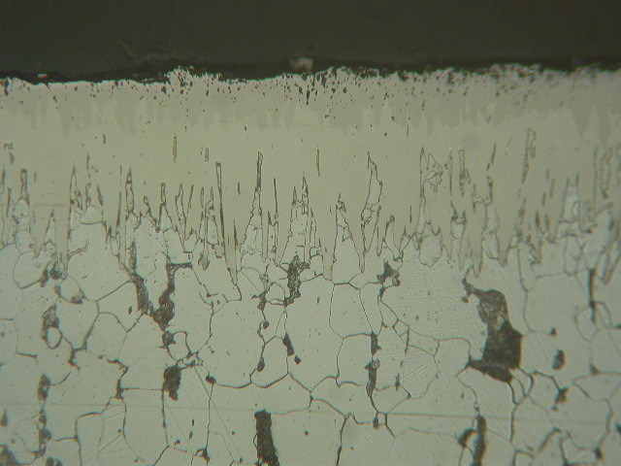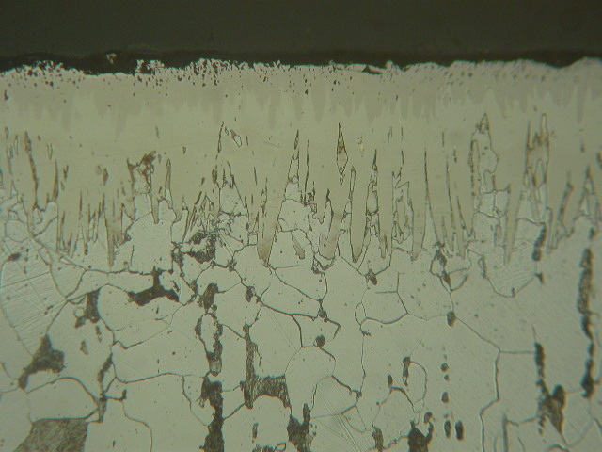
FeB
Fe2B
diffusion zone
Fe2B
FeB
diffusion zone
a b

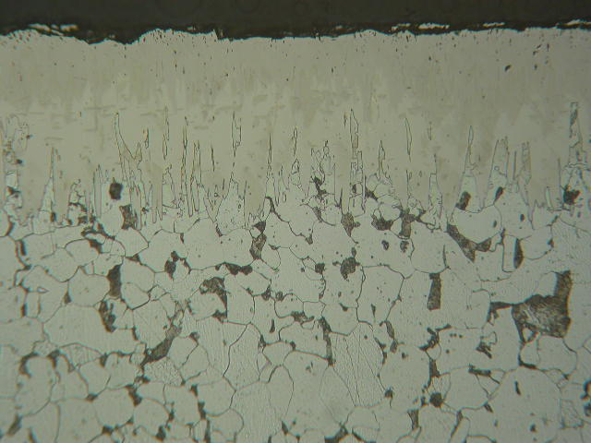
diffusion zone
FeB
Fe2B
c
Figure 2. View of borided cross-sections (St41 steel) treated at (a)700^{O}C, (b) 800^{O}C, and (c) 900^{O}C for 8 hours with powder pack boriding thickness.

On the same condition, the increment of present phases growth kinetic showed the dependence of time and temperature. The increase of time, temperature and boron potential create a massive precipitation of iron boride Fe₂B below the layers, due to its chemical composition St41 low carbon steel. The growth of boride layers and diffusion zone as a function of process time was presented at the figure 4. Values of the slopes presented in figure 4 shows the growth of boride layers and diffusion zone. These parabolic growth constants in table 1 depend on the boron concentration in balancing with the surface of basic sample.

Fig. 3. Pattern of XRD data for St41steel borided at 700, 800, and 900 Celcius with 8 hours of treatment.

To determine the diffusion coefficients of boron on the boride layers and diffusion zone used the concentration value at interfaces and the parabolic growth constans from mass balance equation (8), (9), and (10).

The parabolic growth constan for the St41 low carbon steel on the FeB, Fe₂B phases and diffusion zone reach the maximum value at 900^{O}C for 8 hours time treatment (table 1).

An Arrhenius behavior was assumed for the average values of the diffusion coefficients. This behavior evaluates diffusion coefficients as a function of temperature where Q/R represents the slopes of the straight lines shown in figure 5. Activation energy Q is interpreted as boron diffusion through the preferred crystallographic direction [0 0 1] [20]. The activation energy for the FeB phase is greater than Fe₂B phase, and also the activation energy for the Fe₂B is greater than diffusion zone.

a

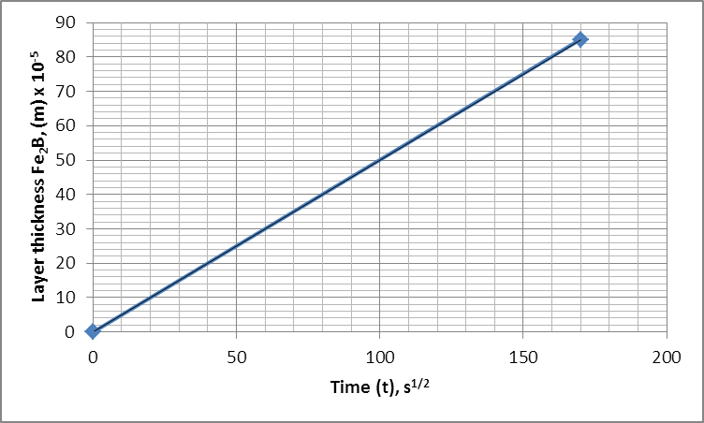
b

c

Figure 4. Growth kinetics of iron boride layers and diffusion zone for St41 low carbon steel:
- FeB, (b) Fe2B and (c) diffusion zone.

Figure 5 show that the activation energy of boron in the FeB layer is greater than the Fe₂B layer. And the activation energy of boron in the Fe₂B layer is greater than diffusion zone for St41 low carbon steel.

Table 1. Parabolic growth constants for the St41 low carbon steel at temperature of 700, 800, and 900^{O} C with 8 hours of treatment time.

Layer | Parabolic growth constant ( k )
Layer | T = 700⁰C | T = 800⁰C | T = 900⁰C
Surface | 0 | 0 | 0
FeB | 0.147 | 0.166 | 0.220
Fe₂B | 0.250 | 0.282 | 0.457
Diffusion Zone | 0.590 | 0.610 | 0.610

Therefore, Arrhenius relationships for boron diffusion coefficients on the FeB, Fe₂B phases, and diffusion zone on the St41 low carbon steel at the temperature range of 700^{O}C < T < 900^{O}C can be written as:

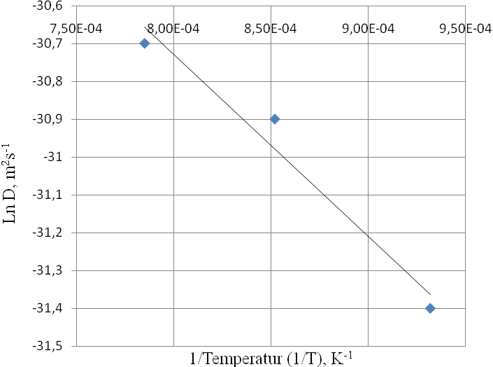
D_{FeB} =5,67x10⁻¹⁴exp(-99,72kJ/RT)
a
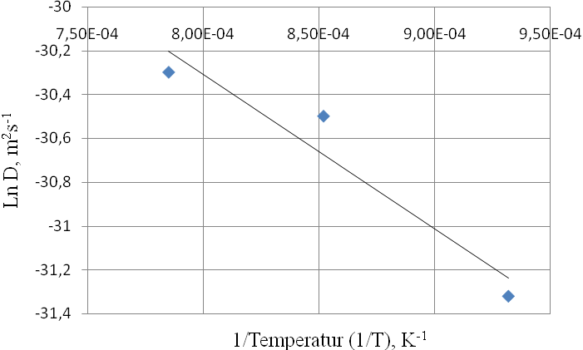
D_{Fe2B} =1,03x10⁻¹³exp(-58,17kJ/RT)
b
D_{Z} = 1,14x10⁻¹³exp(-1,7kJ/RT)
c

Figure 5. Arrhenius relationships for boron diffusion coefficients as a function of treatment temperature on the a).FeB, b).Fe₂B and diffusion zone for St41 low carbon steel.

CONCLUSIONS
In this study the growth kinetics of the boride layers and diffusion zones on St41steels has been analysed. The influence of alloy elements creates the formation of FeB/Fe2B on the surface of St41 steel. The morphology of the iron boride layers present on the St41 steel is saw-toothed after heating at the temperature of 700, 800, and 900^{O}C. The growth kinetics of the iron boride layers and diffusion zones is reflected by incrementing treatment time and temperature. It generates more compact, continuous layers, and more massive precipitates of Fe2B beneath the layers.The activation energy of iron boride layers and diffusion zones, are obtained using the boron diffusion coefficients as a function of treatment temperature in the Arrhenius relationship. In the St41 steel, the activation energy of the FeB phase is greater than the Fe2B phase, and also the activation energy of the Fe2B phase is greater than diffusion zone.

REFERENCES
[1] David V. Ragone, Thermodynamic of Materials, John Wiley & Sons, 1995.
[2] DA Porter, KE Easterling, Phase Transformations in Metals and Alloys, Second Edition, Chapman & Hall, London, 1995
[3] C Suryanarayana, M Grant Norton, X-Ray Diffraction A Practical Approach, Plenum Press, New York, London, 1998
[4] George F. Vander Voort, Metallography, Principles and Practice, McGraw-Hill Book Company, K. Genel, Boriding kinetics of H13 steel, Vacuum 80 (2006), 451-457
[5] A.K, Sinha, Boriding (Boronizing) of Steels, ASM Hanbook Vol 4: Heat Treating, USA, ASM International, 1999.
[6] Walter Fichtl, Boronizing and Its Practical Applications, Material in Engineering, Vol.2, 1981
[7] William D Calister Jr, Material Science and Engineering, An Introduction, Fourth Edition, John Willey, 1997, 89 – 101
[8] Ibrahim Ozbek, Cuma Bindal, Mechanical Properties of boronized AISI W4 steel, Surface and Coatings Technology, 154 (2002), 14 – 20
[9] J. Crank, The Mathematics of Diffusion, Clarendon, Oxford, 1975.
[10] C. Martini, G. Palombarini, Mechanism of Thermochemical Growth of Iron Borides on Iron, Journal of Material Science 39 (2004) 933-937
[11] Saduman S, Ugur S, Cuma Bindal, The growth kinetics of borides formed on boronized AISI 4140 steel, Vacuum 77 (2005) 195 – 202
[12] I. Campos, O. Bautista, G. Ramirez, M. Islas, J. De La Parra, L. Zuniga, Effect of boron paste thickness on the growth kinetics of Fe₂B boride layers during the boriding process, Applied Surface Science 243 (2005), 429-436
[13] M. Keddam, SM. Chentouf, A diffusion model for describing the bilayer growth (FeB/Fe₂B) during the iron powder-pack boriding, Applied Surface Science 252 (2005), 393-399
[14] K. Genel, Boriding kinetics of H13 steel, Vacuum 80 (2006), 451-457
[15] M. Keddam, Computer simulation of monolayer growth kinetics of Fe₂B phase during the paste-boriding process: Influence of the paste thickness, Applied Surface Science 253 (2006), 757-761
[16] Sukru T, A study on the diffusion kinetics of borides on boronized Cr-based steels, J Mater Sci (2006) 41: 7590 – 7596
[17] I Campos, M Islas, E Gonzales, P Ponce, G Ramirez, Use of fuzzy logic for modeling the growth of Fe₂B boride layers during boronizing, Surface and Coating Technology 201 (2006) 2717 - 2723
[18] I Campos, R. Torres, G. Ramı´rez a, R. Ganem c, J. Martı´nez, Growth kinetics of iron boride layers: Dimensional analysis, Applied Surface Science 252 (2006) 8662–8667
[19] I Campos, M Islas, G Ramirez, C Villa Velazquez, C Mota, Growth kinetics of borided layers: Artifcial neural network and least square approaches, Applied Surface Science 253 (2007), 6226 – 6231
[20] I Campos, G Ramirez, U Figueroa, J Martinez, O Morales, Evaluation of boron mobility on the phases FeB, Fe₂B and diffusion zone in AISI 1045 and M2 steel, Applied Surface Science, 253 (2007) 3469 – 3475 I Campos, R Torres, G Ramirez, R Ganem, J Martinez,
[21] I Campos – Silva, M Ortiz-Dominguez, M Keddam, N Lopez-Perrusquia, A Garmona-Vargaz, M Elias-Espinosa, Kinetics of formation of Fe₂B layers in gray cast iron: Effects of boron concentration and boride incubation time, Applied Surface Science 255 (2009) 9290 - 9295
[22] M. Keddam, R. Chegroune, A model for studying the kinetics of the formation of Fe2B boride layers at the surface of a gray cast iron, Appl. Surf. Sci. (2010), doi:10.1016/j.apsusc. 2010.03.048

