**UNDERWATER ROBOT DESIGN**

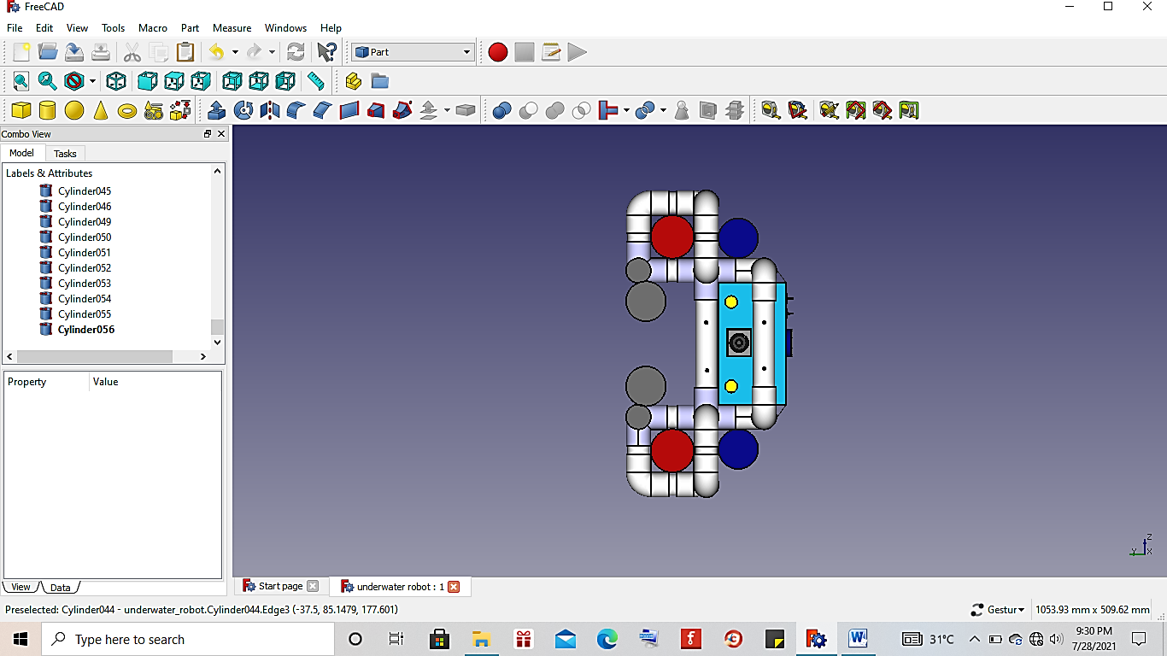

1

1

3

4

3

Figure. 1 Front View Robot

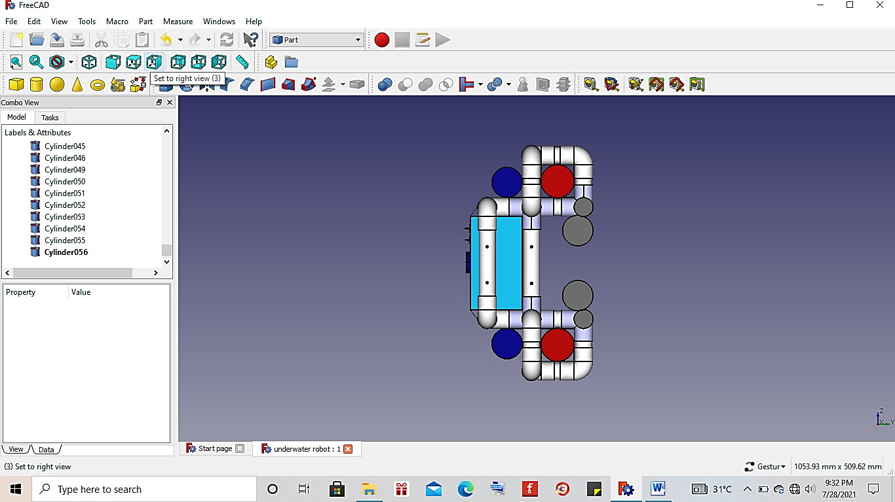

8

3

9

3

10

Figure. 2 Back View Robot

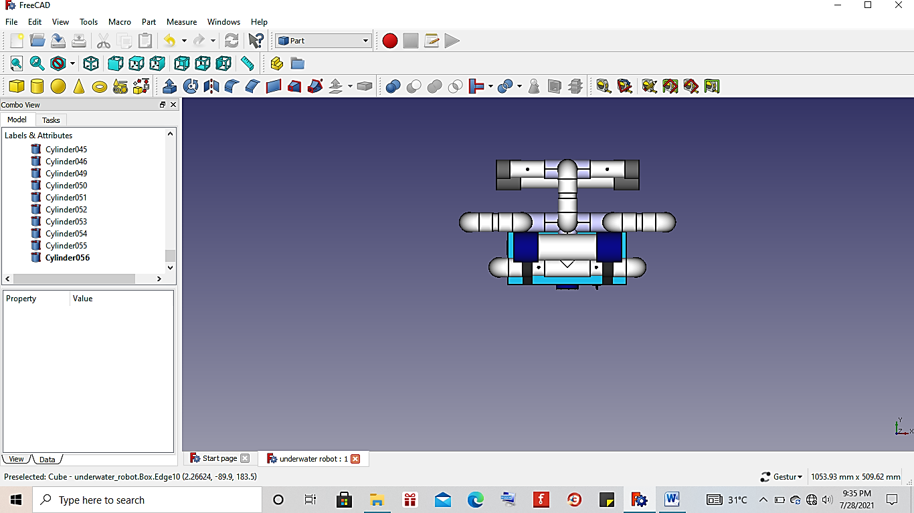

Figure. 3 Side View Robot

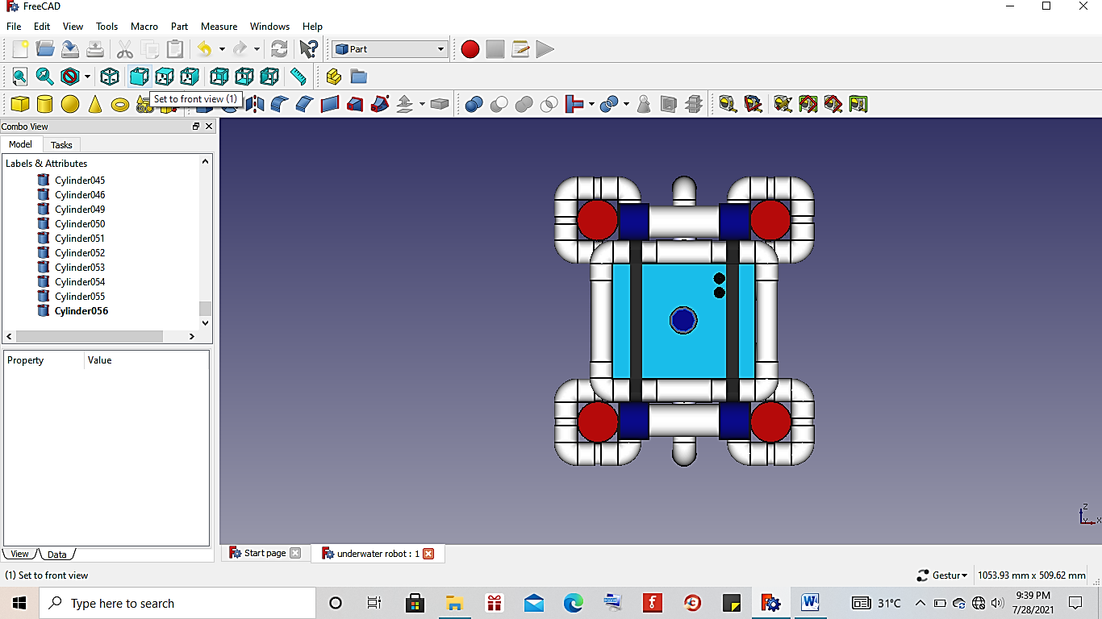

6

2

7

2

2

5

2

**Figure. 4** Top View Robot

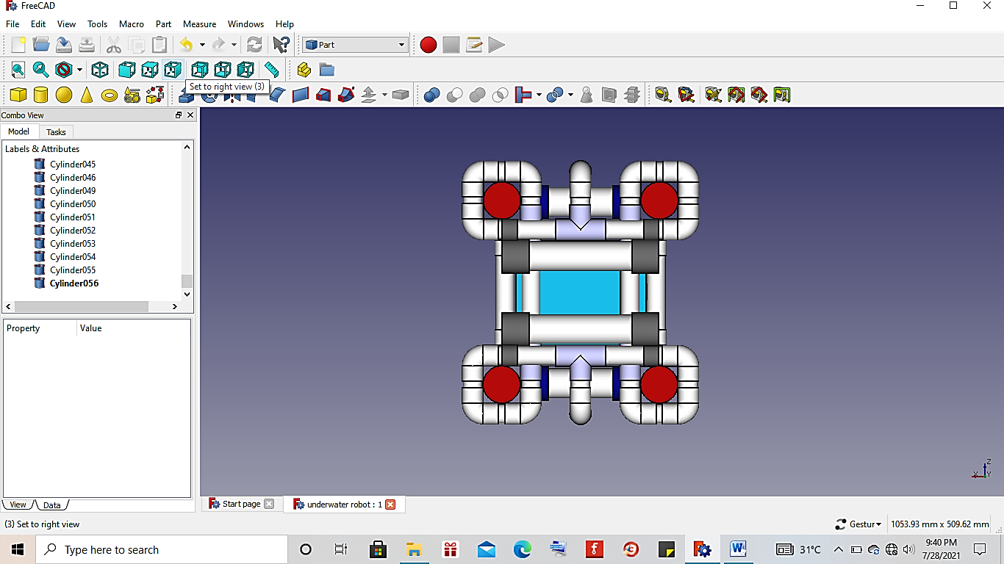

2

2

2

2

Figure. 5 Bottom View Robot

Description:

1. Lamp 1 and lamp 2 as lighting.
2. Motor 1, motor 2, motor 3, and motor 4 as mover for the robot to move up and down in the water.
3. Motor 5 and motor 6 as mover for the robot to move forward, backward and turn.
4. Camera as picture and video taker.
5. MS5802 pressure sensor as robot depth position controller.
6. Switch ON/OFF as a breaker and a connector for electric current on the robot.
7. Belt as a safety control box so it doesn’t lift up when it’s put in the water.
8. Control box as a place to store robot components.
9. Hole as place for water to enter the robot’s PVC frame.
10. Ballast as robot mass increase.