RESULTS:-
Analisis Statistik Deskriptif
Tabel hasil pengolahan
Tabel 1 Statistik Deskriptif Variabel Penelitian
Variabel | N | Minimum | Maksimum | Mean | Standar Deviasi
Pendapatan Asli Daerah (X1) | 55 | -9.871.216 | 38.960.059 | 7.001.569,86 | 9.972.728,521
Flypaper Effect (X2) | 55 | -175.369.537 | 259.996.466 | 24.503.582,67 | 52.419.864,87
Perilaku Oportunisti (Y) | 55 | -147.287.807 | 222.569.543 | 39.448.789,31 | 81.381.256,88
Sumber : Data Diolah, 2019
Tabel 2 Hasil Pengujian Asumsi Multikolinearitas
Variabel | Tolerance | VIF | Keterangan
Pendapatan Asli Daerah (X1) | 0,997 | 1,003 | Non Multikolinearitas
Flypaper Effect (X2) | 0,997 | 1,003 | Non Multikolinearitas
Sumber: Data Diolah, 2019

Gambar 1 Hasil Uji Heteroskedastisitas
Sumber: Data Diolah, 2019
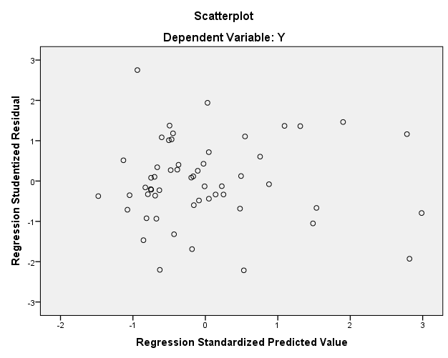

Tabel 3 Hasil Pengujian Asumsi Heteroskedastisitas
Variabel | Sig. | Keterangan
Pendapatan Asli Daerah (X1) | 0,053 | Non Heteroskedastisitas
Flypaper Effect (X2) | 0,343 | Non Heteroskedastisitas

Gambar 2 Hasil Uji Normalitas
Sumber: Data Diolah, 2019
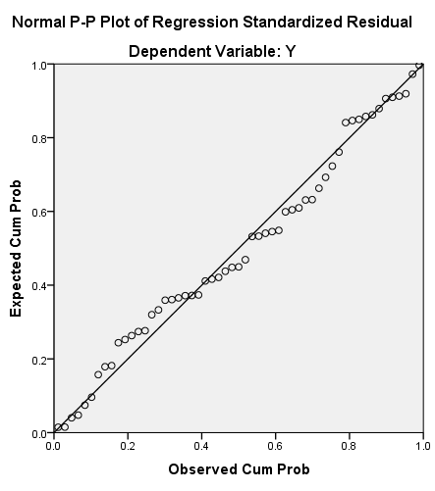
Tabel. 4 Hasil Uji Simultan (Uji F)
ANOVAª
Model |  | Sum of Squares | df | Mean Square | F | Sig.
1 | Regression | 43.715.351.682.569.856 | 2 | 21.857.675.841.284.928 | 3,621 | 0,034^{b}
1 | Residual | 313.921.732.738.491.970 | 52 | 6.036.956.398.817.153
1 | Total | 357.637.084.421.061.820 | 54
a. Dependent Variable: Y
b. Predictors: (Constant), X2, X1
Sumber: Data Diolah, 2019
Tabel 5 Hasil Analisis Regresi Linear Berganda
Hubungan  Antar Variabel | Koefisien Regresi | Standard Error | t-Statistik | Prob. | Keterangan
X₁ Y | 2,649 | 1,062 | 2,495 | 0,016 | Signifikan
X₂ Y | 0,230 | 0,202 | 1,140 | 0,260 | Signifikan

Tabel 6 Koefisien Determinasi
Model Summary
Model | R | R Square | Adjusted R Square | Std. Error of the Estimate
1 | 0,350ª | 0,122 | 0,088 | 77.697.853,245
a. Predictors: (Constant), X2, X1

