LAMPIRAN
- Statistik Deskritif Data Penelitian
Statistik Deskiptif
 | N | Minimum | Maximum | Mean | Std. Deviation
Struktur Perusahaan | 64 | ,00284 | 5,08561 | ,2808258 | ,69861246
Monitoring Perusahaan | 64 | ,00000 | ,98841 | ,6663939 | ,20342238
Kinerja Perusahaan | 64 | -,13486 | ,24092 | ,0323445 | ,06065151
Kualitas Pelaporan Keuangan | 64 | -,82120 | 1,30126 | 0E-7 | ,32213199
Efisiensi Investasi | 64 | -,07590 | ,27672 | 0E-7 | ,07189197
Tabel 4.1 Statistik Deskritif Data Penelitian

- Hasil Uji Asumsi Klasik
  - Pengujian Hipotesis Pertama
- Hasil Uji Multikolonieritas
Model |  | Collinearity Statistics
 |  | Tolerance | VIF
1 | StrukturPerusahaan | ,970 | 1,031
 | MonitoringPerusahaan | ,988 | 1,012
 | KinerjaPerusahaan | ,980 | 1,020

- Hasil Uji Normalitas
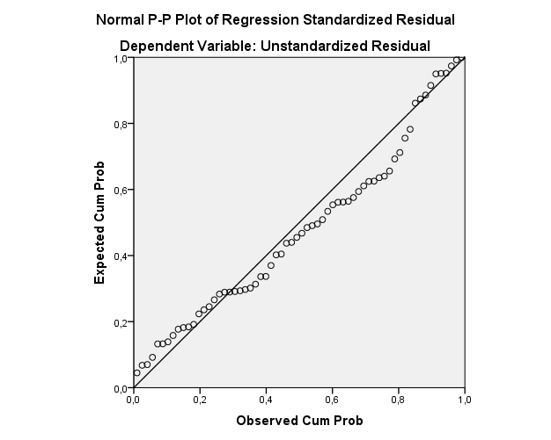
- Hasil Uji Heteroskedastisitas
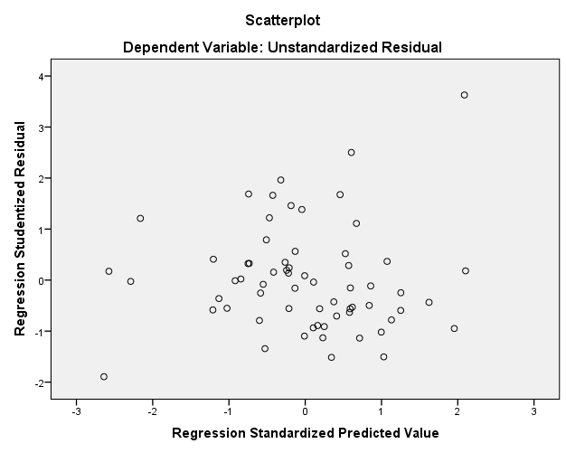
  - Pengujian Hipotesis Kedua
- Hasil Uji Multikolonieritas

Model |  | Collinearity Statistics
 |  | Tolerance | VIF
1 | (Constant)
 | Struktur Perusahaan | ,970 | 1,031
 | Monitoring Perusahaan | ,920 | 1,087
 | Kinerja Perusahaan | ,918 | 1,089
 | Unstandardized Residual | ,878 | 1,138

- Hasil Uji Normalitas
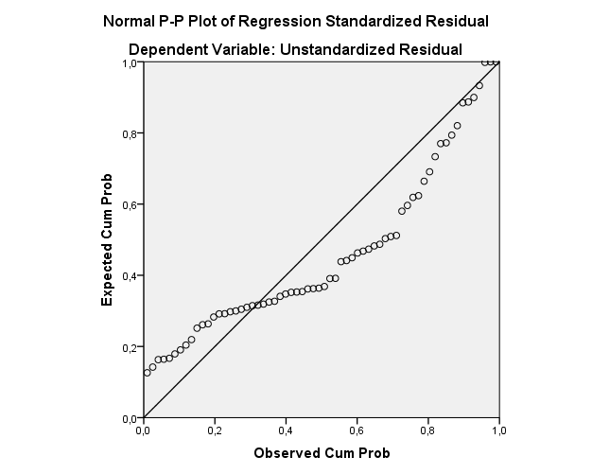
Gambar 5.3 Hasil Uji Normalitas Data

- Hasil Uji Hiteroskedastisitas
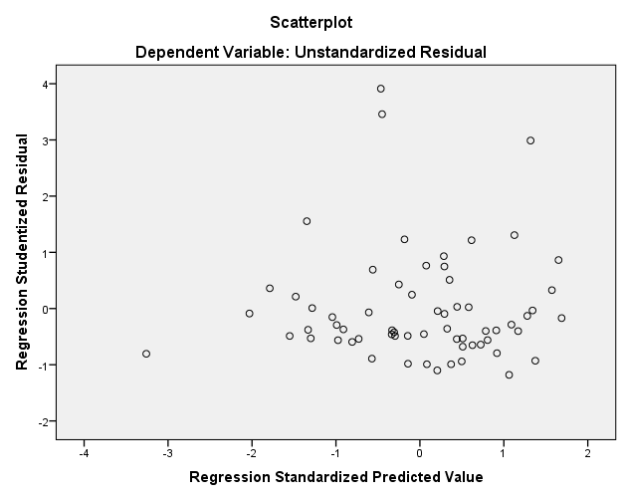
- Hasil Uji Hipotesis
  - Hipotesis Pertama
- Pengaruh Simultan Variabel Independen terhadap Variabel dependen
Model |  | Sum of Squares | df | Mean Square | F | Sig.
1 | Regression | ,795 | 3 | ,265 | 2,770 | ,049^{b}
 | Residual | 5,742 | 60 | ,096
 | Total | 6,537 | 63

- Pengaruh Parsial Variabel Independen terhadap Variabel dependen
Model |  | Unstandardized Coefficients |  | Standardized Coefficients | t | Sig.
 |  | B | Std. Error | Beta
1 | (Constant) | -,316 | ,139 |  | -2,265 | ,027
 | Struktur Perusahaan | ,010 | ,057 | ,021 | ,174 | ,863
 | Monitoring Perusahaan | ,406 | ,193 | ,256 | 2,105 | ,039
 | Kinerja Perusahaan | 1,310 | ,649 | ,247 | 2,018 | ,048

  - Hipotesis Kedua
- Pengaruh Simultan Variabel Independen terhadap Variabel dependen
Model |  | Sum of Squares | df | Mean Square | F | Sig.
1 | Regression | ,009 | 4 | ,002 | ,437 | ,781^{b}
 | Residual | ,316 | 59 | ,005
 | Total | ,326 | 63

- Pengaruh Parsial Variabel Independen terhadap Variabel dependen
Model |  | Unstandardized Coefficients |  | Standardized Coefficients | t | Sig.
 |  | B | Std. Error | Beta
1 | (Constant) | -,014 | ,034 |  | -,409 | ,684
 | Struktur Perusahaan | -,006 | ,013 | -,060 | -,464 | ,645
 | Monitoring Perusahaan | ,018 | ,047 | ,050 | ,373 | ,710
 | Kinerja Perusahaan | ,125 | ,159 | ,105 | ,786 | ,435
 | Kualitas Pelaporan Keuangan | -,032 | ,031 | -,145 | -1,058 | ,294

