Moh. Badri Tamam¹, Hozairi², Januario Freitas Araujo Bernardo³
1,2, Program Studi Teknik Informatika Universitas Islam Madura 3, Universidade Dili, Timor Leste 1, badri.uimadura@gmail.com 2, dr.hozairi@gmail.com 3. essadejaneiro89@gmail.com

Classification Of Sign Language In Real Time Using The Convolutional Neural Network Method
Abstract— To form a good interaction between individuals, it takes a Good communication is using language. In contrast to deaf people who communicate using sign language. Sign Language is the language for people who have difficulty hearing and speaking. But sign language is not a popular language among the people, and neither are the people who have it disabled will be more difficult. This journal will explain the classification of languages
American Signal uses the Convolutional Neural Network (CNN). In this research will be carried out some studies using different parameters such as preprocessing, research will be carried out by looking at the horizontal flip parameter. In addition, research was also carried out by looking at the times.
This research was conducted to monitor the precision and accuracy of the validation. The model created in this study a higher accuracy value when predicting the letters v, and n. The results of the accuracy value of this study are 95.4%.

Keywords: Sign Language, classification, CNN, Python

INTRODUCTION
Sign language users around the world more or less. Every country even every Each region has its own sign language different. On one side of the numbers owned by the general public ability to communicate with Sign language is very limited. Problem will appear when the person is deaf or speech-impaired people want to communicate with normal people who do not understand Sign language. For those who can hear, they can learn and understand written language as a representation spoken language using writing to encode phonemes. But for deaf people, this correspondence can't be done, because writing is only for the deaf having great difficulty in read and write

because on actually no correspondence directly between their natural languages (sign language) with written language.[1]
Difficulty in communicating will affect life and interpersonal relationships in society deaf. Difficulty in communicating between the deaf and the deaf those who can hear can carry problems in the integration process deaf people into society wide. Of course this problem is necessary looking for a solution so that the process of communication with ordinary people can do it smoothly, which in the end will be improve harmonious relations between components of society. something like that
the need for an interpreter from sign language into written language get very big. One example is in the journal who used Doppler Radar and later VGG get 87.5% accuracy.
Learn Others are also used to classify using a cellphone camera. Classification get 92.8% as a result of its accuracy. Therefore, the focus of this journal is to provide an overview of the implementation deep learning Classification Of Sign Language In Real Time Using The Convolutional Neural Network Method. As for The organization of writing this paper is divided into several sections, namely methodology, results and discussion, as well as conclusions.
OpenCV (Open Source Computer Vision Library) is one of the library software intended for dynamic image processing real-time, built by Intel, and now supported by Willow Garage and Itseez.OpenCV is released under the permissive BSD license which is freer than the GPL, and give complete freedom to no need for commercial use reveal source code. He also has a language-enabled interface programming C++, C, Python and Java, including Windows, Linux, Mac OS, iOS and Android. OpenCV by design for efficiency in computing and focus on real time applications.

OpenCV Logo An example of implementing OpenCV in Python is a camera installed in the parking lot can read the number plate. This number plate converted from analog to digital then processed into characters so that it becomes usable data as important information. In essence, OpenCV along with Python is used to process images or videos (stack
frames/images) according to their respective purposes which involves the camera to capture the image then processed on the computer.
Actually, OpenCV can be used across languages C++ and Java, besides Python, but those languages the easiest of the three is Python because simple. I've been studying C++ for
OpenCV, turns out the code is quite complicated. So,
You're lucky to learn Python too lucky to get this module.

OpenCV, also called „Open-Source Computer Vision Library‟ is, as the name suggests, an open-source library for computer vision, machine learning, and image processing. It plays a major role in the real-time operation, important in today‟s systems. One can process images and videos to identify objects, faces, or even the handwriting of a human using the OpenCV. The data can be in several forms; it can be in the form of video sequences, views from multiple cameras, multidimensional data from a 3D scanner, or even
medical scanning device.

Related Work
CNN is playing an important role in many sectors like image processing. It has a powerful impact on many fields. Even, in nano-technologies like manufacturing semiconductors, CNN is used for fault detection and classification [2]

Handwritten digit recognition has become an issue of interest among researchers. There are a large number of papers and articles are being published these days about this topic. In research, it is shown that Deep Learning algorithm like multilayer CNN using Keras with Theano and Tensorflow gives the highest accuracy in comparison with the most widely used machine learning algorithms like SVM, KNN & RFC. Because of its highest accuracy, Convolutional Neural Network (CNN) is being used on a large scale in image classification, video[3][4]

analysis, etc. Many researchers are trying to make sentiment recognition in a sentence. CNN is being used in natural language processing and sentiment recognition by varying different parameters.[5]
Deep learning has extraordinary capabilities clever computer vision with that ability significant in modeling various complex data like image data. One of the Deep Learning methods currently has the best results at image recognition is a Convolutional Neural Network (CNN)[5][1]. This is because of the CNN method trying to emulate the image recognition system on visuals human cortex thus has the ability to process image information. But CNN, like the deep method Journal of Informatics Engineering, Vol. 11, no. August 3, 2019 48 other learning, has a weakness, namely the process ancient training[6][7].
It has many advantages especially for machine learning based programming. Like generally Java and C languages, which are Open Source, interactive, modular, dynamic, object based, and others, the Python language has many libraries which can easily be used for machine learning, such as : Numpy (for operations vectors and matrices),[8] Scikit-learn (data analysis and statistics), Pandas Data Frame (data processing 3 ULTIMA InfoSys, Vol. XI, No. 1 | June 2020 ISSN 2085-4579 such as Excel and SQL), Matplotlib (graphical data visualization), and Keras (neural API network that works on top of Tensor Flow or Theano)[8][9]
Open Computer Vision (OpenCV) itself is an open source library with a specific purpose to perform image processing. The bottom line is that computers have similar capabilities to visual processing in humans. OpenCV has provided many basic computer vision algorithms. OpenCV also provides an object detection module that uses the Viola Jones algorithm. [4]
Python is a high-level programming language that is interpreter, interactive, object-oriented, and can operate on almost all platforms: Mac, Linux, and Windows. Python is a language easy-to-learn programming due to clear syntax, can be combined with the use of ready-to-use modules, and efficient high-level data structures.[10]
To analyze data, especially data that is large enough, tools are needed to calculate and analysis to be more effective and efficient. Python is one of the recommended tools
for that matter. In recent years, Python library support has been improved (especially pandas) have made it a powerful alternative for data analysis tasks.
To analyze data, especially data that is large enough, tools are needed to calculate and analysis to be more effective and efficient. Python is one of the recommended tools for that matter. In recent years, Python library support has been improved (especially pandas) have made it a powerful alternative for data analysis tasks.[11]
Deep Learning is a subfield of machine learning. It was inspired by the structure and function of the brain called artificial neural networks and concerned with similar algorithms. These algorithms inspired by the human brain, learn from large amounts of data just like we, humans, learn from experience. The Deep Learning algorithms repeat the process each time, tweaking it a little to improve the outcome.[12]

Research Method
In this methodology in conduct complete and concise research. Learn will start from the explanation of the dataset, data processing, and the coding used.

A. Datasets
The dataset used is the kaggle dataset in the form of pictures of hand poses for languages cue. This dataset contains 78500 images, sizes 1.04 gb each - each image is 200 pixels wide x 200 pixels. In this dataset there are 26 classes namelyall letters of the alphabet from 'A' to 'Z'. On In this dataset there are 3 additional classes entitled 'none', 'del', and 'space' but because it's not needed then these 3 classes were not used in this study.

B. Initial processing
Image preprocessing is done using some libraries from python including numpay, cv2, matplotlib.pyplot.
The data that is input the first time, the data is in the form of images. 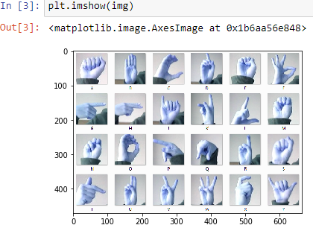

Figure 1. Processed Image Data

after the image enters the second process ie
including the 785 dataset taken from kaggel as well.
count the number of rows
print(train.shape)
print(test. shape)
(27455, 785)
(7172, 785)

put train data & test data into array
train_set = np.array(train, dtype = 'float32')
test_set = np.array(test, dtype= 'float32')
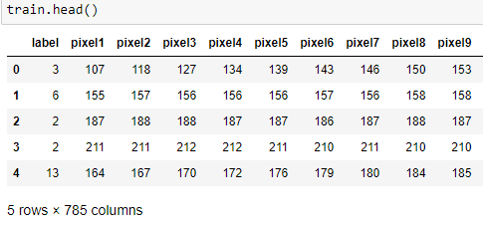
Figure 2. Datasets
create class
class_names =['A', 'B', 'C', 'D', 'E', 'F', 'G', 'H', 'I', 'J', 'K', 'L' , 'M', 'N', 'O', 'P', 'Q', 'R', 'S', 'T', 'U', 'V', 'W', 'X',' Y']
After that, the process of entering training data & test data into the array and create a class name and display RANDOM data, to match all image dimensions. then you will get the sata train size and immediately select the data train randomly starting from 0 and will display the selected image.
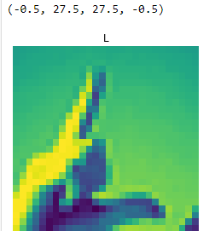
Figure 4. displays images randomly
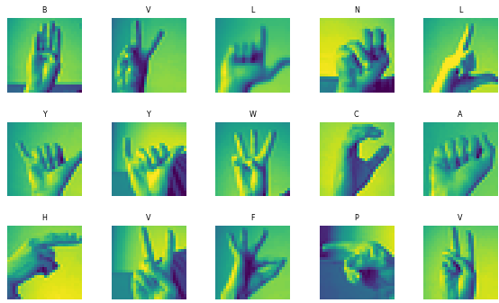
Figure 4. displays the selected image
The next process is preparing training and test data
X_train = train_set[:, 1:] / 255
y_train = train_set[:, 0]

X_test = test_set[:, 1:] /255
y_test = test_set[:,0]

visualize dance
plt. number(figsize=(10, 10))
for me in range(25):
plt. subplot(5, 5, i + 1)
plt. xticks([])
plt. yticks([])
plt.grid(False)
plt.imshow(X_train[i].reshape((28,28)), cmap=plt.cm.binary)
label_index = int (y_train[i])
plt. title(class_name[label_index])
plt. show()
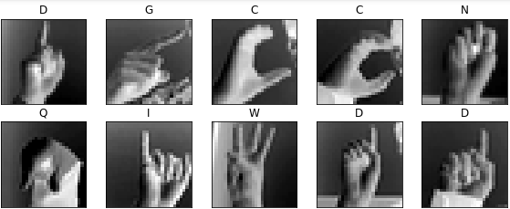
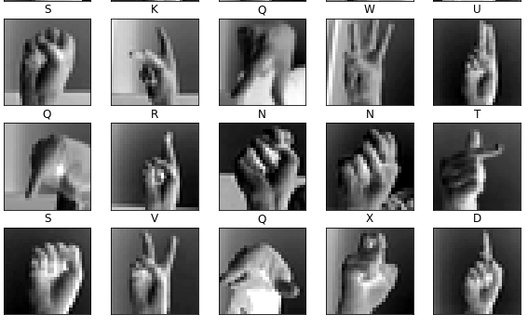
Figure 5. Visualization of train images

Figure 5. Visualization of train images

resizing the train and testing data
X_train = X_train.reshape(X_train.shape[0], *(28,28,1))
X_test = X_test.reform(X_test.form[0], *(28, 28, 1)) X_validation = X_validation.reform(X_validation.form[0], *(28, 28, 1))
(21964, 28, 28, 1)
(21964,)
(5491, 28, 28, 1)
print(X_train.shape)
print(y_train.shape)
print(X_validation.form)
after setting up new train data visualize trains and split the data and measure its tensor flow. then define the convolution neural network (cnn).

cnn_model = Order()

#first layer
cnn_model.add(Conv2D(32, (3, 3), input_shape = (28,28,1), activation='relu'))
cnn_model. add(MaxPooling2D(pool_size = (2, 2)))
cnn_model. add(Drop(0,25))

#second layer
cnn_model.add(Conv2D(128, (3, 3), input_shape = (28,28, 1), activate='relu'))
cnn_model. add(MaxPooling2D(pool_size = (2, 2)))
cnn_model. add(Drop(0,25))

# third screen
cnn_model.add(Conv2D(128,(3, 3), input_shape = (28,28,1), activation='relu'))
cnn_model. add(MaxPooling2D(pool_size = (2, 2)))
cnn_model. add(Drop(0,25))

cnn_model. add(Align())

cnn_model.add(Solid(units = 512, activation= 'relu'))
cnn_model. add(Drop(0,25))
cnn_model.add(Dense(units = 25, activation = 'softmax'))

CNN model results
cnn_model. summary()
Model: "sequential"
_________________________________________________________________
Layer (type) Output Shape Param #
=================================================================
conv2d (Conv2D) (None, 26, 26, 32) 320
_________________________________________________________________
max_pooling2d (MaxPooling2D) (None, 13, 13, 32) 0
_________________________________________________________________
dropout (Dropout) (None, 13, 13, 32) 0
_________________________________________________________________
conv2d_1 (Conv2D) (None, 11, 11, 128) 36992
_________________________________________________________________
max_pooling2d_1 (MaxPooling2 (None, 5, 5, 128) 0
_________________________________________________________________
dropout_1 (Dropout) (None, 5, 5, 128) 0
_________________________________________________________________
conv2d_2 (Conv2D) (None, 3, 3, 128) 147584
_________________________________________________________________
max_pooling2d_2 (MaxPooling2 (None, 1, 1, 128) 0
_________________________________________________________________
dropout_2 (Dropout) (None, 1, 1, 128) 0
_________________________________________________________________
flatten (Flatten) (None, 128) 0
_________________________________________________________________
dense (Dense) (None, 512) 66048
_________________________________________________________________
dropout_3 (Dropout) (None, 512) 0
_________________________________________________________________
dense_1 (Dense) (None, 25) 12825
Table 1. Model: "sequential"

Total params: 263,769
Trainable params: 263,769
Non-trainable params: 0

CNN model training process with 55 epochs to ensure excellent accuracy
Train on 21964 samples, validate on 5491 samples
Epoch 1/55
21964/21964 [==============================] - 62s 3ms/sample - loss: 0.3828 - acc: 0.8684 - val_loss: 0.1218 - val_acc: 0.9723
Epoch 2/55
21964/21964 [==============================] - 61s 3ms/sample - loss: 0.2903 - acc: 0.9003 - val_loss: 0.0959 - val_acc: 0.9836
Epoch 3/55
21964/21964 [==============================] - 61s 3ms/sample - loss: 0.2645 - acc: 0.9103 - val_loss: 0.0732 - val_acc: 0.9869
Epoch 4/55
21964/21964 [==============================] - 61s 3ms/sample - loss: 0.2325 - acc: 0.9228 - val_loss: 0.0567 - val_acc: 0.9907
Epoch 5/55
21964/21964 [==============================] - 61s 3ms/sample - loss: 0.2017 - acc: 0.9317 - val_loss: 0.0435 - val_acc: 0.9945
Epoch 6/55
21964/21964 [==============================] - 61s 3ms/sample - loss: 0.1742 - acc: 0.9428 - val_loss: 0.0370 - val_acc: 0.9945
Epoch 7/55
21964/21964 [==============================] - 61s 3ms/sample - loss: 0.1539 - acc: 0.9498 - val_loss: 0.0263 - val_acc: 0.9969
Epoch 8/55
21964/21964 [==============================] - 62s 3ms/sample - loss: 0.1416 - acc: 0.9527 - val_loss: 0.0198 - val_acc: 0.9998
Epoch 9/55
21964/21964 [==============================] - 60s 3ms/sample - loss: 0.1254 - acc: 0.9588 - val_loss: 0.0157 - val_acc: 0.9993
Epoch 10/55
21964/21964 [==============================] - 60s 3ms/sample - loss: 0.1140 - acc: 0.9635 - val_loss: 0.0120 - val_acc: 0.9996
Epoch 11/55
21964/21964 [==============================] - 63s 3ms/sample - loss: 0.0977 - acc: 0.9685 - val_loss: 0.0108 - val_acc: 0.9996
Epoch 12/55
21964/21964 [==============================] - 61s 3ms/sample - loss: 0.0910 - acc: 0.9715 - val_loss: 0.0077 - val_acc: 0.9998
Epoch 13/55
21964/21964 [==============================] - 60s 3ms/sample - loss: 0.0846 - acc: 0.9730 - val_loss: 0.0064 - val_acc: 1.0000
Epoch 14/55
21964/21964 [==============================] - 62s 3ms/sample - loss: 0.0771 - acc: 0.9753 - val_loss: 0.0052 - val_acc: 1.0000
Epoch 15/55
21964/21964 [==============================] - 61s 3ms/sample - loss: 0.0715 - acc: 0.9769 - val_loss: 0.0041 - val_acc: 1.0000
Epoch 16/55
21964/21964 [==============================] - 61s 3ms/sample - loss: 0.0638 - acc: 0.9799 - val_loss: 0.0033 - val_acc: 1.0000
Epoch 17/55
21964/21964 [==============================] - 61s 3ms/sample - loss: 0.0645 - acc: 0.9798 - val_loss: 0.0036 - val_acc: 1.0000
Epoch 18/55
21964/21964 [==============================] - 61s 3ms/sample - loss: 0.0529 - acc: 0.9841 - val_loss: 0.0029 - val_acc: 1.0000
Epoch 19/55
21964/21964 [==============================] - 62s 3ms/sample - loss: 0.0508 - acc: 0.9845 - val_loss: 0.0024 - val_acc: 1.0000
Epoch 20/55
21964/21964 [==============================] - 63s 3ms/sample - loss: 0.0476 - acc: 0.9859 - val_loss: 0.0015 - val_acc: 1.0000
Epoch 21/55
21964/21964 [==============================] - 61s 3ms/sample - loss: 0.0450 - acc: 0.9862 - val_loss: 0.0023 - val_acc: 1.0000
Epoch 22/55
Epoch 28/55
21964/21964 [==============================] - 62s 3ms/sample - loss: 0.0334 - acc: 0.9897 - val_loss: 6.4232e-04 - val_acc: 1.0000
Epoch 29/55
21964/21964 [==============================] - 61s 3ms/sample - loss: 0.0330 - acc: 0.9891 - val_loss: 7.3649e-04 - val_acc: 1.0000
Epoch 30/55
21964/21964 [==============================] - 61s 3ms/sample - loss: 0.0321 -
21964/21964
21964/21964 [==============================] - 60s 3ms/sample - loss: 0.0229 - acc: 0.9929 - val_loss: 4.2094e-04 - val_acc: 1.0000
Epoch 42/55
21964/21964 [==============================] - 60s 3ms/sample - loss: 0.0219 - acc: 0.9930 - val_loss: 2.3793e-04 - val_acc: 1.0000
21964/21964 [==============================] - 60s 3ms/sample - loss: 0.0196 - acc: 0.9934 - val_loss: 3.3073e-04 - val_acc: 1.0000
21964/21964 [==============================] - 62s 3ms/sample - loss: 0.0173 - acc: 0.9951 - val_loss: 1.0458e-04 - val_acc: 1.0000
Epoch 54/55
21964/21964 [==============================] - 61s 3ms/sample - loss: 0.0175 - acc: 0.9948 - val_loss: 1.6882e-04 - val_acc: 1.0000
Epoch 55/55
21964/21964 [==============================] - 61s 3ms/sample - loss: 0.0157 - acc: 0.9953 - val_loss: 1.3220e-04 - val_acc: 1.0000

Result
This chapter will explain the results of the research
Sign Language Classification in Real Time Using the Convolutional Neural Network Method some data such as the effect of preprocessing data, and epoch 55 for accuracy, validation accuracy, loss and lost validation.
A. Processing Data
In this study, experiments were carried out on data preprocessing. When using Images Libraries will be scrutinized, is it better if used or not.
plt.subplot(2, 2, 1)
plt.plot(history.history['loss'], label='loss')
plt.plot(history.history['val_loss'], label='val_loss')
plt.legend()
plt.grid()
plt.title('Loss evolution')

plt.subplot(2, 2, 2)
plt.plot(history.history['acc'], label='acc')
plt.plot(history.history['val_acc'], label='val_acc')
plt.legend()
plt.grid()
plt.title('Accuracy evolution')
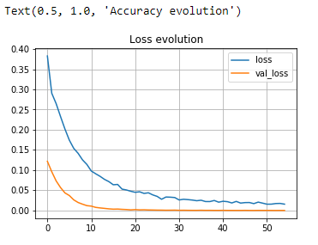
Figure 6. Loss Evaluation

seen from the diagram above the evaluation of eating loss
very good with a loss of 55 and a val_loss of 55

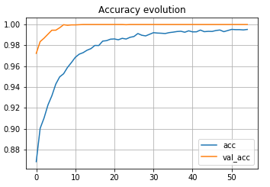
Figure 7. Evolution of accuracy

of the epochal results for the resulting accuracy
99% close to perfect.
The two graphs don't show much differences in accuracy on the use of horizontal flip or not. Moreover, both feature graphics good accuracy on training but on validation
the graph is not stable.

after knowing the results of the epoch, the process of visualizing new prediction results is carried out
visualize the prediction results
L = 5
W = 5
fig, axis = plt. subplot(L, W, figsize = (12,12))
ax = axe.ravel()

for me in np. range(0, L * W):
axes[i].imshow(X_test[i].reshape(28,28))
axes[i].set_title(f"Predicted Class = {predicted_classes[i]:0.1f}\n True Class = {y_test[i]:0.1f}")
axis[i].axis('off')
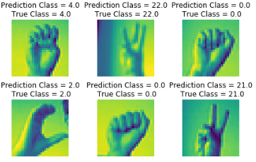
plt. subplots_adjust(wspace=0,5)
Figure 8. Prediction Results
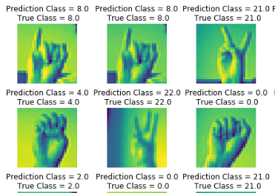

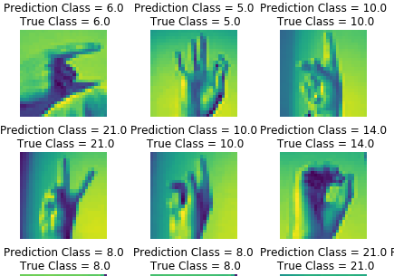
Figure 9. Prediction Results
Figure 10. Prediction Results

From the experiment above, it can be seen that the test has been carried out on the dataset itself has the correct prediction results
while in other images it is not always true. Classification results
Using the ccn method, 95% accuracy is produced.

Conclusion
In this study conducted research on classification Sign Language Classification in Real Time Using the Convolutional Neural Network Method. This CNN model was created with using several layers such as Cv2, split, matloplob and numpay. Some things are done for find out the difference in accuracy in pre-processing data, and time. From this study the results of the accuracy are obtained is 95.4%. From this research found high loss on validation accuracy whereas loss on training quite stable. The most predictable letter the good ones are v and n while the worst ones are when predict the letters n, c, j, and z. For development Going forward, several things will be done
fixing the model by changing its layers and also do different preprocessing order values loss can be reduced and provide more accuracy tall.
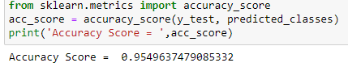
Figture 11. Accuracy Score

References

[1] F. Devina, C. Citra, and E. Tanuwijaya, “Klasifikasi Bahasa Isyarat Amerika menggunakan Convolutional Neural Network American Sign Language Classification using Convolutional Neural Network,” J. Sist. dan Teknol. Inf., vol. 10, no. 1, pp. 139–144, 2022, doi: 10.26418/justin.v10i1.47184.
[2] R. Sistem et al., “JURNAL RESTI,” vol. 1, no. 10, 2021.
[3] F. Siddique, S. Sakib, and M. A. B. Siddique, “Recognition of handwritten digit using convolutional neural network in python with tensorflow and comparison of performance for various hidden layers,” 2019 5th Int. Conf. Adv. Electr. Eng. ICAEE 2019, pp. 541–546, 2019, doi: 10.1109/ICAEE48663.2019.8975496.
[4] C. R. Aritonang, A. Atmam, and E. Zondra, “Analisis Putaran Motor Pada Electrical Submersible Pump (ESP) Menggunakan Fuzzy Logic Controler Berbasis Python,” Sain, Energi, Teknol. Ind., vol. 4, no. 1, pp. 32–39, 2019, [Online]. Available: https://journal.unilak.ac.id/index.php/SainETIn/article/view/6266
[5] D. Yolanda, K. Gunadi, and E. Setyati, “Pengenalan Alfabet Bahasa Isyarat Tangan Secara Real-Time dengan Menggunakan Metode Convolutional Neural Network dan Recurrent Neural Network,” J. Infra, vol. 8, no. 1, pp. 203–208, 2020, [Online]. Available: https://publication.petra.ac.id/index.php/teknik-informatika/article/view/9791
[6] E. Wang, J. J. Davis, and P. Y. K. Cheung, “A PYNQ-Based Framework for Rapid CNN Prototyping,” Proc. - 26th IEEE Int. Symp. Field-Programmable Cust. Comput. Mach. FCCM 2018, p. 223, 2018, doi: 10.1109/FCCM.2018.00057.
[7] A. N. Aziz, “Image Recognition Alfabet Bahasa Isyarat Indonesia (Bisindo) Menggunakan Metode Convolutional Neural Network,” 2021, [Online]. Available: https://dspace.uii.ac.id/handle/123456789/32137%0Ahttps://dspace.uii.ac.id/bitstream/handle/123456789/32137/17523001 Achmad Noer Aziz.pdf?sequence=1
[8] B. D. Prasetya, F. S. Pamungkas, and I. Kharisudin, “Pemodelan dan Peramalan Data Saham dengan Analisis Time Series menggunakan Python,” Prism. Pros. Semin. Nas. Mat., vol. 3, pp. 714–718, 2020, [Online]. Available: https://journal.unnes.ac.id/sju/index.php/prisma/ ISSN
[9] W. F. Holmgren, R. W. Andrews, A. T. Lorenzo, and J. S. Stein, “PVLIB Python 2015,” 2015 IEEE 42nd Photovolt. Spec. Conf. PVSC 2015, 2015, doi: 10.1109/PVSC.2015.7356005.
[10] A. Zein, “Pendeteksian Kantuk Secara Real Time Menggunakan Pustaka OPENCV dan DLIB PYTHON Real Time Sleepiness Detection Using OPENCV Library and PYTHON DLIB,” Sainstech, vol. 28, no. 2, pp. 22–26, 2018.
[11] D. A. Prasetya and I. Nurviyanto, “Deteksi wajah metode viola jones pada opencv menggunakan pemrograman python,” Simp. Nas. RAPI XI FT UMS, pp. 18–23, 2012.
[12] A. S. I. A. M. Binit Choudhary and Dr. Preety Verma Dhaka, “Social Distancing Detection Using Open CV and Yolo Object Detector,” Int. J. Mod. Trends Sci. Technol., vol. 7, no. 01, pp. 93–95, 2021, doi: 10.46501/ijmtst070121.

______________________________________________________________This paragraph of the first footnote will contain the date on which you submitted your paper for review, revised, and accepted.

