UI/UX Design with Task Centered System Design and Evaluation Methods with Heuristic Usability and System Usability Scale in Solution Applications
Meida Cahyo Untoro ¹, Pungki Resti Prabandari ², Mugi Praseptiawan^{3*}, M. Syamsuddin Wisnubroto ⁴
Abstract— Digital transformation requires a software system development method that can identify and analyze user needs. In this research, software system development uses the Task Centered System Design framework with several stages including identification, needs analysis, design and evaluation. The identification stage is carried out by conducting interviews with stakeholders and then the results of the interviews are analyzed and approved by stakeholders. The evaluation phase aims to determine the value of the usability problem in the design that has been designed. The evaluation phase uses the Usability Heuristic method by involving experts in the field of software development and the System Usability Scale method involving end users. After conducting research from the identification to evaluation stage, the average severity rating of the Heuristic Usability test component scored less than 1 (one) in the second iteration and the results of the System Usability Scale test scored 70.3 for admin applications and 73.75 for customer application and entered into grade C with an adjective rating of Good.

Index Terms— Design, Evaluation, Heuristic Usability, System, Usability Scale, Task Centered System Design.

INTRODUCTION
T
he property business sector in Indonesia will rise and develop in 2021. One of them is in the property sector, as revealed by a global property consulting agency, Jones Lang LaSalle (JLL) that the volume of property investment in Asia Pacific will increase by 15% to 20% in 2021[1]. This study aims to implement new life adaptations in the pandemic era by realizing public services in the property business sector using digital technology and raising case studies of service applications, namely solution applications. The Solution Application is a liaison between users and company services.
It takes an application development method that prioritizes the physical and mental work that the user will do. The TCSD method is a method for building an interface that focuses on a list of user needs [2][3]. The analytical mind will think how to be several times ahead of the user and improve the flow of functionality. The TCSD method includes 4 (four) stages, namely identification, requirements, design through scenarios, and evaluation [3].
This study aims to obtain user needs to build an application interface by applying the steps of the Task Centered System Design method and usability evaluation and calculating the weight of the feasibility value by testing the Heuristics method and System Usability Scale on the solution application design [13].

Related Work
The System Usability Scale or SUS was developed in 1986 by John Brooke which is a questionnaire used as a tool to assess the usability level of a website used to obtain a quantitative assessment by student users. The System Usability Scale contains 10 statements in which users rate their level of agreement. Half of the statements (5 statements) are positive statements, and the other 5 statements are negative statements. The Likert scale used in this questionnaire is five points for each statement, from strongly agree to strongly disagree[17].

Research Method
The research used is qualitative and quantitative research. Qualitative research is used to answer the problem formulation at the stage of identification, needs analysis and the results of testing the heuristic method. Meanwhile, the results of the usability scale system test are in the form of quantitative data for the user satisfaction category.
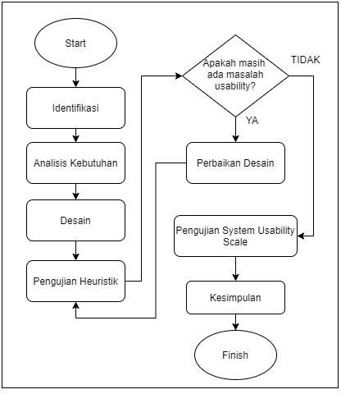
Fig 1. Research Flow

Task Centered System Design (TCSD)
The TCSD method is a method that prioritizes the needs and tasks that have high functionality from users [2][4]. According to (Greenberg, 2004) the TCSD process is described in the next point

Identification
The needs of the system to be built are sought based on the user. The identification process is carried out by articulating the real tasks that will be carried out by the user [5]. This stage aims to produce a list of needs and tasks that will be realized in the system. Identification in this study was carried out by interviewing stakeholders, namely the owner and admin of the company PT. Property Core Solutions. The results of the interviews will then be processed into data that contains the needs and target users of the application.

Needs Analysis
The user needs analysis stage processes and considers the results of the needs identification that have been carried out previously. The suitability of the tasks contained in the system becomes a priority in the needs analysis stage [6]. Requirement’s analysis is made in the form of a conceptual model that contains a project description, classification of functional requirements, target users, company business processes, features and flows that illustrate system processes (use case diagrams) [6].

Design
After identifying and analyzing needs, the next stage is to describe the application interface. The design stage is the stage that changes the description of the requirements into a framework that supports the plot of the system storyline [7]. The system flow is illustrated in the form of an overview of the user's interaction with the application.

Evaluation
After identifying, analyzing and designing application requirements, then the results are tested to find out whether the results of the interface that have been designed are in accordance with the usability aspect of the interface [8]. In this study, the evaluation was carried out using 2 (two) testing methods, namely the usability heuristic method and the system usability scale.

Usability Heuristics
The usability heuristic test method aims to find out whether there are still usability problems in the interface design that is built. In this study, the test was adapted from 10 (ten) heuristic principles [9], [10], including:
- Visibility of status
- Compatibility between the system and the real world
- Control and freedom by the user
- Suitability of use and standards
- Handling in error
- Memory usage by user
- Flexibility and usability
- Aesthetic and minimalist design
- Help users identify, analyze and resolve errors
- Support and documentation
Heuristic usability testing involves evaluators who are experts in the field of UI/UX Design and Human Computer Interaction [10], [11]. Quoted from a study which says that 3 (three) evaluators have been able to find more than 75% of usability problems [10].
Weighting values in this study using a severity rating starting from 0 (zero) to 4 (four)[10]. Severity rating serves to estimate the urgency of the problems found. In table 1, an explanation of the weighting of these numbers can be seen.
Table 1.
Heuristic Value Weighting
No | Value Weighting | Description
1 | 0 (zero) | No usability problems
2 | 1 (one) | There is a cosmetic problem
3 | 2 (two) | Minor usability problem (needs improvement, but with low priority)
4 | 3 (three) | Major usability problem (needs to  have improvements affecting the process and high priority)
5 | 4 (four) | Usability catastrophe (there needs to be a design before the product is released)

Calculation of the total severity rating of all evaluators will be added up and divided by the total negative findings [11]. If the result is not an integer, it is rounded according to mathematical rules [11].

$\overline{x}= \frac{1}{n} \sum_{i=n}^{n}{x_{i}}$ (1)
In accordance with the severity rating category, if the weight value is more than 1 (one) it means that it requires design improvements in the category of heuristic principles [11]. On the other hand, if the weight value is more than equal to (>=) 1 (one), it is categorized as safe.

System Usability Scale
Testing using the system usability scale method is included in the category of empirical testing involving users as respondents. This test summarizes aspects of the user's desires, emotions, perceptions and habits [14]. The System Usability Scale test consists of 10 (ten) questionnaire items and the value is weighted using a linkert scale from 1 (one) to 5 (five). The statements used in testing with the SUS method are as follows [14]:
- I want to use this system more often.
- I don't think this system should be made more complicated than this.
- I think this system is easy to use.
- I need help from a technical person to be able to operate this system.
- I found the various functions of the system well connected.
- I feel there is an inconsistency in the system.
- I think many people will learn to use this system quickly.
- I find the system very complicated to use.
- I feel the need to learn before using this system.

The technical calculation of the System Usability Scale value uses the odd and even numbering rules on the test instrument [10]. An explanation of how to calculate the results of the SUS method [10], is as follows:
a) odd numbered instrument, the answer value will be deducted by 1 (one)
b) For even-numbered instruments, 5 is reduced by the answer value from the respondent
c) Calculation of the total value comes from the accumulated value multiplied by 2.5 (two point five)
d) Calculation of the average value of the answers to the test results of all respondents.

Then to determine the value of the test results, the percentile rank score method is used. The following are the provisions in determining the value using the SUS score percentile rank [10][14]:
a) Grade A (score >= 80.3)
b) Grade B (74 >= score <80.3)
c) Grade C (68 >= score <74)
d) Grade D (51 >= score <68)
e) Grade F (score < 51)
If the rating is above 60 or is included in Grade D, then the adjective rating is OK and it is good or decent [10].

Result
The results of the study explain the implementation of TCSD steps and usability evaluation of the interface design that has been built, for the explanation as follows:

Identification

At the identification stage, data obtained in the form of interviews with stakeholders, namely company owners and customer service PT. Core Property Solutions are summarized in the form of an interview form. The results contain an overview of features, application design references, color components, types of fonts and icons used, target users and company business processes.

Needs Analysis

After the interview results are obtained, the next step is to analyze the results of the interview into a requirements document that contains a description of the project, business requirements, user features, functional requirements, and an overview of the application process flow in the form of a use case diagram. In this study there are 2 (two) applications, namely customer applications and customer service or admin applications. Below is a use case diagram of the solution application.

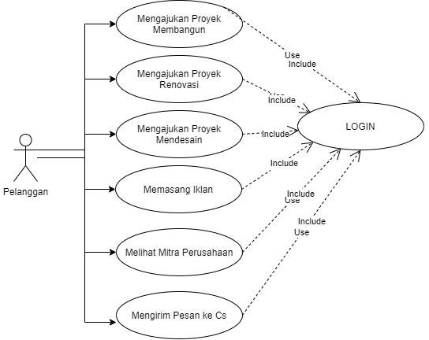

Figure 3. Customer application usecase

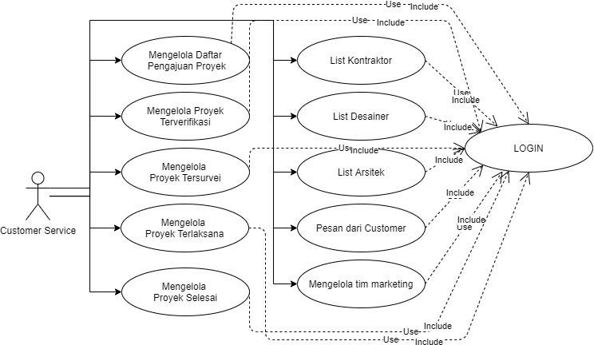
Figure 4. Admin application usecase

Design

The design stage transforms the validated feature description into a framework that supports the application storyline. The design stage in this study builds a high-fidelity prototype that has interactions on each page on its features, adding color elements and customized images/symbols. Some of the main design features can be seen in the image below.

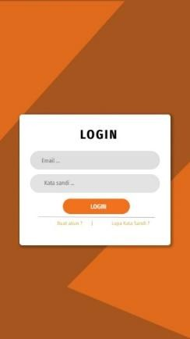

(b)
(a)

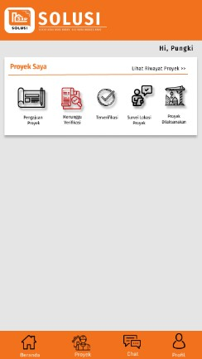
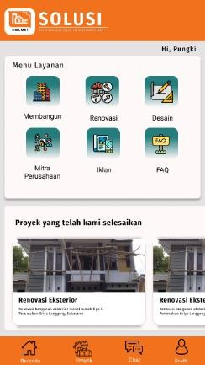

(d)
(c)

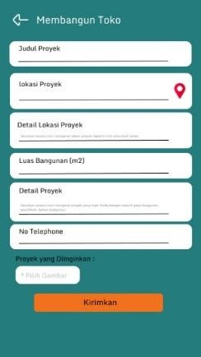
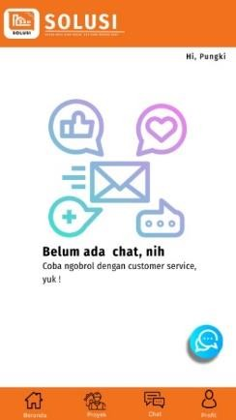

(f)
(e)

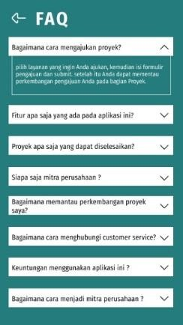

(g)

Fig. 5. High Fidelity Design Customer Solution Application (a) Splashscreen (b) Login (c) Home (d) project flow (e) chat admin (f) project submission form (g) FAQ
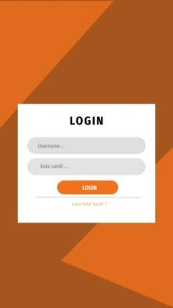
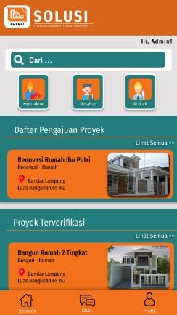

(b)
(a)

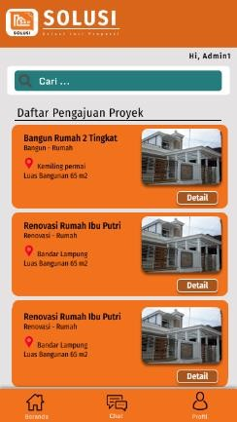
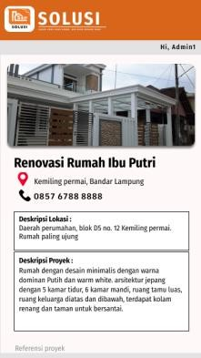

(c)
(d)

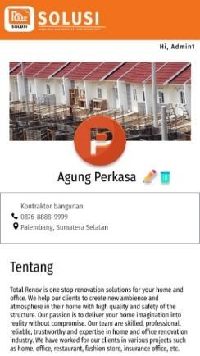
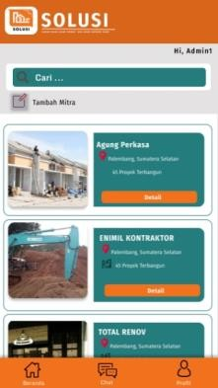

(e)
(f)
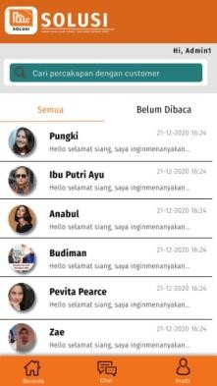
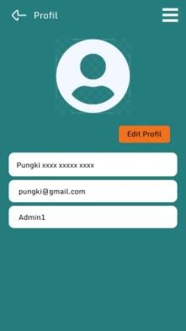

Fig. 6. High Fidelity Design Admin Solution Application (a) Login (b) Admin Home (c) List of project submissions (d) Project details (e) List of company partners (f) Company Partner details (g) Profile (h) message

Evaluation

The evaluation phase is carried out with 2 (two) testing methods, namely usability heuristics involving UI/UX experts and system usability scale involving application end users [15][16]. The results of the test are described in the following subsection.
1. Heuristic Testing

Phase 1 testing uses the heuristic method to test the appearance of the application interface whether there are still usability problems found in the design. The test involves 3 (three) evaluators who have experience in the field of software testing. Stage 1 test results can be seen in the table below.
Table 2. Heuristic Test Results 1

No  (g) |  | Heuristic Principle |  |  | Evaluation |  |  | E1 |  |  |  |  |  | E2 |  |  |  |  |  | E3 |  |  |  |  |  | Average
 |  |  |  |  |  |  |  |  | BN |  |  | TN |  |  | BN |  |  | TN |  |  | BN |  |  | TN
1 |  | User control and freedom |  |  | Apk CS |  |  | 0 |  |  | 0 |  |  | 0 |  |  | 0 |  |  | 0 |  |  | 0 |  |  | 0
 |  |  |  |  |  |  | Apk User |  |  | 0 |  |  | 0 |  |  | 2 |  |  | 2 |  |  | 1 |  |  | 0 |  |  | 2
2 |  | Suitability of use and standards |  |  | Apk CS |  |  | 2 |  |  | 1 |  |  | 3 |  |  | 1 |  |  | 0 |  |  | 0 |  |  | 3
 |  |  |  |  | Apk User |  |  | 2 |  |  | 1 |  |  | 3 |  |  | 1 |  |  | 1 |  |  | 0 |  |  | 3
3 |  | Memory usage by user |  |  | Apk CS |  |  | 0 |  |  | 0 |  |  | 0 |  |  | 0 |  |  | 0 |  |  | 0 |  |  | 0
 |  |  |  |  | Apk User |  |  | 0 |  |  | 0 |  |  | 3 |  |  | 1 |  |  | 0 |  |  | 0 |  |  | 3
4 |  | Aesthetic and minimalist design |  |  | Apk CS |  |  | 0 |  |  | 0 |  |  | 2 |  |  | 1 |  |  | 0 |  |  | 0 |  |  | 2
(h) |  |  |  |  | Apk User |  |  | 0 |  |  | 0 |  |  | 2 |  |  | 1 |  |  | 0 |  |  | 0 |  |  | 2

The average results on the Heuristic component number 3 on customer application testing get an average value of 2 (one) which means that there are repair problems with low priority. The Heuristic Component number 4 in the CS and Customer applications gets an average value of 3, meaning that there must be improvements to the design in accordance with the findings and recommendations for improvement. Then for the Heuristic component number 6, the average value is 3, meaning that there are usability problems that need improvement and have a high priority. As for the Heuristic component number 8 in both applications, an average value of 2 means that there are usability problems with low priority or can be repaired or not.

From the results of stage 1 testing, the desired results have not been obtained, namely there are still usability problems with a severity rating above 1 (one). So that the design must be improved.

2. Repair

Improvements to the design were made based on the negative findings and recommendations for improvement from the evaluators. In this test, improvements were made to the color combination and some features were fixed in location and size.

3. Heuristic Testing Phase 2

Phase 2 testing is carried out on the results of design improvements that have been made. Stage 2 testing uses the same methods and steps as stage 1 testing, namely the Heuristic method. The following is a table of results from stage 2 testing.
Table 3. Heuristic Test Results 2
No | Heuristic Principle | Evaluation | E1 |  | E2 |  | E3 |  | Average
No | Heuristic Principle | Evaluation | BN | TN | BN | TN | BN | TN | Average
1 | User control and freedom | Apk CS | 0 | 0 | 0 | 0 | 0 | 0 | 0
1 | User control and freedom | Apk User | 0 | 0 | 1 | 1 | 0 | 0 | 1
2 | Suitability of use and standards | Apk CS | 0 | 0 | 0 | 0 | 0 | 0 | 0
2 | Suitability of use and standards | Apk User | 0 | 0 | 0 | 0 | 0 | 0 | 0
3 | Memory usage by user | Apk CS | 0 | 0 | 0 | 0 | 0 | 0 | 0
3 | Memory usage by user | Apk User | 0 | 0 | 1 | 1 | 0 | 0 | 1
4 | Aesthetic and minimalist design | Apk CS | 0 | 0 | 0 | 0 | 0 | 0 | 0
4 | Aesthetic and minimalist design | Apk User | 0 | 0 | 1 | 0 | 0 | 0 | 1
Overall, the average value of each component in the results of the second stage of testing gets a value that is categorized as no usability problem. As for components number 3 and 6, the average value is 1, which means that there is a cosmetic problem, but there is no need for improvement.
Based on the severity rating, a value of 0 means there are no usability problems and a value of 1 means a problem that does not need to be fixed. Because the severity rating value obtained already meets the standard requirements, namely < = (less than equal to) 1, this process is considered complete in only 2 iterations.
However, in the Heuristic test, only usability problem values were obtained, so to get the user satisfaction value, the testing phase was continued with the System Usability Scale (SUS) method.

4. Usability Scale System Testing
System Usability Scale testing was carried out by involving 12 respondents who were selected based on predetermined categories using purposive sampling. The categories in question are age, gender and experience of using smartphones.
The distribution of respondents based on age category was selected 3 (three) respondents in the age interval section 18-25 years, 4 (three respondents for the age interval section 26-35 years, 3 (two) respondents for the age interval section 36-45 years and 2 (two)) respondents for the age interval of 46-60 years.
The results of testing the system usability scale (SUS) method are calculated using the odd and even number rules for each instrument. The rating scale used starts from 1 (one) to 5 (five). The results of testing on the customer application interface have been summarized in the table below.
Table 4. Heuristic Test Results 2
R | Odd |  | Even |  | Total |  |  | Value of SUS  (* 2.5)
R | Apk  CS | Apk  User | Apk  CS | Apk  User | Apk  CS |  | Apk  User | Apk  CS | Apk  User
R1 | 17 | 18 | 16 | 18 | 33 |  | 36 | 82,5 | 90
R2 | 19 | 19 | 20 | 20 | 39 |  | 39 | 97,5 | 97,5
R3 | 15 | 16 | 15 | 19 | 30 |  | 35 | 75 | 87,5
R4 | 17 | 11 | 19 | 24 | 36 |  | 35 | 90 | 87,5
R5 | 18 | 18 | 15 | 14 | 33 |  | 32 | 82,5 | 80
R6 | 18 | 18 | 16 | 13 | 34 |  | 31 | 85 | 77,5
R7 | 17 | 19 | 18 | 18 | 35 |  | 37 | 87,5 | 92,5
R8 | 16 | 20 | 16 | 19 | 32 |  | 39 | 80 | 97,5
R9 | 18 | 18 | 16 | 17 | 34 |  | 35 | 85 | 87,5
R10 | 18 | 19 | 13 | 16 | 31 |  | 35 | 77,5 | 87,5
R11 | 20 | 20 | 15 | 16 | 35 |  | 36 | 87,5 | 90
R12 | 18 | 20 | 15 | 16 | 33 |  | 36 | 82,5 | 90
 |  |  |  |  | 337 |  | 354 | 842,5 | 885
Average SUS Score |  |  |  |  |  |  |  | 70,3 | 73,75
Grade |  |  |  |  |  |  |  | C
Adjective Rating |  |  |  |  |  | GOOD
The total SUS scores from the customer application interface testing and CS applications were 885 and 842.5 and the average scores obtained were 73.75 and 70.3. Because the SUS value in the test results of the customer application interface and customer service is 73.75 and 70.3 which means both are included in grade C. Then the adjective rating obtained is Good.

Conclusion

The results of the evaluation stage using the usability heuristic method carried out with 2 iterations resulted in the average severity rating of the first iteration on component number 3 being worth 1, number 4 was worth 3, number 6 was worth 3, number 8 was worth 2. Severity rating is worth 3 and 2 means it needs improvement in the design. Then in the second iteration the average severity rating of each component is less than equal to 1 (one) meaning that there is no need for improvements to usability problems.

The results of the implementation of the usability scale system testing instrument on the customer and admin application interfaces get an average SUS value of 73.75 for customer applications and 70.3 for admin applications. This value is included in grade C with the category of adjective rating Good.

After a combination of testing using two usability methods obtained complementary results, namely the severity of usability problems and recommendations for improvements in the design of the Usability Heuristics test and the value of user experience satisfaction from the method testing.

Acknowledgment
This research was supported by LPPM, Institut Teknologi Sumatera. We thank our colleagues from Institut Teknologi Sumatera who provided insight and expertise that greatly assisted the research, although they may not agree with all of the interpretations/conclusions of this paper.

References
- Hermansyah antara Fakhri, “volume investasi properti,”wartaekonomi.co,id, 2020. https://www.wartaekonomi.co.id/read320580/ bisnis-properti-di-asia-pasifik-akan-naik- hingga-20-di-2021(accessed Jan. 21, 2021).
- C. Lewis and J. Rieman, “Task-Centered User Interface Design: A Practical Introduction,” Text, p. 190, 1993, [Online]. Available: http://hcibib.org/tcuid/tcuid.pdf.
- S. Greenberg, “Working through task- centered system design,” in Handbook of Task Analysis for Human-Computer Interaction, 2004.
- N. Sopiah and A. Muzakir, “Penggunaan Metode Tcsd (Task Centered System Design) Dalam Website Rekam Medis Pada Rumah Sakit Pelabuhan Palembang,” pp. 101–112, 2016, [Online]. Available: http://jurnal.binadarma.ac.id/index.php/jurnal matrik/article/view/449.
- N. P. T. Padmawati, G. Feoh, and P. W. Gunawan, “Perancangan Content Management System Program Studi Universitas Dhyana Pura Menggunakan Metode Tcsd,” J. Teknol. Inf. dan Komput., vol. 3, no. 1, pp. 313–324, 2017, doi: 10.36002/jutik.v3i1.233.
- Rahman, D. Junaedi, and D. D. J. Sumawi, “Perancangan User Interface Aplikasi Mobile Fokus Jabar Menggunakan Metode Task Centered System Design,” vol. 3, no. 3, pp. 5205–5212, 2016.
- Nielsen Norman Group, “10 Usability Heuristics for User Interface Design,” Jakob Nielsen on Apr. 24, 1994; Updated Nov. 15, 2020, 2020. https://www.nngroup.com/articles/ten-usability-heuristics/.
- U. Ependi, T. B. Kurniawan, and F. Panjaitan, “System Usability Scale Vs Heuristic Evaluation: a Review,” Simetris J. Tek. Mesin, Elektro dan Ilmu Komput., vol. 10, no. 1, pp. 65–74, 2019, doi: 10.24176/simet.v10i1.2725.
- A. P. Hendradewa, “Perbandingan metode evaluasi,” Perbandingan Metod. Eval. Usability (Studi Kasus Pengguna. Perangkat Smartphone), vol. 23, no. 1, pp. 9–18, 2017, [Online]. Available: http://journal.uii.ac.id/index.php/jurnal- teknoin/article/viewFile/8332/7102.
- C. Wilson, “Heuristic Evaluation,” User Interface Insp. Methods, pp. 1–32, 2014, doi: 10.1016/b978-0-12-410391-7.00001-4.
- Rosmasari et al., “Usability Study of Student Academic Portal from a User’s Perspective,” Proc. - 2nd East Indones. Conf. Comput. Inf. Technol. Internet Things Ind. EIConCIT 2018, pp. 108–113, 2018, doi: 10.1109/EIConCIT.2018.8878618.
- U. Ependi, F. Panjaitan, and H. Hutrianto, “System Usability Scale Antarmuka Palembang Guide Sebagai Media Pendukung Asian Games XVIII,” J. Inf. Syst. Eng. Bus. Intell., vol. 3, no. 2, p. 80, 2017, doi: 10.20473/jisebi.3.2.80-86.
- Cahyo Untoro, M. (2020). Implementation of User-Centered Design in Online Seminar Application. Pixel:Jurnal Ilmiah Komputer Grafis, 13(1), 1-8. Retrieved from https://journal.stekom.ac.id/index.php/pixel/article/view/152.
- I. Maramba, A. Chatterjee, and C. Newman, “Methods of usability testing in the development of eHealth applications: A scoping review,” Int. J. Med. Inform., vol. 126, no. February, pp. 95–104, 2019, doi: 10.1016/j.ijmedinf.2019.03.018.
- F. C. Ningrum, D. Suherman, S. Aryanti, H. A. Prasetya, and A. Saifudin, “Pengujian Black Box pada Aplikasi Sistem Seleksi Sales Terbaik Menggunakan Teknik Equivalence Partitions,” J. Inform. Univ. Pamulang, vol. 4, no. 4, p. 125, 2019, doi: 10.32493/informatika.v4i4.3782.
- A. Arrieta, S. Wang, U. Markiegi, A. Arruabarrena, L. Etxeberria, and G. Sagardui, “Pareto efficient multi-objective black-box test case selection for simulation-based testing,” Inf. Softw. Technol., vol. 114, no. June, pp. 137–154, 2019, doi: 10.1016/j.infsof.2019.06.009.
- Tullis, T. & Albert, B., . System Usability Scale. [Online] Available at: https://www.sciencedirect.com/topics/computer-science/system-usability-scale[Accessed9 April 2019]

______________________________________________________________This paragraph of the first footnote will contain the date on which you submitted your paper for review, revised, and accepted. ¹S. B. Author, UIN Syarif Hidayatullah Jakarta Indonesia (e-mail: author@uinjkt.ac.id). ²T. C. Author, Electrical Engineering Department, University of Indonesia (e-mail: author@ui.ac.id).

