Evolution of Tatarstan’s Local Self-Governments and Challenges They Face
Refly Setiawan
Kazan Federal University, Russia

Abstract:
The laws in the Republic of Tatarstan tend to limit the powers and coverage of local self-government, but Tatarstan’s laws go even further than most in maintaining the “power vertical” which allows state authorities to keep tight control of local self-governments. This control is exercised officially through the laws, and in practice, with financial controls. The local self- governments have difficulty with self financing and are left beholden to state authorities. Because the heads of the 43 administrative districts and 11 large cities in Tartarstan are directly appointed by the president, he exercises rigid control all the way down to the local level. In addition, because these administration heads are allowed to run for parliament, the president has also consolidated considerable power on the level of the republic’s government. In effect, government on the level of the administrative districts and large cities in the republic is completely in the hands of the president and his appointees, who also have financial control over local self- governments.
Keywords: Evolution, Tatarstan Local Government, Challenges Faced

Abstrak:
Undang-undang di Republik Tatarstan cenderung membatasi kekuasaan dan cakupan pemerintahan setempat, tetapi undang-undang Tatarstan bahkan lebih jauh daripada kebanyakan undang-undang lainnya dalam mempertahankan "vertikal kekuasaan" yang memungkinkan otoritas negara untuk menjaga kontrol ketat atas pemerintahan sendiri. Kontrol ini dilakukan secara resmi melalui undang-undang, dan dalam praktiknya, dengan kontrol keuangan. Pemerintah daerah sendiri mengalami kesulitan dengan pembiayaan dan diserahkan kepada otoritas negara. Karena kepala dari 43 distrik administratif dan 11 kota besar di Tartarstan ditunjuk langsung oleh presiden, maka menjalankan kontrol yang kaku sampai ke tingkat lokal. Selain itu, karena para kepala pemerintahan ini diizinkan mencalonkan diri sebagai parlemen, presiden juga telah mengkonsolidasikan kekuasaan yang cukup besar di tingkat pemerintahan republik. Akibatnya, pemerintahan di tingkat distrik administratif dan kota-kota besar di republik sepenuhnya berada di tangan presiden dan orang-orang yang ditunjuknya yang juga memiliki kendali keuangan atas pemerintahan sendiri daerah.
Kata Kunci: Evolusi, Pemerintahan Lokal Tatarstan, Tantangan Yang Dihadapi

Prologue
The Republic of Tatarstan is situated in the European part of the Russian Federation, with a territory of 6,783,700 hectares. It borders on Chuvashia in the west, on Mari-El in the north-west, on the Kirov Region in the north, on Udmurtia in the north-east, on Bashkortostan in the east, on the Orenburg Region in the south-east and on the Samara and Ulyanovsk Regions in the south. The republic owes its name to the Tatars, the second-largest ethnic group in the Russian Federation after Russians (Demography Tatarstan, 1995). There are 5.522.100 Tatars in the Russian Federation, while in the whole USSR there were 6.648.700 by the 1989 census. The Tatar language belongs to the Kypchak group of the Turkic family, alongside the Kazakh, Bashkir, Karakalpak, Nogay, Kumyk, Crimean Tatar, Karachaev, Balkar and Karaim languages, as well as the Kypchak dialects of the Uzbek language. The Bashkirs are closest to the Tatars in their linguistic and ethno-cultural aspects (The Republic of Tatarstan, 1996).
The Republic of Tatarstan has 43 administrative districts, 19 cities and 22 urban-type settlements. There are 11 major cities, which are not included in any of the administrative districts but are directly under the control of the republic’s government. The other cities, towns and settlements are within the district administrations (Gabdrakhmanova, 2008). Kazan is the republic’s capital. The system of state government and local self-government organs has evolved over the past decade on the basis of the Republic of Tatarstan’s Constitution. Under Article 89 of that document, the supreme representative, legislative and controlling organ of state power in the republic is the State Council, or parliament, which consists of 130 deputies. Half of these deputies are elected by territorial electoral districts, each of which have an approximately equal number of voters. The other half of the State Council’s deputies are elected from within administrative territories, which have large differences in the number of voters. For example, the administrative territory of Yelabuga has a population of 7.700, while Naberezhniye Chelni has a population of 400.000, yet both get to elect one deputy each (Belyaev, 2007).
The principles of local self-government in the Republic of Tatarstan are defined by the Russian Federation’s 1993 Constitution, as well as several federal laws: “On the General Principles of Organizing Local Self- Government in the Russian Federation,” “On the Financial Basis of Local Self-Government in the Russian Federation,” “On the Basis of the Russian Federation Municipal Service” and “On Providing the Constitutional Rights of Russian Federation Citizens to Elect, and Be Elected to, Organs of Local Self-Government.” The republic’s own 1992 Constitution, and several of Tatarstan’s laws, also help define local self-governement. These defining measures include the Republic of Tatarstan’s laws: “On Local Self-Government,” “On the Elections of Deputies to the Representative Organs and of Officials of Local Self-Government” and “On State Property and Local Self-Government Property.” The recently initiated process of bringing regional laws in line with the federal legislation made it necessary to suspend preparation on some other essential laws on local self-government in Tatarstan, such as the republic’s proposed laws “On Local Referendums” and “On the Financial Base of Local Self-Government.” (Dolzhikova & Moseykina, 2020)
Deviations from the Russian Federation’s Norms
In establishing its model of local self-government, the Republic of Tatarstan took an approach that was different from the federal model in that it preserved the old “power vertical,” which allows state authorities to maintain more centralized control over local self-governments. Unlike other republics, Tatarstan did not transform all its local state power organs into local self-government organs of corresponding levels. The republic particularly deviates from federal recommendations in keeping, to this day, the medium level of the local Soviets (councils) of People’s Deputies, and their executive organs, within Tatarstan’s administrative districts, major cities and the urban districts of those cities. The development of local self-government in the republic began from below - from the level of villages, urban settlements and small towns within the administrative districts (Valeev, 2005).
The legal basis of local self-government provided by the Russian Federation’s Constitution may be summed up in four postulates (Djokic, 2020):
- The people exercise their power through the organs of local self-government.
- The Russian Federation recognizes and guarantees local self-government.
- Local self-government is independent within the limits of its competence.
- Organs of local self-government are separate from the system of state power.
Article 72 of Part I, Item “H” of the Russian Federation’s Constitution says: “The joint competence of the Russian Federation and of its constituent territories includes; setting the general principles of organizing the system of organs of state power and of local self-government.” Chapter 8 on “Local Self-Government” in the federal Constitution defines the basic organizing principles for local self-government. This chapter contains loose, general provisions, which leave scope for variations in solving specific local problems. Thus, Article 131 says: “Local self-government is exercised in the urban and rural settlements, and on other territories, with consideration to the historical and other local traditions,” but it does not set rigid spatial limits or specify the historical hierarchy of territorial administrations.
The first organs of local self-government in the republic were elected in 1995. The next local self- government elections in the urban and rural settlements came in April-May 2000, as prescribed by the provisional rules of each local self-government council and the Republic of Tatarstan’s law “On the Elections of Deputies to the Representative Organs and of the Officials of Local Self-Government in the Republic of Tatarstan.” A total of 7,096 deputies were elected, as were the chairmen of the local self-government councils. At present, 959 local self-government organs are functioning in the Republic of Tatarstan, including 908 in villages, 21 in urban settlements, seven in towns and 23 in the housing complexes of Kazan. As the local self-governments have formed in the republic, there has been a tendency toward a sort of two-level system of local self-government organs (Sergey, 2020):
- Local self-government organs formed in small towns, settlements and rural districts on the basis of historical traditions of territorial organization, instead of the former village and town Soviets of People’s Deputies;
- Urban local self-government organs, based in housing complexes and neighborhoods in the major cities.
Certain steps have been taken toward providing for economic independence and development of local self- government organs in the republic (Setiawan, 2017). Since 1999, the Republic of Tatarstan’s budget has included a line to provide these organs with some of the tax revenue. The Republic of Tatarstan law “On the Budget System of the Republic of Tartstan for 2001” recommends that local Soviets of People’s Deputies fund local self- government budgets with part of the revenue from sales taxes, individual property taxes, individual income taxes, the land tax and rents collected by the district and city budgets. If the sum resulting from these sources fails to cover the minimal social norms and standards for local self-government funding, the local Soviets are recommended to allocate subsidies to the local self-government organ. Some progress has been made in this field: The total sum of budget funds available to the local self-government in 2000 was 58 percent higher than in 1999.
Budget Questions and the Dependence of Local Self-Governments
Despite these efforts, specialists point out that, in most districts, local self-governments have no proper financial and economic base (Setiawan, 2016). In 2000, the average local budget financing for self-government territories covered only 73 percent of the minimal requirements. At the same time, the revenue for local self- government budgets came mostly from subsidies: Plans called for subsidies to contribute 84.5 percent of local government budgets, and in reality they contributed 78.3 percent (Zubarevich, 2018).
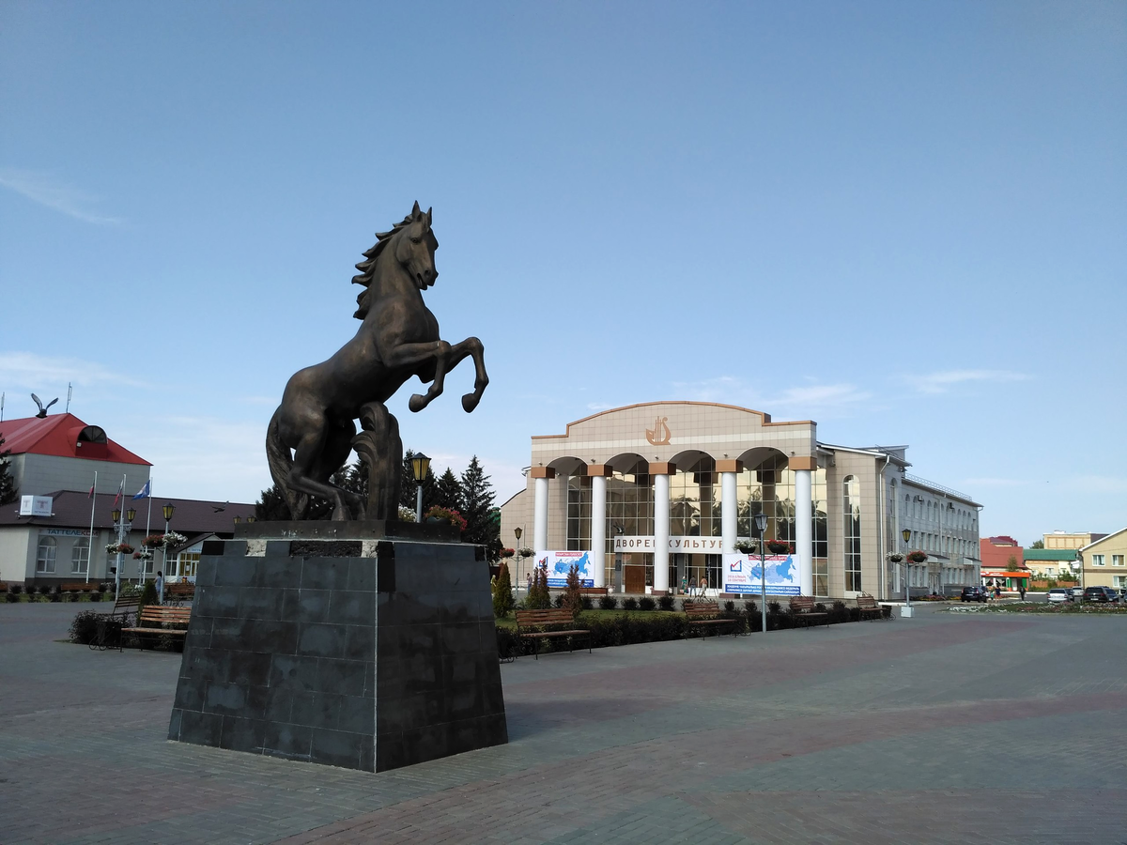
The district administrations, which are the local organs of state power, often choose to centralize all tax revenue and other budget funding. In such cases, local self-government councils can only list expenditures for wages in their budget. This is the situation when all available means are used for solving problems on the district level, and local self-governments receive any funds not taken up by the district the so called “left over principle.” That’s basically what happened in the Nurlat District, where the administration failed to comply with Article 23 of the law “On the Budget System of the Republic of Tatarstan for 2001,” which stipulated that some of the tax revenue raised on a local self-government’s territory should be handed over to that local self-government. In fact, the district administration never handed over any taxes at all to any of the 26 local self-government councils in Nurlat. The administration did not leave the local self-governments penniless: It gave them subsidies from the district budget, but that method of financing is actually a convenient way of “taming” the local self-government leaders. Therefore, as experts point out, it is necessary to define clearly the structure of local self-government budget revenue and the minimal share of taxes that can be allocated to them by the local Soviets. Until that is done, local funding basically depends on the attitude of the head of the district administration toward local self-government organs.
Currently, most local self-government organs are dependent on the heads of local administrations, just as the former village Soviets were dependent on the chairmen of the collective farms. And just like the old farm chairmen, today’s local administration heads are unwilling to yield any of their power, which is linked, as usual in Russia, with property and other benefits. Analysts note that the local state powers give local self- government organs only what is absolutely necessary - such as the wages for the members of the local self- government staff - plus what the administration heads can, or more precisely wish, to concede, on the basis of their good will or personal relations with the local self-government members.
According to Tatarstan’s Finance Ministry, even if 100 percent of the taxes due to local self-governments were handed over, it would still not be enough to cover the budgets of some of them, because of the discrepancies in the taxable bases of different territories. For instance, in the Bugulminsk District, 100 percent of the property tax yielded just 10,000 rubles, whereas in the Petrichinsk District, only 16 percent of that tax amounted to 410,000 rubles. Such problems came up in preparing the bill “On the Financial Base of Local Self-Governments.” For example, there was a question of how to deal with the existing differences in territories not only in their economic, but also demographic, ethnic and natural characteristics. Policy makers wanted to provide fair financing for all the local self-government organs, so that a doctor or a teacher in one locality should not subsist on minimum wages while their colleagues in other areas receive an adequate income. That obviously required a more flexible approach to the distribution of financing than simply guaranteeing equal shares of the local tax revenue for all local self-government organs. Another problem is the shortage of personnel specially trained for work in local self-government: Out of 1,742 local self-government organ chairmen and their deputies working on a permanent basis, 33.5 percent have higher education or unfinished higher education, and 48.3 percent have secondary education or vocational training. But there are too few economists, lawyers and specialists in municipal management among the leaders of local self-government organs. And yet it is clear that the practical realization of local self-government rights and powers depends on the presence of adequate managerial staff with some legal knowledge. There is some awareness of this problem in Tatarstan: With its developed network of good colleges, the republic has done a lot to train, or re-train personnel for local self-government. There are special courses functioning under the Republic of Tatarstan’s State Council, as well as local self-government and sabbatical courses, run by the Institute of Civil Service, to train local self-government organs’ chairmen and their deputies. Some of the leading personnel in local self-government are enrolled as corresponding students of the Kazan Technological University, the Tatar-American Regional Institute and the Almetiev Municipal University.
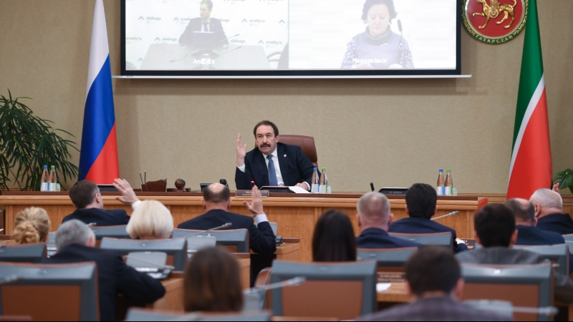
Other efforts are being made toward improving the situation of local self government organs. The commission of State Institutions and Local Self-Government in the Republic of Tatarstan State Council is preparing a legislative package that is meant to give local self-government organs real powers. That package would include a bill on reserving certain state functions for the local organs, in particular notary and registrar procedures. There is also a proposal to give local self-government organs some other, financially backed functions, such as maintaining health and education facilities; controlling public utilities, like gas supply; the improvement of the local territory; and even a right to collect local taxes and undertake commercial activities to raise profits that can meet local needs.
In 1999, the Republic of Tatarstan set up a Council on Local Self-Government, which was chaired by the speaker of parliament and included some leading members of the government apparatus, deputies and heads of parliamentary commissions. The council was to provide interaction between the organs of state power and the local self-government organs. To help in this work, the district Coordinating Councils on Local Self- Government were formed in 2000. These councils are supposed to work out the legal and financial relationship between state structures and local self-government organs, to represent the interests of the latter in the legislative and executive organs and to study the experience of local self-government. The Coordinating Councils’ plans for 2001 included the following urgent measures for the development of local self-government:
- Helping to set up a department for the support of local self-government attached to the Cabinet of Ministers and helping to create a fund for the support of local self-government in the republic - an idea that has already been discussed for several years;
- Putting forth proposals for preparing and passing “The State Complex Program of Support for Local Self-Government in the Republic of Tatarstan,” as well as the following laws aimed at the realization of local
self-government in the republic: “On Citizens’ Meetings,” “On Recalling Deputies of the Representative Organs and Officials of Local Self-Government” and “On the Financial Base of Local Self-Government in the Republic of Tatarstan.”
The republic’s Council on Local Self-Government has reportedly discussed the possibility of allowing local self-governments to take over the collection of rent or taxes for: the use of land for summer cottages, the use of mineral resources, the use of roads, hunting and fishing. Specialists point out that the local self- governments can collect such taxes more successfully, which was confirmed in the case of land taxes. After collection was handed over to local self-government organs in 1999, land taxes, which had been collected at 50–60 percent of the estimated value in previous years, were collected at 204 percent of the estimated value.

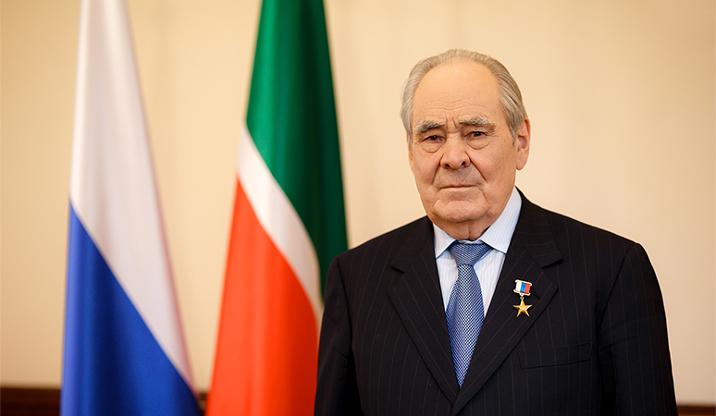
Efforts to Maintain the “Power Vertical”
Though the president’s consolidation of power is a legitimate cause for concern, it has also had some benefits. The local organs of state power, or more precisely the heads of local administrations, formed the core of Shaimiyev’s “power vertical” and helped to keep the republic governable during the most difficult initial period of Russia’s economic and political reforms. In my opinion, that “vertical” played, a positive, rather than negative role, in the 1990s. It helped to shield Tatarstan from the social and economic chaos generally observed during the course of economic and political transition in post-totalitarian Russian society: the massive sales of state property at symbolic prices; the crunch of industrial and agricultural production; the disastrous fall in living standards caused by uncontrolled price rises for basic food products; etc.
But now, instead of favoring a “cautious” pace of reforms, the “power vertical” seems to encourage stagnation of the present transitional forms of economic and political systems in Tatarstan, including the sphere of local self-government. It appears that the “power vertical” is getting out of hand - even the hand of its creator, Shaimiyev. Problems have arisen from within the president’s mainstay - the heads of local administrations - who have begun to acquire their own economic interests and developed certain political activities to maintain their status of local “kings.” A group of local administrators dared to openly manifest their desire to control the political process for the first time in May 1988. The State Council was electing a new speaker, and Shaimiyev proposed Prime Minister F. Mukhametshin. But several deputies tried to rebel against the president’s wishes by seeking to nominate Naberezhniye Chelni’s Mayor R. Altynbayev. He won 50 votes, which was not enough for his election.
There was nothing strange about these rebellious administration heads attempting to become independent political actors. They have absolute power and financial and organizational resources within their districts, and they seek to obtain more. But the president, who appointed the administrative heads to their lucrative posts and can remove them at any time, wants his local leaders to be obedient team members, rather than independent political players. Because their social and political status gives the administrative leaders objectively different interests from the president, their union with Shaimiyev is doomed to disintegration. Yet Shaimiyev is certainly not the sort of leader who would part with a functioning, albeit archaic, “power vertical” without finding an adequate substitute. In the current situation, the structure of the district and city Soviets and administrations resembles the old-fashioned structure of the Communist Party of the Soviet Union’s district committees and Soviets. Although that structure has a certain effectiveness in a totalitarian command system, and even in the transitional period, it cannot adapt well to the current system of changing market relations and emerging democratic institutions (Valeev, 2005). Under modern management theory, the solution to this situation would be to create a different, parallel managerial structure that can take over the functions of the old one. Indeed, it seems that this is what Shaimiyev has in mind. His plans to reform local state and government organs appear to signal the first steps in the creation of a more modern “power vertical” (Sergey, 2020).
In his annual address to the State Council on February 2001, the president clearly pointed out the inadequacy of the style of work and level of professionalism of the republic’s government structures for today’s needs. Shaimiyev could also argue that reform is necessary, because the republic’s law on local self- government has to be brought in line with the federal legislation, which would involve introducing local self- government at the level of administrative districts and large cities. This reform could radically change the status of the administration heads, because their posts would be contested in local elections. Trying to anticipate the direction that the reform will take brings us into the realm of political forecasts, but some current events seem to indicate the president’s future plans: On July 11, 2001, Mukhametshin, the chairman of the republic’s State Council, met with S. Kiriyenko, the Russian Federation president’s envoy in the Volga Federal District. According to official reports, they discussed the alignment of Tatarstan’s laws on local state powers and self-government with federal legislation. Mikhametshin said that, since the federal level still lacks a totally clear conception of local self-government, it would be unreasonable to change anything in Tatarstan, where a system of power organs working in contact with the people has developed. He cited the findings of experts of the Volga Federal District commission on the alignment of regional and federal laws, who supported his position. In the end Mukhametshin and Kiriyenko agreed that the best course for the Republic of Tatarstsan State Council would be to carry on its work in the chosen direction by way of an experiment. On the same night, Mukhametshin met in Moscow with the Russian Federation president’s head of staff, A. Voloshin, and discussed the same issues with him (Sergey, 2020).
It would seem from these actions that Tatarstan’s leadership is trying to maintain the peculiarities of the republic’s political system as long as possible, at least in the relations between the local self-government and state power organs. And, even in the eyes of the federal government, the events in other regions of the Russian Federation justify a conservative approach. Conflicts over power and budget sharing between the mayors of large cities and the regional governors, both in Udmurtia and in Primorye, only harmed the local population, which was supposed to benefit from local self-government. So it seemed that there would not be any speedy, radical change in Tatarstan’s model of the “power vertical,” at least not in the sphere of local self-government. Under the new presidential decree, this situation is changing, as the specialized departments of the local administrations are transformed into territorial branches of the republic’s ministries. For instance, a district or city education department will become a territorial branch of Tatarstan’s Education Ministry and will be financed by the republic’s budget - though the schools and other educational establishments will be financed by the local budget. The process of forming the territorial branches of the ministries is now in full swing, with the help of experts who used to work in the local administrations and therefore understand local problems. Certain changes are being made in the structure of local administrations, to avoid duplication of functions (Farida & Setiawan, 2018).
It is no secret that the misuse of budget money is chronic among local bosses (Farida et al, 2020). An inspection of three districts conducted by the Committee of Parliamentary Control during the period of 1998–2000, found serious breaches in the execution of budget expenditures: Some items were under-financed, others - particularly the item “state government” - were over-financed. Too much was spent on transport services, communications, equipment, capital construction and management and current expenses. In the Arsk district over-financing in these areas amounted to 40.531.000 rubles; in the Kaibitsk district it was 10.042.000 rubles; and in the Muslyum district 14.502.000 rubles. There were also sums spent for purposes that are not supposed to be financed from the district budgets, such as support of livestock breeding, subsidies of animal products and compensation for price rises on mineral fertilizers (Belyaev, 2007). Spending for such inappropriate purposes amounted to 72.352.000 rubles in Arsk, 12.785.000 rubles in the Kaibitsk district and 1,135,000 rubles in the Muslyum district. At the same time, the district administration and the management of state-owned enterprises failed to take adequate measures toward solving urgent problems of repaying debt on outstanding wages. The Arsk district was 21.771.000 rubles behind in wages; the Kaibitsk district was behind 5.789.000 rubles; and the Muslyum district owed 11.414.000 rubles in this category. Furthermore, the district administrations relieved some enterprises and organizations of taxes and duties, in spite of their already sizable debts to budget and non-budget funds (Gabdrakhmanova, 2008).
It is not only budgeting by local administrators that causes concern. Many of the republic’s politicians and experts express the opinion that local administration heads hamper the development of private farms and farm privatization (Sergey, 2020). These leaders obviously have more resources at their disposal as long as the farms remain under state control. The slow pace of private farm development was outlined in a report “On the State and Development of Private Farms in Tatarstan,” which was presented by the deputy-head of the president’s Control Department at a joint meeting with the Committee of Parliamentary Control.9 As of April 1, 2001, the republic’s 1.603 private farms had 2.7 percent of the arable land at their disposal, and they only owned about half that land. These farmers produced about 1 percent of the republic’s agricultural products. The report noted other indicators that agricultural reform in the republic is proceeding slowly: In some districts there are less than 10 farms, in others there are none at all (Andrew, 2015).
The fact is that leaders in local administrations and their commissions, who are responsible for allotting land for private farms, are not fair to beginning farmers. A poll of 26 heads of large state or collective farms showed that 58 percent of all private farmers wishing to go on their own were denied their fair share of land. Many district administrations failed to lease out farm machinery to private farmers from the pool specially reserved for that purpose. They also by-pass private farms when building roads and electric power lines - in defiance of an officially established order. More than 60 percent of the farmers polled say their work is hampered by problems with obtaining long-term credit, and most of them are not happy about their relations with the district administrations (Sergey, 2020).

Epilogue
At present, effective system of local self-government either in Russia as a whole or in Tatarstan, there is not even a clear conception of local self-government that would define its powers and responsibility, its financial base and its relations with other organs of power and government. That conception will probably emerge after the above mentioned delimitation of powers at the federal level between the federal government, the federation’s constituent territories and local self-government. The authorities of Tatarstan insist that, given the population’s limited level of political culture and the problems involved in providing financial independence for self-government organs, there is a need for caution in developing local self-government. Only after ensuring that the basic level of local self-government has the necessary legislative, taxation and personnel backing can local self-government be spread to the larger territorial communities administrative districts and cities. It is important to remember that local self- government is now at the initial stage of its development, and leaders are still searching for its optimal form. The political leadership of Tatarstan also argues that questions of local self-government should be left to the competence of Russia’s constituent territories, because the territories can best sort out the right territorial level where local self-government can start solving the problems of the local population.
In the absence of a clear strategy at the federal level concerning local self-government, the federal center views Tatarstan’s experiments in that sphere rather favorably. The fact that the republic can retain laws on local self-government that are different from the federal ones only shows that the federation’s presidential team has not made a final decision on the basic principles of local self-government, even though the federal law on it was passed back in 1995. It is true that the political and legislative climate was different then many laws were passed under the pressure of the changing political situation both in Russia and in the world. In the case of local self-government, the legal changes were prompted by a desire to join the Council of Europe. In Tatarstan, it seems possible that the changes in the organization of local self-government will be made simultaneously with the changes in the republic’s Constitution, which was expected before the end of 2001.
References:
Andrew, D. (2015). Languages history for official use. Ogon press: Republic Mari-El. pp. 26-56.
Belyaev, V.A. (2007). Worldview and social behavior of the ruling elite of Tatarstan. Social
sciences and modernity: Kazan.
Demography Tatarstan. (1995). Goscomstat RT (Demographia Yazykom Tsifr). Tatarskiye
kraya, No. 30.
Djokic, A. (2020). The Perspectives of Russia’s Soft Power in The Western Balkans Region.
RUDN Journal of Political Science, 22, (2). 231-244. doi: 10.22363/2313-1438-2020-22-2-231-244
Dolzhikova, A.V., & Moseykina, M.N. (2020). Institutions and Educational and Cultural Tools
of Migration Policy in Modern Russia. RUDN Journal of Political Science. Vol. 22 (3). 387-400. doi: 10.22363/2313-1438-2020-22-3-387-400
Farida, I., Setiawan, R. (2018). Leadership In Cope With Prostitute In Social Department of
Bandar Lampung. International Journal of Social Sciences And Development, 2 (1). 1-8. http://dx.doi.org/10.24967/saburaiijssd.v2i1.325
Farida, I., Setiawan, R., Maryatmi, A.S., & Juwita, M.N. (2020). The Implementation of E-
Government in The Industrial Revolution Era 4.0 in Indonesia. International Journal of Progressive Sciences and Technologies. Vol. 22 (2).
Gabdrakhmanova, G.F. (2008). We are they (attitude towards migrants in the Republic of
Tatarstan). Sotsiol: Kazan.
Iskhakov, D.M.. (1997). “Modern Tatar Nationalism” (Sovremenniy nationalism tatar)
//Panorama- Forum, No. 13.
Sergey, S. (2020). The Republic of Tatarstan: Reduced to a Common Denominator?. Russian
Politics & Law. Vol 56 (36). 222-235. doi:10.1080/10611940.2019.1784627
Setiawan, R. (2017). Partisipasi Publik Dalam Program Bantuan Listrik Pedesaan Masyarakat
Kabupaten Mesuji. Jurnal Kebijakan & Pelayanan Publik (e-JKPP), 3, (3). 82-92.
Setiawan, R. (2016). Peranan Etika Aparatur Sipil Negara Dalam Pelayanan Publik Pada Dinas
Kependudukan Dan Catatan Sipil (Disdukcapil) Kota Bandar Lampung. Jurnal Kebijakan & Pelayanan Publik (e-JKPP), 2 (2), 46-57.
The Republic of Tatarstan. (1996). Collected Statistics (Statistichesky sbornik). Kazan. Karpol.
p.18.
Valeev, R. (2005). Tatars at home. Kazan Press: Kazan.
Zubarevich, N. (2018). The Center–Regions Relationship: What Has Changed in Four Years of
Crisis?. Russian Politics & Law, 56 (36), 208-221. doi: 10.1080/10611940.2019.1784626

