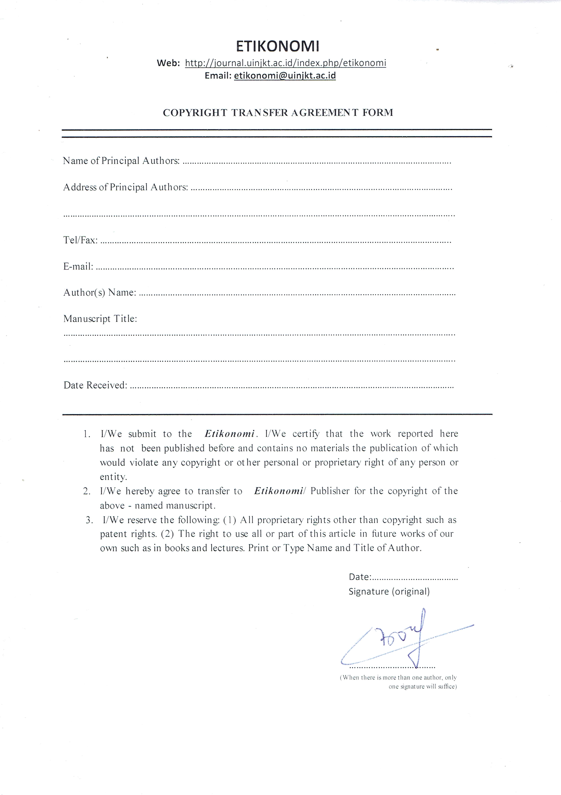
Boulila Hadjer
1060 lgt building D appartment n°14, Imama , Mansourah, Tlemcen, Algeria
+213659287147
b.hadjer94@gmail.com / mbenbouziane@yahoo.fr

Boulila Hadjer and Benbouziane Mohamed
Austerity in time of crisis, a solution or a dangerous idea ? evidence from algeria
15/01/2018
15/01/2018

