**ETIKONOMI**

**Web:** <http://journal.uinjkt.ac.id/index.php/etikonomi>

**Email:** [**etikonomi@uinjkt.ac.id**](mailto:etikonomi@uinjkt.ac.id)

Name of Principal Authors: Fanglin Li……………………………………………

Address of Principal Authors: School of Finance & Economics, Jiangsu University, China

Tel/Fax: +8618605248837…………………………………………

E-mail: 5103181209@stmail.ujs.edu.cn…………………………………………………

Author(s) Name: Michael Appiah

Benjamin Korankye

Manuscript Title:

**Financial Development and Economic Sustainability in ECOWAS Countries; the role of Institutional Quality**

Date Received: 13th December, 2019

1. I/We submit to the ***Etikonomi*** . I/We certify that the work reported here has not been published before and contains no materials the publication of which would violate any copyright or ot her personal or proprietary right of any person or entity.
2. I/We hereby agree to transfer to ***Etikonomi***/ Publisher for the copyright of the above - named manuscript.
3. I/We reserve the following: (1) All proprietary rights other than copyright such as patent rights. (2) The right to use all or part of this article in future works of our own such as in books and lectures. Print or Type Name and Title of Author.

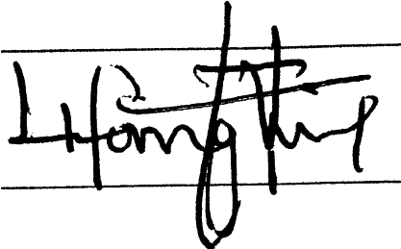Date:………………………………

Signature (original)

…

………

…

……

…

……

…

…

(

W

h

en

t

h

e

r

e

is

m

o

r

e

th

a

n

o

n

e

a

u

th

o

r

,

on

l

y

o

n

e

s

i

g

n

at

u

r

e

w

i

l

l

s

u

f

f

ic

e

)

