Suplementary Files Technology Acceptance Model (TAM) Terhadap Penggunaan Aplikasi Gojek Pada Mahasiswa Di Kota Palembang

- Orisinalitas Penelitian
Orisinalitas adalah hal yang penting dalam membuat sebuah karya, terutama pada karya akademik. Penelitian ini didasari oleh penelitian dari Rena Eka Setyawati yang membahasa tentang pengaruh usefulness dan ease of use terhadap behavioural intention of use melalui attitude towards using sebagai variabel intervening dan penelitian Widyananda, et. al yang membahas tentang analisis faktor-faktor minat menggunakan situs berita suara.com dengan sikap penggunaan sebagai variabel intervening.
Namun, terdapat perbedaan antara penelitian ini dengan dua penelitian tersebut, yakni pada variabel interveningnya. Kedua penelitian tersebut meneliti niat perilaku penggunaan (behavioural intention of use) dengan sikap perilaku penggunaan (attitude toward using)sebagai variabel intervening, sedangkan penelitian ini menjadikan niat perilaku penggunaan sebagai variabel intervening.
- Uji Full Model SEM
Gambar 1. Model Full SEM

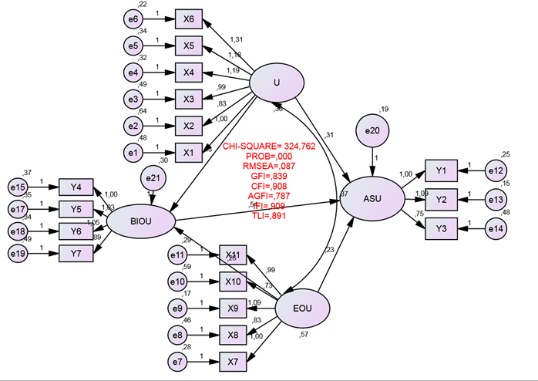

Tabel 1. Hasil Uji Kelayakan Full Model SEM

Goodness of Fit Index | Cut-off Value | Hasil Model | Keterangan
t² | χ2 Hitung Diharapkan kecil dari χ2 Tabel | 324,762 | Poor Fit
Probability | >0,05 | 0,000 | Poor Fit
RMSEA | >0,08 | 0,087 | Good Fit
GFI | >0,90 | 0,839 | Marginal Fit
AGFI | >0,90 | 0,787 | Marginal Fit
CMIN/DF | <2,00 | 2,518 | Marginal Fit
TLI | >0,95 | 0,891 | Marginal Fit

Tabel 2. Assessment of Normality

Variable | Min | Max | Skew | c.r. | Kurtosis | c.r.
Y7 | 1,000 | 4,690 | -,059 | -,341 | -,264 | -,763
Y3 | 1,000 | 4,780 | -,515 | -2,975 | -,694 | -2,004
Y2 | 1,000 | 5,200 | -,213 | -1,229 | -,389 | -1,122
Y1 | 2,000 | 5,867 | -,226 | -1,302 | -,533 | -1,538
X6 | 1,000 | 4,727 | -,277 | -1,602 | -,470 | -1,357
X5 | 1,000 | 5,212 | -,200 | -1,155 | -,349 | -1,007
X4 | 1,000 | 4,985 | -,181 | -1,043 | -,361 | -1,041
X3 | 1,000 | 5,396 | -,067 | -,385 | -,268 | -,774
X2 | ,000 | 5,058 | -,205 | -1,181 | ,294 | ,849
X1 | 1,000 | 4,924 | -,218 | -1,256 | -,425 | -1,228
X11 | 1,000 | 4,767 | -,244 | -1,411 | -,006 | -,016
X10 | 1,000 | 5,154 | -,210 | -1,213 | -,116 | -,334
X9 | 1,000 | 4,820 | -,259 | -1,493 | -,218 | -,630
X8 | 1,000 | 5,255 | -,041 | -,240 | -,182 | -,525
X7 | 1,000 | 4,705 | -,309 | -1,785 | -,311 | -,899
Y6 | 1,000 | 4,939 | -,147 | -,848 | -,365 | -1,055
Y5 | 1,000 | 5,203 | -,075 | -,434 | -,271 | -,781
Y4 | 1,000 | 5,212 | -,191 | -1,102 | -,415 | -1,198
Multivariate |  |  |  |  | 97,527 | 25,701
Sebuah dimensi dikatakan normal jika angka critical ratio (c.r) skewness atau kurtosisnya berada diantara rentang –2,58 hingga ± 2,408. Berdasarkan tabel dapat dilihat bahwa data terdistribusi tidak normal karena melebihi 2,58. Namun, Waluyo menyatakan bahwa program AMOS telah menyediakan fasilitas ”warning” pada monitor jika model tidak dapat dilanjutkan. Dari hasil output penelitian ini tidak terdapat “warning” yang muncul, sehingga meskipun data berdistribusi tidak normal, pengolahan dan analisis data tetap dapat dilanjutkan.
Tabel 3. Mahalanobis Distance

Observation number | Mahalanobis d-squared | p1 | p2
152 | 77,575 | ,000 | ,000
51 | 55,207 | ,000 | ,000
42 | 50,659 | ,000 | ,000
150 | 50,434 | ,000 | ,000
4 | 45,902 | ,000 | ,000
196 | 44,131 | ,001 | ,000
86 | 43,716 | ,001 | ,000
198 | 43,472 | ,001 | ,000
189 | 41,636 | ,001 | ,000
98 | 40,802 | ,002 | ,000
88 | 40,342 | ,002 | ,000
163 | 40,026 | ,002 | ,000
37 | 39,319 | ,003 | ,000
121 | 37,920 | ,004 | ,000
197 | 37,867 | ,004 | ,000
46 | 36,752 | ,006 | ,000
162 | 36,493 | ,006 | ,000
182 | 35,358 | ,009 | ,000
170 | 35,170 | ,009 | ,000
34 | 34,022 | ,013 | ,000
20 | 33,630 | ,014 | ,000
119 | 32,376 | ,020 | ,000
181 | 32,284 | ,020 | ,000
5 | 32,221 | ,021 | ,000
187 | 32,192 | ,021 | ,000
73 | 32,145 | ,021 | ,000
171 | 29,854 | ,039 | ,000
3 | 29,514 | ,042 | ,000
12 | 29,063 | ,048 | ,000
188 | 28,449 | ,056 | ,000
115 | 28,200 | ,059 | ,000
102 | 28,144 | ,060 | ,000
135 | 27,680 | ,067 | ,000
183 | 27,471 | ,071 | ,000
58 | 26,855 | ,082 | ,000
59 | 26,682 | ,085 | ,000
156 | 26,183 | ,096 | ,000
83 | 25,822 | ,104 | ,000
77 | 25,705 | ,107 | ,000
190 | 25,612 | ,109 | ,000
53 | 25,115 | ,122 | ,001
158 | 24,189 | ,149 | ,013
56 | 23,990 | ,155 | ,016
7 | 23,583 | ,169 | ,037
148 | 23,436 | ,174 | ,040
2 | 23,294 | ,180 | ,042
192 | 23,263 | ,181 | ,031
111 | 22,920 | ,194 | ,061
193 | 22,659 | ,204 | ,091
107 | 22,631 | ,205 | ,072
199 | 22,191 | ,224 | ,163
195 | 22,184 | ,224 | ,128
116 | 22,139 | ,226 | ,109
164 | 22,087 | ,228 | ,094
136 | 22,066 | ,229 | ,074
70 | 21,735 | ,244 | ,135
172 | 21,697 | ,246 | ,114
1 | 21,611 | ,250 | ,110
71 | 21,581 | ,251 | ,090
65 | 21,561 | ,252 | ,071
92 | 21,435 | ,258 | ,077
178 | 21,394 | ,260 | ,065
69 | 21,046 | ,277 | ,132
13 | 20,697 | ,295 | ,241
79 | 20,555 | ,302 | ,267
184 | 20,133 | ,325 | ,471
186 | 19,918 | ,337 | ,556
126 | 19,754 | ,347 | ,606
49 | 19,749 | ,347 | ,551
64 | 19,733 | ,348 | ,503
142 | 19,360 | ,370 | ,694
194 | 19,333 | ,372 | ,658
80 | 19,310 | ,373 | ,618
32 | 19,101 | ,386 | ,699
74 | 18,904 | ,398 | ,767
153 | 18,857 | ,401 | ,747
8 | 18,639 | ,414 | ,819
14 | 18,417 | ,429 | ,880
200 | 18,083 | ,450 | ,950
143 | 17,975 | ,457 | ,956
35 | 17,931 | ,460 | ,950
91 | 17,931 | ,460 | ,933
155 | 17,842 | ,466 | ,936
87 | 17,814 | ,468 | ,924
81 | 17,398 | ,496 | ,981
167 | 17,243 | ,506 | ,987
63 | 17,130 | ,514 | ,990
17 | 16,895 | ,530 | ,996
84 | 16,863 | ,533 | ,995
44 | 16,803 | ,537 | ,994
19 | 16,551 | ,554 | ,998
43 | 16,537 | ,555 | ,997
117 | 16,303 | ,571 | ,999
94 | 16,259 | ,574 | ,999
157 | 16,132 | ,583 | ,999
185 | 16,123 | ,584 | ,999
48 | 15,922 | ,598 | 1,000
141 | 15,895 | ,600 | ,999
78 | 15,880 | ,601 | ,999
128 | 15,795 | ,607 | ,999

Tabel 4. Regression Weights pada Full Model SEM

 |  |  |  |  | Estimate |  | S.E. |  | C.R. |  | P |  | Label
BIOU | <--- |  | EOU |  | ,259 | ,132 |  | 1,964 |  | ,049 |  | par_3
BIOU | <--- |  | U |  | ,427 | ,160 |  | 2,675 |  | ,007 |  | par_5
ASU | <--- |  | EOU |  | ,233 | ,112 |  | 2,087 |  | ,037 |  | par_1
ASU | <--- |  | U |  | ,308 | ,142 |  | 2,172 |  | ,030 |  | par_2
ASU | <--- |  | BIOU |  | ,538 | ,090 |  | 5,984 |  | 000 |  | par_4
Y4 | <--- |  | BIOU |  | 1,000
Y5 | <--- |  | BIOU |  | 1,025 | ,103 |  | 9,917 |  | 000 |  | par_7
Y6 | <--- |  | BIOU |  | 1,045 | ,101 |  | 10,305 |  | 000 |  | par_8
X7 | <--- |  | EOU |  | 1,000
X8 | <--- |  | EOU |  | ,832 | ,080 |  | 10,389 |  | 000 |  | par_9
X9 | <--- |  | EOU |  | 1,093 | ,072 |  | 15,164 |  | 000 |  | par_10
X10 | <--- |  | EOU |  | ,732 | ,086 |  | 8,491 |  | 000 |  | par_11
X11 | <--- |  | EOU |  | ,986 | ,075 |  | 13,104 |  | 000 |  | par_12
X1 | <--- |  | U |  | 1,000
X2 | <--- |  | U |  | ,830 | ,119 |  | 7,007 |  | 000 |  | par_13
X3 | <--- |  | U |  | ,985 | ,118 |  | 8,318 |  | 000 |  | par_14
X4 | <--- |  | U |  | 1,192 | ,123 |  | 9,655 |  | 000 |  | par_15
X5 | <--- |  | U |  | 1,177 | ,126 |  | 9,351 |  | 000 |  | par_16
X6 | <--- |  | U |  | 1,308 | ,128 |  | 10,195 |  | 000 |  | par_17
Y1 | <--- |  | ASU |  | 1,000
Y2 | <--- |  | ASU |  | 1,087 | ,069 |  | 15,811 |  | 000 |  | par_18
Y3 | <--- |  | ASU |  | ,749 | ,077 |  | 9,742 |  | 000 |  | par_19
Y7 | <--- |  | BIOU |  | ,892 | ,105 |  | 8,470 |  | 000 |  | par_20

Gambar 2. Hasil dari Modification Indices

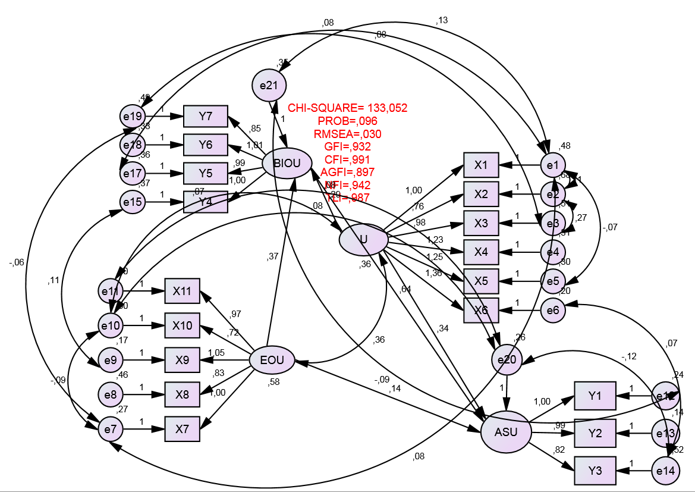

Tabel 5. Hasil Evaluasi Kriteria Goodness of Fit

Goodness of Fit Index | Cut-off Value | Hasil Model | Keterangan
t² | χ2 Hitung Diharapkan kecil dari χ2 Tabel | 133,052 | Poor Fit
Probability | >0,05 | 0,960 | Good Fit
RMSEA | >0,08 | 0,087 | Good Fit
GFI | >0,90 | 0,932 | Good Fit
AGFI | >0,90 | 0,897 | Marginal Fit
CMIN/DF | <2,00 | 1,777 | Good Fit
TLI | >0,95 | 0,987 | Good Fit
CFI | >0,95 | 0,991 | Good Fit

Minto Waluyo, Mudah Cepat Tepat Penggunaan Tools Amos dalam Aplikasi SEM, (Jawa Timur: UPN Veteran, 2016), hlm. 69

