Available online at

**EDUSAINS**

*Center For Science Education*

Journal homepage : http://journal.uinjkt.ac.id/index.php/edusains

**EDUSAINS Volume 11 Nomor 02 Tahun 2019**

**Research Article**

**EXPLORING STUDENTS' PROBLEM-SOLVING SKILLS ON DIRECT CURRENT ELECTRICAL IN VOCATIONAL HIGH SCHOOL**

**Luh Sukariasih1, Erniwati1, La Tahang1**

1Department of Physics Education, Universitas Halu Oleo

Luh.sukariasih@uho.ac.id, 085218232800

|  |  |
| --- | --- |
| **Abstract** | This research aimed to explore the problem-solving skills of Vocational High School 1 Kendari students in direct current electricity. The research used the descriptive-quantitative method, and the research sample was twelve science-grade students in Vocational High School 1 Kendari. The research instruments already used as several questions and problem-solving skills had 0,88 validity. Data collections were tests and interviews. The result was analyzed using the indicator of problem-solving already by Docktor & Heller. The result has obtained problem-solving skills with low criteria. This phase included an accurate description in 61% of higher criteria, a physics approach in 33%, and a specific application of physics in 26% of low criteria. On the other hand, mathematical procedures 22% and logical progression 16% were included as very low criteria. Students need help untangling electrical circuits in series or parallel and applying Kirchhoff's I and II laws. The problem of applying mathematical procedures was algebra and fractions in electrical circuits. This research can be used to improve students' problem-solving ability on direct current electrical material for Vocational high school physics subjects. |
| **Keywords** | ability; direct current; physics; problem-solving. |
| **Abstrak** | Penelitian ini bertujuan untuk mengetahui kemampuan pemecahan masalah siswa SMK 1 Kendari pada mata pelajaran listrik arus searah. Penelitian ini menggunakan metode deskriptif-kuantitatif, dan sampel penelitiannya adalah dua belas siswa kelas IPA di SMK Negeri 1 Kendari. Instrumen penelitian yang digunakan berupa beberapa soal dan keterampilan pemecahan masalah memiliki validitas 0,88. Pengumpulan data dilakukan dengan tes dan wawancara. Hasilnya dianalisis dengan menggunakan indikator pemecahan masalah yang sudah dikembangkan oleh Docktor & Heller. Hasilnya diperoleh keterampilan pemecahan masalah dengan kriteria rendah. Fase ini mencakup deskripsi akurat pada 61% kriteria tinggi, pendekatan fisika pada 33%, dan penerapan fisika spesifik pada 26% kriteria rendah. Sedangkan prosedur matematika 22% dan perkembangan logika 16% termasuk dalam kriteria sangat rendah. Siswa memerlukan bantuan untuk mengurai rangkaian listrik secara seri atau paralel dan menerapkan hukum Kirchhoff I dan II. Masalah penerapan prosedur matematika adalah aljabar dan pecahan dalam rangkaian listrik. Penelitian ini dapat digunakan untuk meningkatkan kemampuan pemecahan masalah siswa pada materi listrik arus searah pada mata pelajaran fisika SMK. |
| **Kata Kunci** | Kemampuan; arus searah; fisika; pemecahan masalah. |

**Permalink/DOI:** [.....................]

**INTRODUCTION**

The ability to solve the problem was one of the educational aspects demanded in the 21st century. Problem-solving skills are an essential target of education because they can teach students to solve their daily problems (Kim & Md-Ali, 2017; Retnawati, Djidu, Kartianom, Apino, & Anazifa, 2018). The experts consider problem-solving a key learning process, especially in science and mathematics (Anderson & Krathwohl, 2015).

Problem-solving ability involves the roles of teachers and students. The teacher was expected to be a facilitator, assisting or scaffolding students to practice their problem-solving skills (Retnawati et al., 2019). Problem-solving in Physics is used to understand physics and is an excellent strategy for proving students' abilities (Docktor et al., 2016; Riantoni, Yuliati, Mufti, & Nehru, 2017).

The practice of problem-solving was a major factor in education and technology, especially in physics education. In physics education, problem-solving is used to understand physics and the right strategy to prove students' problem-solving abilities (Riantoni et al., 2017). Problem-solving ability is used in physics learning as a teaching mechanism. It assesses whether the concept has been studied, deeply understands the concepts of physics, and recognizes how to connect them so that students can solve physics problems (Yulianti, Riantoni, & Mufti, 2018).

The nature of physics is curiosity about a natural phenomenon or objects that create new problems. It can be solved by the scientific method, which includes the preparation of hypotheses, planning or experiments, evaluation, drawing conclusions, and discovering theories and concepts. Physics is a subject that not only memorizes calculations, but the concepts in physics also need more understanding. In physics learning, accuracy, and logical thinking skills are needed because physics learning is based on observations and problem-solving activities (Docktor, Strand, Mestre, & Ross, 2015).

Direct current electrical is one of the physics materials related to problem-solving. Direct current electrical is an abstract material, and it was highly complex to apply electrical problem-solving in various types (Riantoni et al., 2017). Direct electrical concepts such as Ohm's Law, resistance, current, and tension in parallel series, and Kirchhoff's Law were prerequisite concepts that must be understood in problem-solving (Riantoni et al., 2017; Yulianti et al., 2018).

However, they were difficult for students to master the concepts regarding direct current electricity. Students are difficulty drawing and interpreting electrical circuits (Riantoni et al., 2017). Another difficulty was determining the resistivity of lamps connected in series and parallel (Yulianti et al., 2018).

Students are challenged to solve problems because they do not understand the basic concepts of problem-solving (McNeill, Douglas, Koro‐Ljungberg, Therriault, & Krause, 2016; Yadav, Subedi, Lundeberg, & Bunting, 2011). When solving the problem, students were not motivated to find the basic concepts but only look at the formulas and examples they had worked on before without understanding the deep structure of relevant concepts and principles (Ding, Reay, Lee, & Bao, 2011). Students tend to memorize formulas given by the teacher without understanding the physical meaning of each formula and only focus on the problem-solving results, not the problem-solving process (Buteler & Coleoni, 2016). This process means solving problems with controlled activities to achieve the target or solution (Çalişkan, Selçuk, & Erol, 2010; Ridhwan, Sumarmi, Ruja, Utomo, & Sari, 2019).

Problem-solving strategies taught mainly by school teachers focus on solving problems requiring only mathematical calculations. The measurement of students' abilities was only assessed from the final results. When students succeed in answering questions correctly, students are considered to have mastered the concept without needing to review the process to get the final result (Harun, Abdullah, Wahab, & Zainuddin, 2017).

Students' difficulty in solving problems was due mainly to a lack of practice. The next challenge was the need to give problem-solving questions. Problem-solving abilities can be improved if students are accustomed to facing problems, and a problem-solving process is needed to find solutions to these problems (Kim & Md-Ali, 2017).

Students' problem-solving ability can be checked in terms of their success in solving physics problems, which is related to the assessment of learning outcomes through tests, written tests, multiple-choice, and essays. In problem-solving, the steps or strategies carried out by each student are different in solving problems even though the issues faced by the students were the same depending on each individual (Arifin, Sholeh, Hafiz, Agustin, & Wardana, 2021; Hsbollah & Hassan, 2022). Therefore, solving a problem requires a systematic step until the process becomes efficient and effective.

In problem-solving, the steps or strategies taken by each student were different in solving problems, even though the problems faced were the same. This case depends on the ability of each individual. Solving a problem requires systematic steps to make problem-solving easy and direct (Hsbollah & Hassan, 2022). Complex processes such as problem-solving were assessed using a rubric (Çalişkan et al., 2010; Docktor et al., 2016).

In addition, complex problem-solving processes were assessed using five categories, first, helpful description; second, physics approach; third, specific application of physics; fourth, mathematical procedure; and fifth, logical progression. The process of solving the problems in each indicator was essential to analyze.

Based on the observations at Vocational High School 1 Kendari District conducted during the Covid-19 epidemic, teachers and students faced obstacles, such as the tendency of students to be less active in online physics learning activities. Learning activities were passive, with explanations and assignments or questions only. Students only see the learning material with the target so they can answer the assignments or questions without understanding the problem-solving process.

The fact in observation results shows that there was a tendency for students to be less active in learning physics which makes students difficult when dealing with complex physics problems. Passive students need help mastering problem-solving abilities or learning objectives (Hsbollah & Hassan, 2022; Umar & Ahmad, 2010). At the same time, the activeness of students in the learning process interaction can affect the success of the learning outcome target (Mohd Radzi, Tan, & Yusoff, 2019; Sejati, Kasmiati, & Ikhsan, 2019).

The level of a student's ability to solve physics problems affects the learning outcomes achieved. So, there is an effort to explore students' problem-solving abilities in learning physics, especially direct current electrical, through tests and measurement of problem-solving abilities using a problem-solving rubric, which involves students directly in problem-solving. Therefore, the researcher conducted the study exploring students' problem-solving ability on direct current electrical in Vocational high school.

Previous research has been identified applied to explore the student's problem-solving skills in various ways (Demir, 2021; Martaningsih et al., 2022). The research (Arifin et al., 2021) using interactive multimedia based on scientific inquiry to improve student problem-solving in mathematics subject. The research used Agile Method to use software. The research involved 120 students Madrasah Ibtidaiyah Teacher Education Department in The Universitas Muhammadiyah Sidoarjo, East Java, Indonesia. Interactive Mobile Mathematics Inquiry's research results were valid and proven to improve the student's problem-solving ability.

Research (Yulianti et al., 2018) explore the student's problem-solving skills through inquiry-based learning with PhET simulation in the direct current electricity matter. The research uses a mixed method that involves 34 physics teachers in the Universitas Negeri Jambi, Indonesia. Tests and interviews collect data, then analyzed by the Kruskal Wallis test and rubric. The research results showed that many students who applied the scientific approach had better problem-solving skills than another approach.

Research (Riantoni et al., 2017) identifies the approach used to problem solving by determining and interpreting resistive in electrical energy and power test. The research subject is a student in physics education who joined a basic physics class at the Universitas Jambi, Indonesia. The research showed that many students needed a clearer, memory-based approach to solve the problem. The students did not use the physics concepts to solve the problem and only used the equation they memorized.

This research was different from previous research in exploring problem-solving ways. This research used the essay test question and analyzed it based on the scores and problem-solving indicators that had never been done before. This research was a basic analysis in various ways, such as prototypes, learning mobile, and PhET simulation. This research aimed to explore the problem-solving skills of Vocational high school 1 Kendari students in direct current electricity.

**METHOD**

The design of the research was quantitative descriptive. The research quantitatively described the problem-solving ability in the direct current electricity matter, physics subject. Descriptive research was used in this study which seeks to describe the characteristics of the object systematically to be studied appropriately. The independent variable was a physics test or question for direct current electricity. The dependent variable was students' problem-solving ability and difficulties in direct current electricity.

The population of the research was 47 students in XII class in Vocational High School 1 Kendari. All students in class XII Computer Technique and Informatics 1 and XII Computer Technique and Informatics 2 were a sample or the saturated sample. The school location is in Kendari City, Southeast Sulawesi Province, Indonesia. The research was conducted in the odd semester of the 2020/2021 academic year from September 28, 2020, to October 3, 2020.

The instrument was an essay test question. The distributions of question topics were question 1 about the parallel series concept, question 2 about parallel series and Ohm's Law, question 3 about Ohm's Law, question 4 about Kirchoff's Law II, and question 5 about Kirchoff's Law I and II. The research instruments already used as several questions and problem-solving skills had 0.88 from 1.00 validity. The validity test results were calculated by calculating the rater agreement with the Aiken index. The results of the validity test (V) with three expert validators (V1, V2, and V3) are shown in Table 1.

Tabel 1. The Result of The Validity Problem-solving Ability Test

|  |  |  |  |  |  |  |  |  |
| --- | --- | --- | --- | --- | --- | --- | --- | --- |
| **Question Number** | **Rated Aspect** | | | | | | | |
| **Content** | | | | **Language and Writing** | | | |
| **Score** | | | **V** | **Score** | | | **V** | |
| **V1** | **V2** | **V3** | **V** | **V1** | **V2** | **V3** | **V** | |
| 1 | 5 | 5 | 4 | 0,92 | 5 | 5 | 4 | 0,92 | |
| 2 | 5 | 5 | 4 | 0,92 | 3 | 5 | 4 | 0,75 | |
| 3 | 4 | 5 | 4 | 0,83 | 4 | 5 | 4 | 0,83 | |
| 4 | 5 | 5 | 5 | 1 | 4 | 5 | 3 | 0,75 | |
| 5 | 5 | 5 | 5 | 1 | 5 | 5 | 3 | 0,83 | |
| Index | 0,93 | | | | 0,82 | | | |
| Final Deal Index | 0,88 | | | | | | | |

The procedures carried out in this study include the preparation, implementation, and final stages. First, the preparation stage consists of six steps. First, prepare the instruments to be used in conducting research. Second, perform an instrument validation test before it is used in research. A validation test was carried out to determine the validity of the direct current electrical material test. Third, the researcher prepares the research design, determines the research location, makes an observation permit approved by the institution, and asks the school for permission to make observations.

Fourth, researchers conducted preliminary observations at Vocational High School 1 Kendari to determine the school's state, the number of subjects to be used, and the research time. Fifth, researchers interviewed physics teachers about learning physics at school and the problems in physics lessons. Sixth, researchers prepare classes to be used as research sites considering testing class tests with 15 students per class and complying with health protocols during the covid-19 pandemic.

The Implementation phase consists of seven steps. First, the researcher directs students to sit in the place provided by adjusting the distance according to the health protocol. Second, as supervisors of test testing, teachers and researchers explain the procedure for working on the test by providing examples. Third, researchers give description test questions to students according to the predetermined sample class. Fourth, researchers give students a 90-minute problem-solving test. Fifth, researchers checked the results of the students' problem-solving description test answers. Sixth, list the student's answers whose problem-solving abilities are based on scores on the test and use the rubric of problem-solving indicators. Seventh, interviewing several students with qualified problem-solving skills with high, medium, low, and very low criteria. Furthermore, interviews were conducted directly with students.

The final stage consists of two steps. First, perform data analysis from the data obtained. In the data analysis stage, the test result data will be analyzed and processed by the researcher and described in tables and diagrams. Second, discuss by describing and making conclusions based on the research data obtained and interviews conducted.

Data collections were tests and interviews. The test is designed to analyze students' problem-solving abilities and difficulties in direct current electricity material. In contrast, the tests are given by giving questions in the form of descriptions that contain electrical circuit drawing questions.

The interview is structured. Each student is given the same question, and the researcher knows the information based on the research aim. The interviews to determine students' problem-solving abilities by asking questions about students' answers with problem-solving indicators. The interviews to learn about students' difficulties with direct current electricity material.

Data analysis techniques were related to students' problem-solving abilities based on students' answers in tests and interviews. The results of students' problem-solving abilities were analyzed based on the scores and problem-solving indicators. To determine the level of problem-solving abilities of students obtained was compared with Table 2, which shows the range of test results value and (Sugiyono, 2016). Then in Table 3 shows the percentage of indicators of problem-solving ability (Docktor et al., 2016).

Table 2. Range of Test Result

|  |  |  |
| --- | --- | --- |
| **Nu.** | **Value** | **Criteria** |
| 1 | 0 – 19 | Very low |
| 2 | 20 – 35 | Low |
| 3 | 36 – 59 | Middle |
| 4 | 60 – 79 | High |
| 5 | 80 – 100 | Very high |

Table 3. Percentage of Problem-solving Ability

|  |  |  |
| --- | --- | --- |
| **Nu.** | **Percentage** | **Criteria** |
| 1 | \0 % < *X* ≤ 25% | Very low |
| 2 | 25 % < *X* ≤ 42% | Low |
| 3 | 42 % < *X* ≤ 58% | Middle |
| 4 | 58 % < *X* ≤ 75% | High |
| 5 | 75 % < *X* ≤ 100% | Very high |

**RESULT AND DISCUSSION**

The data on students' problem-solving ability on the material of direct current electricity was obtained based on the test given on direct current electricity. The data were obtained from 47 students with a maximum value of 65.7, a minimum value of 0.6, an average of 19.2, and a standard deviation of 15.42. The data are shown in Table 4.

Table 4. Value of Problem-solving Ability Test

|  |  |  |  |
| --- | --- | --- | --- |
| **Value** | **Number of students** | **Percentage** | **Criteria** |
| 0 – 19 | 29 | 62% | Very low |
| 20 – 35 | 13 | 28% | Low |
| 36 – 59 | 3 | 6% | Middle |
| 60 – 79 | 2 | 4% | High |
| 80 – 100 | 0 | 0% | Very high |

The results of students' problem-solving abilities were in very low criteria. The data were shown that most students were in very low criteria, with 29 or 62% of all students, and 13 students with low criteria, or 28%. In contrast, the middle to very high was 10%. Three students, or 6%, were in moderate criteria; two students, or 4%, in high criteria; and very high criteria, 0 students, or 0%.

The data obtained for each sub-concept on problem-solving abilities that students can solve is presented in Table 5.

Table 5. Score of Problem-solving Ability for Each Sub-concept

|  |  |  |
| --- | --- | --- |
| Sub concept on test | Maximum score | Average |
| Parallel-series circuit | 20 | 3,01 |
| Parallel-series circuit and Ohm’s law | 19 | 5,63 |
| Ohm’s law | 17,5 | 3,97 |
| Kirchoff’s II law | 17,5 | 3,62 |
| Kirchoff’s I and II law | 26 | 2,97 |

Based on Table 5, students can solve the problem with the highest average score in the parallel series sub-concept and Ohm's law with 5.63. The lowest average score in Kirchoff's Law I and II sub-concepts with 2.97. The students' problem-solving abilities for each indicator are shown in Table 6.

**TABLE 6.**

**PERCENTAGE OF PROBLEM-SOLVING**

|  |  |  |
| --- | --- | --- |
| Indicator of problem-solving ability | Percentage | Criteria |
| Useful Description (UD) | 61% | High |
| Physics Approach (PA) | 33% | Low |
| Specific Application of Physics (SAP) | 26% | Low |
| Mathematical Procedure (MP) | 22% | Very low |
| Logical Progression (LP) | 16% | Very low |
| Average | 32% | Low |

One problem-solving indicator included in the high criteria, UD, with a percentage of 61%, and two indicators with low criteria were PA, with a percentage of 33%, and SAP, with a percentage of 26%. Meanwhile, two indicators with very low criteria were MP, with a percentage of 22%, and LP, with a percentage of 16%. The average ability of students on direct current electrical based on problem-solving indicators was in the low criteria with a percentage of 32%.

A diagram of the relationship between problem-solving and the sub-concept of direct current electrical material is shown in Figure 1.

Figure 1. The Relationship Diagram between Percentage of Problem-solving Ability and Sub-concept of Direct Current Electrical

Based on the diagram in Figure 1, the percentage of students problem-solving for each sub-concept obtained the highest percentage of UD indicators was the Kirchoff II law sub-concept with 71% and the lowest in the parallel series sub-concept series with 38%. For the highest percentage of PA, indicators were the sub-concept of parallel series and Ohm's law with 51%, and the lowest was the sub-concept of Kirchoff's law I and II with 20%.

The highest percentage of SAP indicators was the parallel series sub-concept and Ohm's law, with 40%, and the lowest was the sub-concept of Kirchoff's law I and II, with 14%. The highest percentage of MP indicators was in the parallel series sub-concept and Ohm's law, with 34%, and the lowest was in the sub-concept of Kirchoff's law I and II, with 11%. Meanwhile, the highest percentage of the LP indicators was the sub-concept of parallel series and Ohm's law, with 24%, and the lowest was the sub-concept of Kirchoff's law I and II, with 9%.

**Students' Problem-Solving Ability on Direct Current Electrical**

The ability of Problem-solving of Vocational High School 1 Kendari, XII Science 1, and XII Science 2 on direct current electrical were classified as very low criteria. It can be seen in Table 4, which shows most of the students were in the very low score, with a percentage of 62%, more than half of the students who took the test. In solving problems related to direct current electrical, students got an average score, which was very low compared to the maximum value of each sub-concept, as seen in Table 5. Meanwhile, table 5 explains the lowest average value in Kirchoff's I and II laws sub-concepts. Based on the problem-solving indicators in Table 5, students were good at collecting the information on the Useful Description (UD) indicator with high criteria. Students needed to be higher in applying physics concepts to solve problems; there were physics approaches (PA) and the specific application of physics (SAP).

Meanwhile, other indicators were very low criteria, mathematical procedures (MP), and logical development (LP). It shows that students memorize only a little in applying physics concepts to solve problems (Yulianti et al., 2018). In direct current electrical, many students still need help understanding the basic concepts of electricity, which affects students' ability to solve problems (Riantoni et al., 2017). Students' difficulty in solving electrical problems is due to their low mastery of concepts, lack of mathematics, and the lack of ability to convert units (Arifin et al., 2021; Kim & Md-Ali, 2017). In addition, an issue that becomes an obstacle for students in solving problems in the form of questions in pictures can deceive and reduce student interest in solving problems because it has particular difficulties in analyzing, especially in electrical problems using electrical series pictures (Docktor et al., 2016; Singh et al., 2020).

**The ability of Problem Solving for Sub Concept Based on Problem Solving Indicators Sub-concept of Parallel-Series Circuit**

The ability of students to solve problems in the sub-concept of a parallel series in UD indicator, some students can write the information correctly in the questions. Still, students need to convert kW (kilo-Ohm) to W (Ohm) units, unit conversion errors, writing symbols errors, and some incorrectly or erroneously written information in the questions. For the PA and SAP indicators, students can write the concepts used to solve problem 1 with the concept of parallel series. Still, students need help describing the resistance correctly in series and parallel. Figure 2 shows the question text on the parallel series sub-concept.

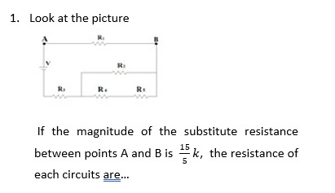

Figure 2. Problem Text on Parallel Series Sub-concept

Students tend to perceive all resistance in a series arranged in parallel or series. The MP indicator most of the students still need to complete this indicator. For solving MP using algebraic mathematics, the resistance was written with the symbol R and the mathematical rules for fractional number operations. The LP indicators of students report conclusions, but the conclusions made need to be corrected. Figure 3 shows an example of the answers of students with errors in mathematical rules.

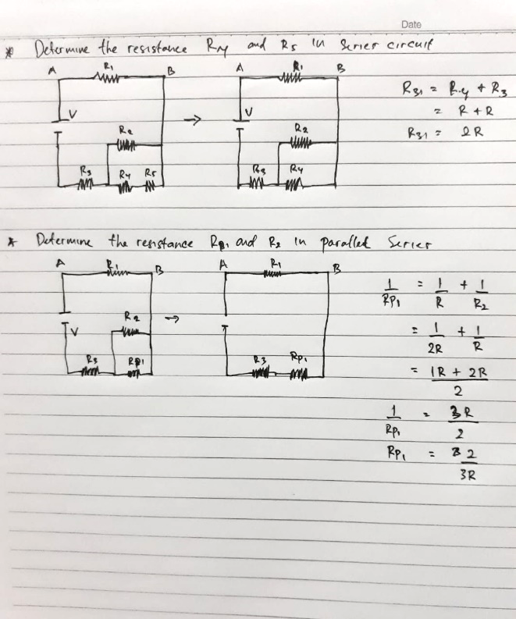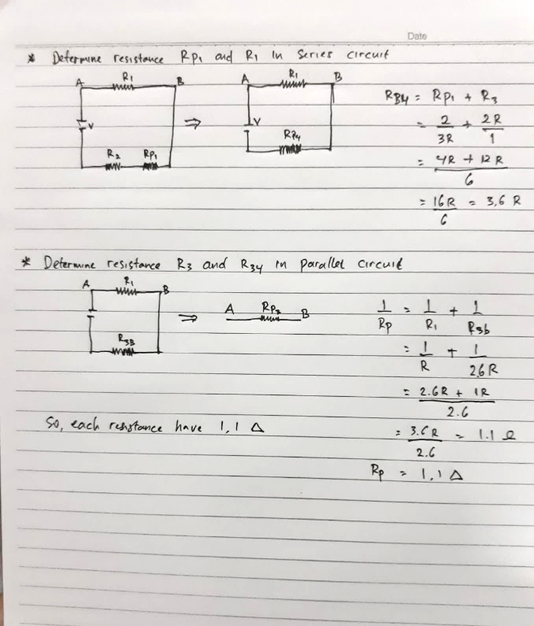

Figure 3. Students' Answers of Mathematical Procedure Errors

Based on Figure 3, students make mistakes in the mathematical operations of fractions in algebraic form. The Errors happened because students ignored numerators and denominators in algebraic fractions, and the tendency of students to assume that complete mathematical operations of R algebra by eliminating or deleting similar terms in the accurate numerator and denominator in mathematical rules are not allowed. After all, the function used was algebraic fractions.

The interviews conducted on students for the sub-concept of parallel series, namely students with the code S1-18, show that the problem can be solved. The UD indicator can precisely determine the information in the problem, convert the units, and answer what is asked in the question. For PA and SAP indicators, he can explain well that the concept used is the concept of parallel series and correctly describes every obstacle that is arranged in series or parallel. For the MP indicator, he said that it was quite difficult to use the formula, a parallel series with algebraic mathematical operations. In the LP indicator, there is an error. This error is because the mathematical procedure that needs to be appropriately ordered can affect the results of solving problems in parallel series circuits.

From some of the findings above, students' difficulty in solving problems in the sub-concept of parallel series shows that some students have yet to be able to describe obstacles in series or parallel. Students make mistakes in mathematical operations in adding fractions in algebraic forms. Errors in mathematical operations occur because students, in addition, ignore the numerator and denominator in algebraic fractions. Students think solving mathematical algebraic operations R by eliminating or removing like terms in the actual numerator and denominator in mathematical rules is not allowed. This condition is because the operation used is the addition of algebraic fractions.

It was the line previous research revealed that most students have been unable to carry out mathematical rules, algebra, and particles (Çalişkan et al., 2010). Lack of students' accuracy in conducting the calculations can cause low ability, and when bit mistakes happen in mathematics, they can make all answers errors (Azid, Yaacob, & Shaik-Abdullah, 2016; Kim & Md-Ali, 2017). The significant influence of mathematics on the ability to solve physics problems. Students with high initial mathematical abilities have better cognitive physics abilities than students with low initial mathematical abilities in solving physics problems (Docktor et al., 2016; Riantoni et al., 2017; Yulianti et al., 2018). The students must improve basic mathematical skills by understanding mathematical concepts well (Erdoğan & Gül, 2020; Kim & Md-Ali, 2017).

**Sub Concepts of Parallel Series Circuits and Ohm's Law**

The ability of students to solve problems in the sub-concept of series and parallel series and Ohm's law in UD indicator, most students can write precisely the information in the questions. Still, students did not convert mA units (milliampere) to A (ampere), and students wrote symbol I (current) in a series resistance as same as the current in a parallel series resistance circuit without giving any specific information such as I series or I series-parallel. For the PA indicator, students can determine the physics approach to solving the problem in item 2: the concept of parallel series and Ohm's law. However, some students only choose the replacement resistance in series, not the resistance to be replaced in parallel.

In the SAP indicator, some students do not use Ohm's law to find the V tension and the total resistance. Students only solve problems that focus on parallel series equations. Some of the MP indicators on mathematical procedures are needed to be written. It was related to the concepts or formulas used by students, such as determining the value of tension and the circuit's total resistance. Furthermore, the LP indicator of students tends to write wrong conclusions due to errors in the previous indicators. It shows that students cannot apply Ohm's law to determine the amount of tension and total resistance. Students tend to assume they only use parallel series equations to solve the problem (Riantoni et al., 2017).

From some of the findings above, students' difficulty in solving problems in this sub-concept problem shows that students need to convert units or conversion errors can affect the results of mathematical calculations. Students have been unable to apply Ohm's law to determine the magnitude of the total voltage and resistance. Students tend to assume it is only enough to use parallel series equations to solve the problem. Students do not use the special physics applications needed to solve the problem.

Students did not use special physics applications needed to solve the problem. The mistakes made by students, such as problems mA (milliampere), were not converted to A (amperes). The errors happened in calculations (Ding et al., 2011). The student's knowledge of a series of resistance to direct current electricity in the high and medium categories, students could solve problems easily using a resistor in direct current electricity because they had studied in junior and Vocational high school (Taşlıdere, 2013). However, students find it difficult when they are not accustomed to working on tests with the ability to improve their previous concepts because solving problems requires understanding the basic concepts (Leary, Walker, Lefler, & Kuo, 2019; Mohd Radzi et al., 2019).

**Sub Concept of Ohm's Law**

The ability of students to solve problems in the sub-concept of Ohm's law in UD indicator, most students can write precise information in the questions. Still, students did not convert mW (milli Ohm) to W (Ohm), and some students needed to write the symbols and value of resistance in (r). PA indicator, some students still need to complete the indicator after writing the information in the questions, and some students could determine the concept of the approach to solving the problem in question number 3 using Ohm's law.

SAP indicator was in low criteria. The students tend to perceive all resistance as arranged in series without paying attention to the characteristics of resistance arranged in series or parallel because the currents divide the value of the potential difference, which affects the determination of total resistance on the circuit. MP indicator, students use formulas and conduct the calculations to the formula without checking the mathematical rules used. LP indicator, most students did not write the conclusion because they were not accustomed to re-examining the problem-solving results to determine whether they were correct and precise.

From some of the findings above, students solving problems on Ohm's law sub-concepts show that some students can determine the concepts used to solve problems in problems and know the obstacles arranged in series or parallel. Students do not consider the value of internal resistance to determine the total resistance, so there is an error in the value of the current flowing in the circuit.

Previous research revealed that when students solve problems in a series, students must have prerequisite knowledge which includes: first, characteristics that describe how the current flows and the potential difference in a series and parallel circuit; second, knowing the characteristics of the total resistance in series and parallel; and third, concept of Ohm's law, a concept that explains the relationship between electric current, potential difference, and electrical resistance (Riantoni et al., 2017). However, students need help determining the characteristics of series and parallel and cannot use Ohm's law correctly. Also, their mistakes were deceived by the resistance (r). Students assume this resistance does not affect the circuit's current value; the mistake is based on its assumption (Docktor et al., 2016, 2015).

**Sub Concept of Kirchof's II Laws**

The ability to solve problems in this subject, UD indicator, most students can write the information in the questions and make unit conversions. Still, students must be more accurate in writing symbols in the questions. PA and SAP indicators students think that question number 4 only needs to be solved using Kirchoff's second law and ignore Ohm's law for determining potential differences and incorrectly defining the concepts used in solving problems. Applying Kirchoff's second law, students were careless and made mistakes when the value of Ɛ (tension source) was positive or negative. So, it affects the MP indicator in the applied mathematical procedure. LP indicator, students did not provide correct and precise solutions, and then they did not answer all the questions.

Based on the findings above, in Kirchoff's Law II sub-concept, students can complete the UD indicator on the question well, and errors in writing down what is asked on the question greatly affect the next indicator. The concept can be determined for some students who understand previously studied concepts. In applying Kirchhoff's II law, many things still need to be corrected in determining the value of the voltage source, which is positive or negative, based on the specified current direction.

Previous research revealed that the ability of students to apply the concepts of physics was used to the special conditions of the problem (Docktor et al., 2016). Students need basic concepts being studied and previously needed concepts; some still need clarification about adding some concepts or principles (Leary et al., 2019). Students make mistakes in applying Kirchoff's law because students directly answer the questions without attention to the direction of the current in the circuit known in the question. Students cannot apply Kirchoff's second law in the form of mathematical equations in the circuit because students need to understand when tension is positive or negative (Yadav et al., 2011).

**Sub Concept of Kirchoff's I and II Law**

Ability of students to solve problems with this concept, most students still need to answer or complete indicators besides writing information on the questions. UD indicator, most students can write the information in the questions and conduct the conversions, but all students still need to write or describe the direction of the current in two loops. Most students need help solving the indicators of PA, SAP, MP, and LP. They only wrote or completed the UD indicator. Furthermore, students must correct mistakes and misconceptions in applying Kirchoff's law to the single series and compound loops. Figures 4 and 5 show the question text and examples of student answer sheets with errors and misconceptions in applying the concept.

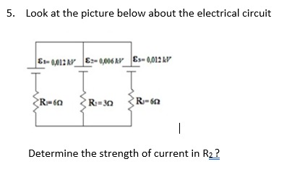

Figure 4. Text Problem on Sub-concept of Kirchoff’s I and II Laws

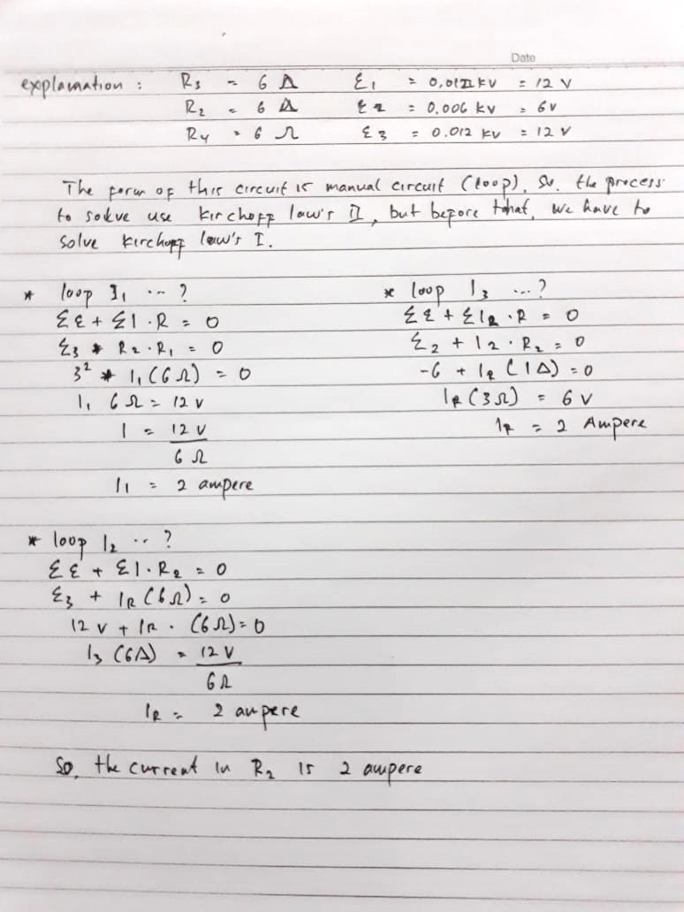

Figure 5. Answer Sheet of Students with Concept Errors and Misconceptions

Based on Figure 5, students can write the concepts correctly. To apply it, students still need to write the inrush and outflow as the application of Kirchoff's I law. Determining the current in the loop made errors and misconceptions, errors in determining the loops. Question number 4 only has two loops, but students wrote three loops. Misunderstanding happened in contrast to the number of tensions for each loop and ignored the positive and negative values.

The misunderstanding was in line with the results of interviews with students who revealed that they did not know how to apply Kirchoff's I law to compound loops with branching points. Students wrote three loops because there are three tension sources. Therefore, they wrote the total tension for only one on each loop. Misunderstanding in understanding concepts is often experienced by students (Riantoni et al., 2017).

Based on the findings above, on the sub-concepts of Kirchoff's laws I and II, students can only complete the UD indicator but need help describing the current's direction in the two-loop circuit. Most of the students did not answer or did not complete the next indicator other than UD. Some students can only write down the concepts used and need help to apply these concepts in problem-solving, especially in Kirchoff's first law, which does not write out current and incoming current. Kirchoff's II law does not pay attention to positive and negative voltages. The error in determining the number of loops causes other errors, namely the number of voltages, both positive and negative.

Previous research revealed that students got the highest error was determining the electric current in a closed circuit with two loops and more than one source of tension and resistance (Yulianti et al., 2018). The application of the concept was not appropriate because students only wrote equations as a center for obtaining quantitative answers and tended to ignore them conceptually (Ding et al., 2011). In addition, students were not taught to determine the basic concepts used in these problems, which affects students' difficulties in indicators or later stages (Mohd Radzi et al., 2019; Yadav et al., 2011).

**CONCLUSION**

The students' problem-solving ability in direct current electrical was within the very low criteria. The results of the tests show that most of the students got the low criteria, 29 (62%) out of 47 students. Low criteria students were only able to write information on the questions given but did not solve the problems on the questions, and they answered only some. Students' problem-solving ability for each sub-concept of direct current electrical was in low criteria, based on the low average of students than the score on each sub-concept. The students' problem-solving ability on the UD indicator was 61% in the high criteria, PA with 33%, and SAP with 26% in the low criteria.

Meanwhile, two stages were included in very low criteria, the MP stage with 22% and LP with 16%. Students have difficulty describing resistance in series or parallel. The problem in solving the sub-concept of Kirchoff's law regards determining positive or negative potential differences and the inrush or outflow in the loop circuit. Another problem was conducting mathematical calculations on algebra and fractions. It was shown that the ability of students to apply a mathematical concept or procedure needs to be improved again by considering the appropriate learning strategies both in online and offline learning.

**ACKNOWLEDGMENTS**

The LPPM Universitas Halu Oleo supported this work. The authors gratefully acknowledge using Vocational High School 1 Kendari, the headmaster, vice headmaster, physics teacher, and the students willing to be research subjects.

**REFERENCES**

Anderson, L. W., & Krathwohl, D. R. (2015). *Kerangka Landasan untuk Pembelajaran, Pengajaran, dan Asesmen Revisi Taksonomi Pendidikan Bloom* (A. Priantoro, Ed.). Yogyakarta: Pustaka Pelajar.

Arifin, M. B. U., Sholeh, M., Hafiz, A., Agustin, R. D., & Wardana, M. D. K. (2021). Developing Interactive Mobile Mathematics Inquiry to Enhance Students’ Problem-solving Skill. *International Journal of Interactive Mobile Technologies (IJIM)*, *15*(01), 24–38. https://doi.org/10.3991/IJIM.V15I01.20067

Azid, N. H., Yaacob, A., & Shaik-Abdullah, S. (2016). The Multiple Intelligence Based Enrichment Module on the Development of Human Potential: Examining its Impact and the Views of Teachers. *Malaysian Journal of Learning and Instruction*, *13*(2), 175–200. https://doi.org/10.32890/MJLI2016.13.2.7

Buteler, L., & Coleoni, E. (2016). Solving problems to learn concepts, how does it happen? A case for buoyancy. *Physical Review Physics Education Research*, *12*(2), 020144. https://doi.org/10.1103/PHYSREVPHYSEDUCRES.12.020144/FIGURES/8/MEDIUM

Çalişkan, S., Selçuk, G. S., & Erol, M. (2010). Effects of the problem solving strategies instruction on the students’ physics problem solving performances and strategy usage. *Procedia - Social and Behavioral Sciences*, *2*(2), 2239–2243. https://doi.org/10.1016/J.SBSPRO.2010.03.315

Demir, S. (2021). The effects of science teaching differentiated according to the grid model. *Pegem Journal of Education and Instruction*, *11*(4). https://doi.org/10.47750/pegegog.11.04.14

Ding, L., Reay, N., Lee, A., & Bao, L. (2011). Exploring the role of conceptual scaffolding in solving synthesis problems. *Physical Review Special Topics - Physics Education Research*, *7*(2), 020109. https://doi.org/10.1103/PHYSREVSTPER.7.020109/FIGURES/9/MEDIUM

Docktor, J. L., Dornfeld, J., Frodermann, E., Heller, K., Hsu, L., Jackson, K. A., … Yang, J. (2016). Assessing student written problem solutions: A problem-solving rubric with application to introductory physics. *Physical Review Physics Education Research*, *12*(1), 010130. https://doi.org/10.1103/PHYSREVPHYSEDUCRES.12.010130/FIGURES/7/MEDIUM

Docktor, J. L., Strand, N. E., Mestre, J. P., & Ross, B. H. (2015). Conceptual problem solving in high school physics. *Physical Review Special Topics - Physics Education Research*, *11*(2), 020106. https://doi.org/10.1103/PHYSREVSTPER.11.020106/FIGURES/2/MEDIUM

Erdoğan, F., & Gül, N. (2020). An investigation of mathematical problem posing skills of gifted students. *Pegem Eğitim ve Öğretim Dergisi*, *10*(3), 655–696. https://doi.org/10.14527/pegegog.2020.022

Harun, H., Abdullah, N., Wahab, N. S. A., & Zainuddin, N. (2017). The use of metalanguage among second language learners to mediate l2 grammar learning. *Malaysian Journal of Learning and Instruction*, *14*(2), 85–114. https://doi.org/10.32890/MJLI2017.14.2.4

Hsbollah, H. M., & Hassan, H. (2022). Creating meaningful learning experiences with active, fun, and technology elements in the problem-based learning approach and its implications. *Malaysian Journal of Learning and Instruction*, *19*(1), 147–181. https://doi.org/10.32890/MJLI2022.19.1.6

Kim, K. M., & Md-Ali, R. (2017). Geogebra: Towards realizing 21st century learning in mathematics education. *Malaysian Journal of Learning and Instruction*, *2017*(Specialissue), 93–115. https://doi.org/10.32890/MJLI.2017.7799

Leary, H., Walker, A., Lefler, M., & Kuo, Y. (2019). Self‐Directed Learning in Problem‐Based Learning. *The Wiley Handbook of Problem‐Based Learning*, 181–198. https://doi.org/10.1002/9781119173243.CH8

Martaningsih, S. T., Maryani, I., Prasetya, D. S., Prwanti, S., Sayekti, I. C., Aziz, N. A. A., & Siwayanan, P. (2022). Stem Problem-Based Learning Module: A Solution to Overcome Elementary Students’ Poor Problem-Solving Skills. *Pegem Journal of Education and Instruction*, *12*(4).

McNeill, N. J., Douglas, E. P., Koro‐Ljungberg, M., Therriault, D. J., & Krause, I. (2016). Undergraduate Students’ Beliefs about Engineering Problem Solving. *Journal of Engineering Education*, *105*(4), 560–584. https://doi.org/10.1002/jee.20150

Mohd Radzi, S. H., Tan, W. H., & Yusoff, A. (2019). Shipping Management Simulation Game for Teaching and Learning in Higher Education: A Quasi-Experimental Study. *Malaysian Journal of Learning and Instruction*, *16*(2), 155–186. https://doi.org/10.32890/MJLI2019.16.2.6

Retnawati, H., Apino, E., Djidu, H., Ningrum, W. P., Anazifa, R. D., & Kartianom, K. (2019). Scaffolding for international students in statistics lecture. *Journal of Physics: Conference Series*, *1320*, 012078. https://doi.org/10.1088/1742-6596/1320/1/012078

Retnawati, H., Djidu, H., Kartianom, Apino, E., & Anazifa, R. D. (2018). Teachers’ knowledge about higher-order thinking skills and its learning strategy. *Problems of Education in the 21st Century*, *76*(2), 215–230.

Riantoni, C., Yuliati, L., Mufti, N., & Nehru, N. (2017). Problem Solving Approach in Electrical Energy and Power on Students as Physics Teacher Candidates. *Jurnal Pendidikan IPA Indonesia*, *6*(1), 55–62. https://doi.org/10.15294/JPII.V6I1.8293

Ridhwan, Sumarmi, Ruja, I. N., Utomo, D. H., & Sari, R. M. (2019). Student perception on teaching materials development to increase students’ knowledge of aceh’s maritime potential. *Journal for the Education of Gifted Young Scientists*, *7*(4), 1295–1309. https://doi.org/10.17478/JEGYS.618245

Sejati, A. E., Kasmiati, S., & Ikhsan, F. A. (2019). The relationship between learning process interactions and student’s learning outcomes in environmental sustainability matter geography-social science education subject. *IOP Conference Series: Earth and Environmental Science*, *382*(1). https://doi.org/10.1088/1755-1315/382/1/012026

Singh, C. K. S., Gopal, R., Ong, E. T., Singh, T. S. M., Mostafa, N. A., & Singh, R. K. A. (2020). Esl teachers’strategies to foster higher-order thinking skills to teach writing. *Malaysian Journal of Learning and Instruction*, *17*(2), 195–226. https://doi.org/10.32890/MJLI2020.17.2.7

Sugiyono. (2016). *Statistik Pendidikan*. Jakarta: Balai Pustaka.

Taşlıdere, E. (2013). Effect of Conceptual Change Oriented Instruction on Students’ Conceptual Understanding and Decreasing Their Misconceptions in DC Electric Circuits. *Creative Education*, *04*(04), 273–282. https://doi.org/10.4236/ce.2013.44041

Umar, I. N., & Ahmad, N. H. (2010). Trainee teachers’ critical thinking in an online discussion forum: A content analysis. *Malaysian Journal of Learning & Instruction*, *7*, 75–91.

Yadav, A., Subedi, D., Lundeberg, M. A., & Bunting, C. F. (2011). Problem-based Learning: Influence on Students’ Learning in an Electrical Engineering Course. *Journal of Engineering Education*, *100*(2), 253–280. https://doi.org/10.1002/J.2168-9830.2011.TB00013.X

Yulianti, L., Riantoni, C., & Mufti, N. (2018). Problem Solving Skills on Direct Current Electricity through Inquiry-Based Learning with PhET Simulations. *International Journal of Instruction*, *11*(4), 123–138.