# SEISMIK VULNERABILITY INDEX ANALYSIS IN NAGARI MALALAK TIMUR AS AN EFFORT TO DETERMINE LANDSLIDE POTENTIAL AREAS THE HVSR METHOD

Yese Angga Marito Silitonga 1,**†**, Syafriani2

1Department of Physics, Universitas Negeri Padang, Jl. Prof. Dr. Hamka Air Tawar Padang 25131,

†anggasilitonga52@gmail.com

**Abstract.** Nagari Malalak Timur, Malalak Subdistrict, Agam Regency has experienced landslides caused by soil movement so that the soil conditions become unstable. Landslides are also influenced by external factors such as vibrations from earthquakes and vibrations from human activities. For this reason, a study was conducted to describe the distribution of seismic vulnerability index as an effort to determine the potential landslide area. The sampling was limited to 10 measurement points using a set of seismograph sysmatrack MAE sensor type S3S. The basic principle of HVSR method is to obtain the value of Dominant Frequency (f0) and Amplification Factor (A0) by comparing the value of horizontal component and vertical component of microtremor data. From the value of Dominant Frequency (f0) and Amplification Factor (A0), the calculation of Dominant Period (T0) and Seismic Susceptibility Index (Kg) can be done. The results of research in Nagari Malalak Timur show the value of Dominant Frequency (f0) is in the range of 2.676 - 7.22 Hz. The Amplification Factor (A0) value is in the range of 1.4 - 6.563. The Dominant Period (T0) value is in the range of 0.138 - 0.373 s. The Seismic Susceptibility Index (Kg) value is in the range of 0.365 - 14.62 cm/s2. Based on the distribution of Seismic Susceptibility Index (Kg) values in the 10 research points, the highest landslide potential is in point D with a Seismic Susceptibility Index (Kg) value of 14.62 cm/s2. This causes landslides to occur at any time.

***Keywords****: Amplification Factor, Dominant Frequency, HVSR, Seismic Susceptibility Index.*

**INTRODUCTION**

Nagari Malalak Timur, Malalak Sub-district, Agam Regency is one of the zones that has a high vulnerability of ground movement, this is shown on the landslide prone map of Agam Regency which needs to consider the safety of slopes because it has many factors that trigger landslides, especially in the purpose of making it as an access road. Landslides in Nagari Malalak Timur occur due to an imbalance of forces acting on the slope such as slope height, slope angle, and moisture content conditions. Landslides are also influenced by external factors such as vibrations from earthquakes and vibrations from human activities [1].

Landslides are natural disasters that claim many lives. There are several factors that can cause landslides, including heavy rains with a relatively long time, deforested mountain slopes and unstable soil conditions that can make these soils unable to hold water during very heavy rains. However, landslides can also be caused by volcanic activity or earthquakes [2].

Seismic waves are elastic waves and their propagation depends on the elasticity of rocks and the density of rocks, so knowing the speed of seismic wave propagation in rock layers can determine the hardness and density of rocks When seismic waves propagate to the boundary between layers, some of these waves are reflected and some are refracted, so that physical symptoms can be detected [3].

Natural disasters that have occurred somewhere will almost certainly happen again someday. The only problem is that we do not know when and where the disaster will happen again. On the contrary, unexpectedly, landslide natural disasters occur in areas that are not listed as vulnerable areas [4]. HVSR is one way to understand the nature of subsurface structure without causing disturbance to the structure. This method is a method that shows the relationship between the subsurface structure of the soil by comparing the ratio of the Fourier spectrum of the microtremor signal of the horizontal component to its vertical component [5] at the same frequency so as to obtain the dominant amplification value and the dominant frequency.

Amplification is an increase in the amplitude of the horizontal component wave compared to the amplitude of the vertical component wave. Brittle or soft layers amplify the horizontal component, but not the vertical component. The amplification gain value of the soil is related to the impedance contrast of the layer on the surface and the layer below. If the impedance contrast of the two layers is high, there is a high amplification factor and vice versa [6]. Amplification values indicate changes in layer impedance and possible changes in rock density caused by changes in rock cohesiveness. This makes areas with high soil amplification factor values vulnerable to earthquake shaking. Amplification and the proximity of bedrock to the ground surface are not the only factors that determine the level of structural damage caused by an earthquake that leads to landslides [7]. From the dominant frequency, the dominant period value is obtained, which is the time required to propagate through the sediment layer.

Based on the amplification factor and dominant frequency, the seismic vulnerability index value is obtained, the seismic vulnerability index serves for the implementation of the geological characteristics of an area. For this reason, research was conducted on the potential for landslides in Nagari Malalak Timur, Malalak District, Agam Regency.

**RESEARCH METHOD**

This research is located in the Nagari Malalak Timur area, Malalak District, Agam Regency, West Sumatra. The scope of the research area focuses on the Nagari Malalak Timur area with a total of 10 location points with an average time of 45-90 minutes per point using the HVSR method. By utilizing the HVSR method, the H/V peak curve is obtained which contains information on the amplification and dominant frequency of the soil. The amplification value is related to the impedance contrast of the surface layer and the layer below. [8] The amplification equation can be seen in Equation 1 below:

$A_{0}=\frac{ρ_{b}.v_{b}}{ρ_{s}.v_{s}}$ (1)

where ρb is the density of bedrock (gr/ml), ρsf is the density of soft rock (gr/ml), vb is the speed of wave propagation in bedrock (m/s) and vs is the speed of wave propagation in soft rock (m/s). The following classification of amplification factor values can be seen in Tabel 1 below:

Tabel 1. Classification of Amplification Factor Values

|  |  |  |  |
| --- | --- | --- | --- |
| **Zone** | **Amplification Factor Value** | **Classification** | **Mapping Color** |
| 1  2  3  4 | A0 < 3  3 ≤ A0 < 6  6 ≤ A0 < 9  A0 ≥ 9 | Low  Medium  High  Very high | Green  Blue  Yellow  Red |

Based on Table 1, [9] Amplification is a wave amplification event that occurs as seismic waves pass through a softer medium. In addition, amplification can occur when seismic waves pass through a medium that has the same frequency. High amplification indicates that the area is experiencing wave amplification and is prone to earthquake damage. Amplification values are affected by rock deformation and weathering. [10] While the dominant frequency is the frequency value of the rock layer in an area to show the type and characteristics of the rock. Based on the frequency of the soil, it is formulated by Equation 2 below:

$f_{0}=\frac{v_{b}}{4AH}$ (2)

where vb is the wave velocity below the ground surface, A is the amplification factor and H is the sediment thickness. The following soil classification based on the dominant frequency according to Kanai can be seen in Table 2 below:

**Table 2.** Classification of Dominant Frequency Values

|  |  |  |  |  |  |
| --- | --- | --- | --- | --- | --- |
| **Soil Classification** | | **Dominant Frequency** | **Kanai Classification** | **Description** | **Soil Character Classification** |
| Type | Type |
| Type IV | Type I | 6,667-20 | Tertiary or older rocks. Consisting of hard, sandy, gravel, etc. | The thickness of the surface sediments is very thin, dominated by hard rock. | Hard |
| Type III | Type II | 4-10 | Alluvial rock, with a thickness of 5m. Consists of sandy-gravel, sandy hard clay, loam, etc. | The surface sediments are in the medium category of 5-10 meters | Medium |
| Type II | Type III | 2,5-4 | Alluvial rock, >5m thick. Consists of sandy-gravel, sandy hard clay, loam, etc. | The thickness of surface sediments is in the thick category, about 10-30 meters | Soft |
| Type I | Type IV | <2,5 | Alluvial rocks formed from delta sedimentation, top soil, mud, etc. With a depth of 30m or more | The thickness of surface sediments is very thick | Very soft |

Based on Table 2, the Dominant Frequency (f0) has a soil classification based on the dominant frequency value which is divided into four types proposed by Kanai, where the dominant frequency has a soil character classification according to the dominant frequency value based on Kanai's classification and its description. [11] The dominant frequency is related to the dominant period. The dominant period value is used to identify the character of the rock layer. The dominant period can be seen in Equation 3 below:

$T_{0} =\frac{1}{f_{0}}$ (3)

where f0 is the dominant frequency. The following soil classification based on the dominant period according to Kanai can be seen in Table 3 below:

**Table 3.** Classification of Dominant Period Values

|  |  |  |  |  |
| --- | --- | --- | --- | --- |
| **Soil Classification** | | **Period (T) secon** | **Description** | **Soil Character Classification** |
| Kanai | Omote-Nakajima |
| Type I | Type A | 0,05-0,15 | Tertiary or older rocks. Consists of hard pebbly sandstone. | Hard |
| Type II | 0,15-0,25 | Alluvial rocks with a thickness of 5m. Consists of sandy-gravel, sandy hard clay, clay, loam. | Medium |
| Type III | Type B | 0,25-0,40 | Alluvial rocks are almost the same as type II, only distinguished by the presence of Bluff formation. | Soft |
| Type IV | Type C | >0,40 | Alluvial rocks formed from delta sedimentation, top soil, mud, humus, delta deposits or mud deposits, which are classified as soft soil with a depth of ≥ 30 meters. | Very soft |

Based on Table 3, the Dominant Period (T0) has two types of classifications proposed by Kanai and Omote-Nakajima that have been converted and used as standards in earthquake-resistant building planning, where the dominant period has a soil character classification according to the value of the dominant period based on its description.

The seismic susceptibility index is a value that describes the level of susceptibility of the soil layer to surface deformation during an earthquake. The seismic susceptibility index can be obtained by squaring the the amplification factor A0 divided by the resonantfrequency, [12] which is given by Equation 4 below:

$K_{g}=\frac{A^{2}}{f_{0}}$ (4)

where Kg is seismic susceptibility, A0 is amplification and fo is frequency. By performing dominant frequency inversion, the value of the dominant period will be obtained, providing information about the soil type so that a distribution map (contour map) of the natural frequency value, amplification factor, and dominant period can be made [13]. The classification of seismic vulnerability index values can be seen in Table 4 below:

**Table 4**. Classification of Seismic Vulnerability Index Values

|  |  |
| --- | --- |
| **Zone** | **Value Kg** |
| Low | <3 |
| Medium | 3-6 |
| High | >6 |

Based on Table 4, the level of seismic vulnerability index obtained is proportional to the amplification value and inversely proportional to the dominant frequency value. This shows that the higher the value of the Seismic Vulnerability Index (Kg), the higher the level of damage caused by the earthquake to cause landslides [14].

**RESULTS AND DISCUSSIONS**

Data collection in the research in Nagari Malalak Timur, Malalak Subdistrict, Agam Regency using the HVSR method was carried out at nine points with different coordinates with a distance between measurement points of 250-500 meters and 45-90 minutes of recording time. After obtaining the recorded data, the data was processed using Geopsy software to convert the time form to frequency using the FFT process to obtain the H/V curve. The H/V curve shows the analysis of seismic wave data to obtain the amplification factor value and dominant frequency. The amplification and dominant frequency are related to the type and character of the soil and sediment layer by using Equations (1) and (2), then the analysis of frequency and amplification can be seen in Table 5 below:

**Table 5.** Analysis of Factor Amplification (A0) and Dominant Frequency (f0)

|  |  |  |  |  |  |  |  |
| --- | --- | --- | --- | --- | --- | --- | --- |
| **Point** | **Longitude (m)** | **Latitude (m)** | **Amplification Factor** | **Classification** | **Dominant Frequency (Hz)** | | **Soil Character Classification** |
| A | 100o17′07,4″ | 0o22′33,9″ | 3,408 | Medium | | 3,765 | Soft |
| B | 100o16′54,4″ | 0o22′34,7″ | 1,4 | Low | | 5,361 | Medium |
| C | 100o16′44,1″ | 0o22′35,1″ | 1,767 | Low | | 2,676 | Soft |
| D | 100o16′31,3″ | 0o22′33,2″ | 6,563 | High | | 2,946 | Soft |
| E | 100o16′34,4″ | 0o22′26,1″ | 7,193 | High | | 7,22 | Hard |
| F | 100o16′43,6″ | 0o22′29,7″ | 3,996 | Medium | | 3,686 | Soft |
| G | 100o16′57,9″ | 0o22′25,8″ | 2,104 | Low | | 3,107 | Soft |
| H | 100o17′12,6″ | 0o22′22,6″ | 2,127 | Low | | 4,831 | Medium |
| I | 100o17′20,6″ | 0o22′18,0″ | 2,904 | Low | | 4,611 | Medium |
| J | 100o17′12,9″ | 0o22′09,7″ | 2,409 | Low | | 6,724 | Hard |

Based on Table 5, the results of the amplification factor analysis are that points B, C, G, H, I and J have a low classification, points A and F have a medium classification and points D and E have a high classification. It can be concluded that the greater the value of A0, the greater the potential damage to a building in the area when exposed to earthquake shocks. Thus, it is known that landslide-prone areas are areas whose subsurface soil is composed of soft sediments which can be seen in Figure 1(a).

While the results of the dominant frequency analysis can be concluded that at points A, C, D, F and G have soil classification Type II/Type III with classification as alluvial rocks with thickness >5 meters, at points B, H and I have soil classification Type III/Type II with classification as alluvial rocks with thickness of 5 meters, while at points E and J have soil classification Type IV/Type I with classification as tertiary rocks dominated by hard rocks, for the distribution of the dominant frequency can be seen in Figure 1(b) below:

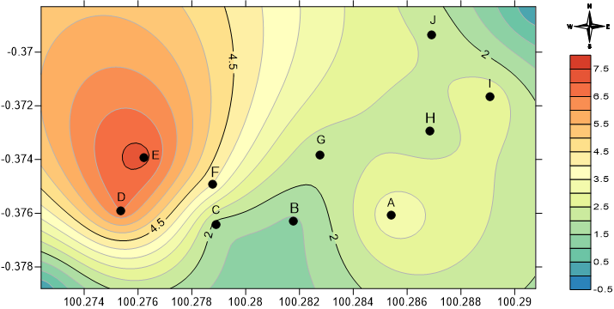

(a)

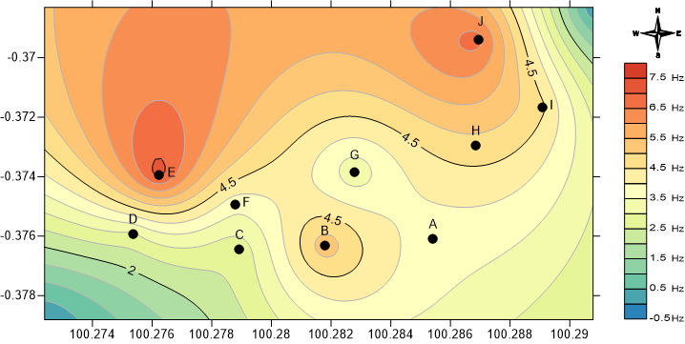

(b)

**Figure 1**. Distribution Map of (a) Amplification (b) Dominant Frequency values in the Nagari Malalak Timur Region

In Figure 1(a) illustrates the Factor Amplification (A0) value, where the highest amplification value is at point E with an amplification value of 7.193 which has a high classification and the lowest value at point B with an amplification value of 1.4 which has a low classification. [15] The Amplification Factor (A0) is the magnification of seismic waves that occur due to significant differences between layers, in other words, seismic waves will experience magnification, if it propagates in a medium to another medium that is softer than the softer than the initial medium through which it traveled. The greater the difference, then the magnification experienced by the wave will be greater.

In Figure 1(b) illustrates the Dominant Frequency (f0) value, where the highest frequency value is at point E with a frequency value of 7.22 Hz which has a hard soil category and the lowest value at point C with a value of 2.676 Hz which has a soft soil category. It is known theoretically that the smaller the dominant frequency value, the thicker the sediment layer and the deeper the bedrock layer. [16] The dominant frequency value shows the frequency value that often appears in the area and can give an idea of the thickness of the sediment in the area. description of the sediment thickness in the area. The dominant frequency can indicate the type and characteristics of rocks and rock characteristics classified by Kanai, and has a close relationship with sediment (bedrock) thickness.

Based on Table 6 the characteristics of soil types are also known through the value of the Dominant Period (T0), the results of T0 are obtained by converting the dominant frequency value into Equation (3), then the resulting dominant period data as in Table 6 below:

**Table 6.** Analysis of Dominant Period (T0)

|  |  |  |  |  |
| --- | --- | --- | --- | --- |
| **Point** | **Longitude (m)** | **Latitude (m)** | **Dominant Period (s)** | **Soil Character Classification** |
| A | 100o17′07,4″ | 0o22′33,9″ | 0,265 | Soft |
| B | 100o16′54,4″ | 0o22′34,7″ | 0,186 | Medium |
| C | 100o16′44,1″ | 0o22′35,1″ | 0,373 | Soft |
| D | 100o16′31,3″ | 0o22′33,2″ | 0,339 | Soft |
| E | 100o16′34,4″ | 0o22′26,1″ | 0,138 | Hard |
| F | 100o16′43,6″ | 0o22′29,7″ | 0,271 | Soft |
| G | 100o16′57,9″ | 0o22′25,8″ | 0,321 | Soft |
| H | 100o17′12,6″ | 0o22′22,6″ | 0,206 | Medium |
| I | 100o17′20,6″ | 0o22′18,0″ | 0,216 | Medium |
| J | 100o17′12,9″ | 0o22′09,7″ | 0,148 | Hard |

Based on Table 6, the results of the dominant period analysis can be concluded that at points E and J have Kanai type I classification and Omote-Nakajima type A classification consisting of tertiary rocks that have hard soil character, at points B, H and I have Kanai type II classification and Omote-Nakajima type A classification consisting of alluvial rocks with a thickness of 5 meters which have medium soil character, while at points A, C, D, F and G have Kanai classification type III and Omote-Nakajima classification type B which consists of alluvial rocks which are almost the same as type II only distinguished by the presence of bluff formations that have soft soil characteristics, for the distribution of the dominant period can be seen in Figure 2 below:

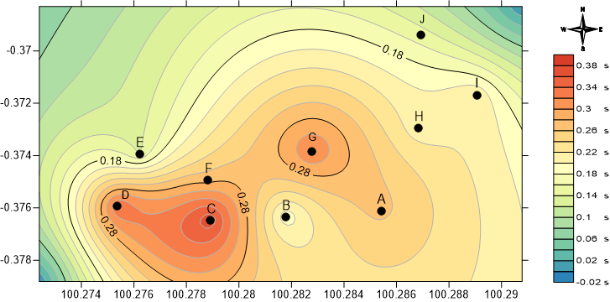

Figure 2. Distribution Map of Dominant Period Values in the Nagari Malalak Timur Region

Figure 2 illustrates the value of the Dominant Period (T0), where the highest T0 value is at point E with a value of 0.138 which has a hard soil character and the lowest value at point C with a value of 0.373 which has a soft soil character. It is known theoretically that if the dominant period value is inversely proportional to the f0 value, which indicates that if the f0 value is low, the T0 value will be high, and vice versa. This means that the dominant period value is influenced by the dominant frequency value, The traveling ground wave is trapped in the soft soil layer and the phenomenon of multiple reflections occurs, resulting in ground vibrations corresponding to the period of the ground wave.

The period value is the time it takes for a microtremor wave to propagate through a layer of surface sediment deposits or experience one reflection on its reflected plane to the surface. [17] The dominant period is the time it takes for a wave to propagate through a layer of sediment that bounces once to the surface on the reflecting plane. sediment layer that bounces once to the surface on the reflecting plane. Based on this analysis which is associated with the soil classification table by Kanai and Omote-Nakajima, three categories are obtained dominant period values, namely high, medium and low categories. This is because the dominant period value is directly proportional to the amplification value.

Based on Table 6 after obtaining information about the amplification value and dominant frequency, the seismic vulnerability index can be obtained by substituting it into equation (4), with the acquisition of the Kg value in Table 7 below:

**Table 7.** Analysis of Seismic Vulnerability Index (Kg)

|  |  |  |  |  |
| --- | --- | --- | --- | --- |
| **Point** | **Longitude** | **Latitude** | **Kg (cm/s2)** | **Zone** |
| A | 100o17′07,4″ | 0o22′33,9″ | 3,085 | Medium |
| B | 100o16′54,4″ | 0o22′34,7″ | 0,365 | Low |
| C | 100o16′44,1″ | 0o22′35,1″ | 1,166 | Low |
| D | 100o16′31,3″ | 0o22′33,2″ | 14,620 | High |
| E | 100o16′34,4″ | 0o22′26,1″ | 7,166 | High |
| F | 100o16′43,6″ | 0o22′29,7″ | 4,331 | Medium |
| G | 100o16′57,9″ | 0o22′25,8″ | 1,423 | Low |
| H | 100o17′12,6″ | 0o22′22,6″ | 0,936 | Low |
| I | 100o17′20,6″ | 0o22′18,0″ | 1,828 | Low |
| J | 100o17′12,9″ | 0o22′09,7″ | 0,863 | Low |

Based on Table 7, the Seismic Vulnerability Index (Kg) can be categorized as high, medium, and low as the Amplification Factor (A0). The variation of Kg values is shown with color contours, where dark blue indicates low Kg values and red indicates high Kg values, for the distribution of seismic vulnerability index values can be seen in Figure 3 below:

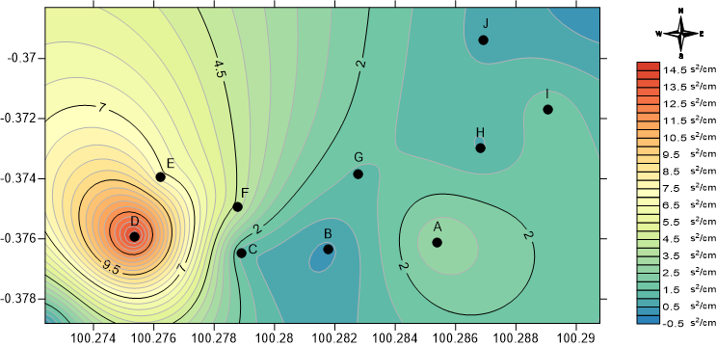

**Figure 3**. Seismic Vulnerability Index Distribution Map

Figure 3 shows the value of the Seismic Susceptibility Index (Kg), where the highest Kg value is at point D with a value of 14.621 in the high zone and the lowest value at point B with a value of 0.365 in the low zone. The Kg value is a measurement value to determine the level of resistance of the earth's layers, the Kg parameter can reflect local effects and can be used as an indicator in determining weak points, especially in slope areas.

The Seismic Susceptibility Index (Kg) indicates the level of vulnerability to earthquakes based on the rock conditions in the area. The value of this sesymic susceptibility is different in each region. The reference of the Kg number is usually compared to other points in the area [18].

High Kg values are generally found on soils with soft sedimentary rock lithology, this high value illustrates that the area is vulnerable to earthquakes and in the event of an earthquake can experience strong shaking. The rock constituent material has a characteristic density in relatively small rock types because this rock constituent material is classified as having low to moderate water permeability [19].

The Seismic Vulnerability Index (Kg) parameter, which combines A0 and f0 to identify areas where seismic hazard and damage are greater. Nakamura points out that some destructive earthquake events show areas that are often exposed to major damage resulting in landslides [20]. It can be concluded that point D in the research which is located in Nagari Malalak Timur, Malalak District, Agam Regency, has the greatest chance of landslides.

**CONCLUSIONS**

Based on the results and discussion, Nagari Malalak Timur has a Seismic Vulnerability Index (Kg) value range of 0.365-14.62 cm/s2 which is composed of alluvial rocks seen based on the dominant frequency value of type II/III and the dominant period of type A/B which has an amplification factor value range of 1.4-7.193 which is classified as low-high. When mapped based on the Seismic Vulnerability Index (Kg), the area with the highest landslide probability is located at point D with a value of 14.62 which is classified as high with alluvial rock types.

**REFERENCE**

[1] E. Suedi *et al.*, “Analisis Stabilitas Lereng Ruas Jalan Sicincin-Malalak Km 31 Kecamatan Malalak, Kabupaten Agam, Provinsi Sumatera Barat,” *J. Bina Tambang*, vol. 3, no. 3, 2018.

[2] Nurfaiz Fathurrahman Yasien, Felia Yustika, Intan Permatasari, and Muthiah Sari, “Aplikasi Geospasial Untuk Analisis Potensi Bahaya Longsor Menggunakan Metode Weighted Overlay (Studi Kasus Kabupaten Kudus, Jawa Tengah),” *J. Geosains dan Remote Sens.*, vol. 2, no. 1, pp. 33–40, 2021, doi: 10.23960/jgrs.2021.v2i1.47.

[3] S. Ayub, M. Zuhdi, and S. Syamsuddin, “Aplikasi Konsep Gelombang dalam Menentukan Struktur Bawah Permukaan Persawahan Sembalun Bumbung bagi Mahasiswa Calon Guru,” *J. Ilm. Profesi Pendidik.*, vol. 7, no. 4b, pp. 2718–2725, 2022, doi: 10.29303/jipp.v7i4b.1055.

[4] L. Octavia and E. Prawoto, “Kesiapsiagaan Desa Terhadap Bencana Tanah Longsor,” 2018. Accessed: Oct. 28, 2023.

[5] Y. Nakamura, “A Method for Dynamic Characteristics Estimation of Subsurface Using Microtremor on the Ground Surface,” vol. 30, no. 1, pp. 25–33, 1989.

[6] Y. Nakamura, “Clear Identification Of Fundamental Idea Of Nakamura’s Technique And Its Applications,” 2000. Accessed: Oct. 28, 2023.

[7] M. N. Irham, M. Zainuri, G. Yuliyanto, and A. Wirasatriya, “Measurement of ground response of Semarang coastal region risk of earthquakes by Horizontal to Vertical Spectral Ratio (HVSR) microtremor method,” *J. Phys. Conf. Ser.*, vol. 1943, no. 1, 2021, doi: 10.1088/1742-6596/1943/1/012033.

[8] A. Satria *et al.*, “Analisis Ketebalan Lapisan Sedimen dan Indeks Kerentanan Seismik Kota Jambi Bagian Timur,” *J. Geofis. Eksplor.*, vol. 6, no. 1, pp. 18–30, 2020, doi: 10.23960/jge.c6i1.58.

[9] S. Supriyadi, W. H. Muttaqin, K. Khumaedi, and S. Sugiyanto, “Soil Vulnerability Levels based on Microtremor Data using the HVSR method in the Old City Area of Semarang,” *J. Phys. Theor. Appl.*, vol. 6, no. 1, p. 34, 2022, doi: 10.20961/jphystheor-appl.v6i1.59119.

[10] D. Widyawarman, “Subsurface Identification of Campus i Universitas PGRI Yogyakarta using the Microtremor Wave Method,” *J. Phys. Conf. Ser.*, vol. 1823, no. 1, 2021, doi: 10.1088/1742-6596/1823/1/012065.

[11] M. Ridwan, Y. Yatini, and S. Pramono, “Mapping of Potential Damages Area in Lombok Island Base on Microtremor Data,” *J. Pendidik. Fis. Indones.*, vol. 17, no. 1, pp. 49–59, 2021, doi: 10.15294/jpfi.v17i1.27028.

[12] L. Hamimu, R. Ramadhani, and A. Manan, “Identifikasi Potensi Tingkat Kerusakan Gempabumi Berdasarkan Indeks Kerentanan Seismik Menggunakan Metode HVSR di Identification of Potential Earthquake Damage Levels Based on the Seismic Vulnerability Index Using the HVSR Method in Kadia District , Kenda,” vol. 05, no. 01, 2023, doi: 10.56099/jrgi.v5i01.16.

[13] E. D. Percindira and L. Dwiridal, “Seismic Vulnerability Index Analysis In The Sub-District Of Lake Kembar , Solok Regency , As An Effort To Determine The Potential Aslided Area Using HVSR Method,” *J. Exp. Appl. Phys.*, vol. 1, no. 1, pp. 22–29, 2023.

[14] Y. Asnawi, U. Muksin, Y. P. Tarniati, A. V. H. Simanjuntak, S. Rizal, and M. Syukri, “Seismic Vulnerability Based on Microtremor Data and HVSR Method in Krueng Raya, Aceh Besar,” *AIP Conf. Proc.*, vol. 2613, no. January, 2023, doi: 10.1063/5.0119573.

[15] I. Demulawa, M., dan Druwati, “Analisis Frekuensi Natural dan Potensi Amplifikasi Menggunakan Metode HVSR,” *Edu Res.*, vol. 10, no. 1, pp. 59–63, 2021.

[16] B. Legowo, Harjana, and K. W. Rantanaka, “Microzonation efforts of disaster mitigation using mikrotremor refraction method (ReMi) in Kuwu, Grobogan,” *J. Phys. Conf. Ser.*, vol. 1825, no. 1, 2021, doi: 10.1088/1742-6596/1825/1/012025.

[17] N. L. F. Laksana, M. S. L, Hernawati, and A. Wahyuni, “Analisis Distribusi Nilai Peak Ground Acceleration ( PGA ) Berdasarkan Data Mikrotremor Di Wilayah Perkantoran,” *J. Ilmu Fis. dan Teknol.*, vol. 6, no. 1, pp. 40–51, 2022.

[18] A. Kansa Maimun *et al.*, “Analisis Indeks Kerentanan Seismik, Periode Dominan dan Faktor Amplifikasi Menggunakan Metode HVSR di Stageof Tangerang,” 2020. Accessed: Oct. 28, 2023.

[19] U. Fadhilah, N. Budi Wibowo, D. Darmawan, U. Negeri Yogyakarta, and B. Meteorologi Klimatologi dan Geofisika Yogyakarta, “Microzonation of Seismic Vulnerability Index At Grindulu Fault Line Area in Pacitan Regency Based on Microtremor Data,” pp. 27–35, 2017.

[20] M. Rizki Aditama, A. Gunar Saadi, and B. Eka Nurcahya, “Investigasi Kerentanan Tanah Berpotensi Likuefaksi Menggunakan Metode Mikroseismik di Wilayah Prambanan, Yogyakarta Site Effect Investigation for Liquefaction Based on Microseismic Method in Prambanan, Yogyakarta,” 2020.