Measurement of Social Technology Utilization on Employee Performance

M. Qomarul Huda
Information System Department
Syarif Hidayatullah State Islamic University Jakarta
Tangerang, Indonesia
mqomarul@uinjkt.ac.id
Romi Irawan
Metrodata Electronics, Tbk
Tangerang, Indonesia
Romiirawan15@gmail.com

Nia Kumaladewi
Information System Department
Syarif Hidayatullah State Islamic University Jakarta
Tangerang, Indonesia
nia.kumaladewi@uinjkt.ac.id

Abstract — Employees who are performing are assets in an organization to improve effectiveness and efficiency of work. The use of Social Technology has experienced a significant increase in the context of the company to help employee performance. By adopting previous research from Model a Conceptual Social Technology dan Model of Impact of Social Networking at Employee Performance Factors. this study proposes a model of employee performance measurement in terms of the use of Social Technology. The method used is a quantitative method with an extended Social Technology model. This model has 7 variables: collaboration, communication, frequency of access, resource sharing, usefulness as independent, employee performance as dependent and social technology use which is the mediator. In its testing using PLS-SEM data analysis technique with SmartPLS 3.0. The test results show that there are six hypotheses tested, with 5 hypotheses accepted or influential and 1 hypothesis not accepted. 5 accepted hypotheses prove that collaboration, communication, resource sharing, and usefulness have a significant effect on the use of Social Technology use and the use of Social Technology use which has a significant relationship to employee performance.
Keywords — Measurement of Social Technology Utilization, Mediator, Employee Performance.

- Introdction

The progress of the digital is experiencing very rapid development today. The use of technology is a necessity to solve problems. Both in terms of community life and individual life. Over the past three decades, the internet has become an alternative media for delivering information. This is because using the internet, information can be accessed quickly anywhere and anytime so that many people prefer to become internet users.
The internet is also part of a partnership from the Social Technology application so that it can run well. Social Technology is a technology created to make communicate and connect one person to another easier in social relations.
Generally, Social Technology has been used by the young generation (millennial) (Panjaitan & Prasetya, 2017). But the use of Social Technology continues to evolve to suit all ages. The use of social techonology has become a part of everyday life of everyone. Nowadays people ask for email addresses or cellphone numbers to be able to communicate with each other over long distances (Avalos, 2014).

Social Technology is not only useful for individuals but also groups and organizations, who use Social Technology for professional benefits. According to Mckinsey et al. (2011), there are many benefits that organizations get by using Social Technology, especially for commercial organizations to help employees. But behind the many positive impacts obtained from Social Technology, there are negative impacts that follow its users. The tendency to always use social media without knowing time is a very vulnerable negative impact. For an employee who is supposed to work become too busy with social media such as posting status, checking friends and family, streaming and downloading music or videos, and so on. This activity will spend a lot of time on employees compared to completing their work.
The success of an organization or company depends on the quality of employees. Employee quality is supported by an employee performance which is the most valuable asset for an organization, because they are able to create the value and benefits of the organization itself (Nyaribo, 2013).
Organizations are very dependent on the productivity of their employees, this will have an impact on the performance of the employees themselves. If the level of productivity is high, the employee's performance is getting better. However, if the level of productivity is low due to the time they spend on social media, then the performance of employees is getting worse.
With the use of Social Technology, many positive impacts are obtained such as enabling new relationships, expanding communication with colleagues, and even making it easier to obtain information needed to improve company performance (Skarzauskiene et al., 2013). However, along with the increasing use of this application, there will be risks that can have a negative impact on the organization. The most negative aspect of Social Technology is the lack of information control.

- Literature review

- Social Technology
Generally, Social Technology is implementation of technology to make socialize easier with use ICT (Information Communication Technology) components for environmental. Skarzauskiene et al. (2013), explain that perhaps Social Technology can be solution for social problem. But Social Technology is not only benefit for personal, for the group too. According Bughin et al. (2011), so many benefits for organization with use Social Technology, especially for commercial organization. The benefit that will be got by organization is increase operation and new opportunist in market

- Social Technology Company
Companies increase their social technology mastery, use it to improve operations and take advantage of new market opportunities. According to Klososki (2012), categorizing Social Technology includes social relevance, social media and social networks. Bughin and Chui (2011), explained that many global organizations are utilizing Social Technology. Social Technology implementation in large-scale organizational work processes in all types of corporate networks that will be integrated into the employee work process will have an impact on improving financial performance and expanding markets.

According to Bughin and Chui (2011), executive organizations that feel the most increase in the use of Social Technology. They can more easily interact with their employees, especially for global companies that have a very large number of employees. In addition, Social Technology also helps corporate executives to communicate with suppliers, partners and customers. Such as providing services to complaints quickly.
- Employee Performance
Employee performance is the extent to which an employee is able to fulfill all the demands set by the organization (Berman et al. 2010). In other words, performance is the result that someone achieves according to the size that applies to the job in question. While the degree to which a person's success in carrying out his job is called Simamora's level of Performance in Wijaya (2015), stating that employee performance refers to the level of achievement of tasks that form an employee's job. According to Ashraf and Javed (2014) that employee performance can be seen from several aspects such as: knowledge, ability, work motivation, and productivity.

- Research Method

  - Population and Sampling Technique

The population and the research technique carried out direct observations and then distributed questionnaires to the object under study and in conducting the cake questionnaire researchers used a random sampling technique to determine the number of samples taken using solvin techniques. The population of respondents of PT Pegawai Gas Negara (Directorate of Human Resources and General) of Indonesia is 90 employees consisting of ICT, HCM, LFM. Sampling.

  - Data Type and Data Collection
The type of data used in this study is primary data which is known by using a questionnaire to determine the responses of respondents related to the problem. Collecting this research data through three stages, namely the interview stage, literature study, and survey conditions in the field.

  - Method of Analysis
After all the data collected, an analysis was performed using the Partial least square PLS-SEM method approach. Data is processed using SmartPLS version 3.0 software. Following is the Social Technology Use Extend Model with PLS-SEM before being analyzed by forming a reflective construct.

Picture 3.1
Equation Model of Social Technology Extended

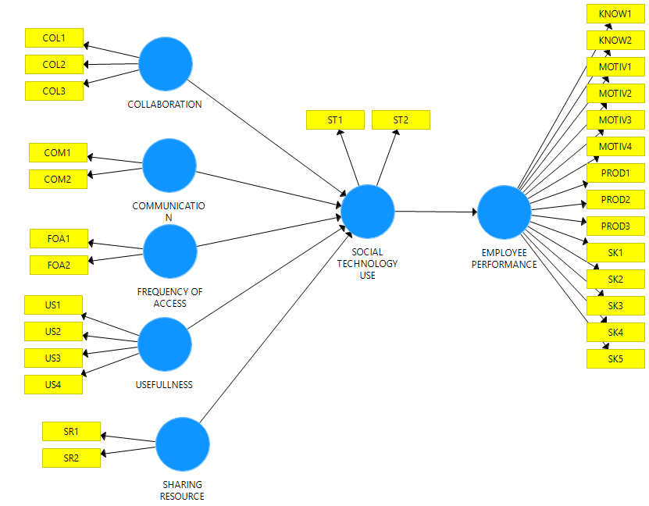

- RESULT

The survey conducted on 75 respondents, it is known that based on gender, respondents were dominated by men as much as 59%. While female respondents were 41%. The differences between the two differ slightly so that it can be said that employees of male and female sex at PT. The State Gas Company is almost balanced.
Based on age, respondents were dominated by respondents aged 39 years and over by 51%. This figure is far greater than respondents aged 31-38 by 27%, ages 23-30 by 21%, and age 22 and under by 1%.
Based on employment status, respondents were dominated by 25% assistant manager positions. This amount is not much different from the manager's position of respondents at 24%. In contrast to respondents with assistant vice presidents at 20%, 8% supervisors, 8% senior staff, 8% staff, and 7% vice presidents.
Based on the workplace division, respondents were dominated by respondents who worked in the HCM division by 45%. This amount is very far compared to the ICT division by 29% and LFM by 26%.
Based on education background, respondents were dominated by an S1 education background of 57%. This figure is very far compared to respondents with a D3 educational background of 24%, S2 at 18% and S3 at 1%.

Table 4.1
Demography of respondents
Sex |  | Total | Percentage
 | Male | 44 | 59%
 | Female | 31 | 41%
Age
 | < 22 | 1 | 1%
 | 23-30 | 16 | 21%
 | 31-38 | 20 | 27%
 | 39 > | 38 | 51%
Job Level Status
 | Asisten Manger | 19 | 25%
 | Asistant Vice Precident | 15 | 20%
 | Manager | 18 | 24%
 | Staff | 6 | 8%
 | Senior Staff | 6 | 8%
 | Supervisor | 6 | 8%
 | Vice Precident | 5 | 7%
Division
 | HCM | 34 | 45%
 | ICT | 22 | 29%
 | LFM | 19 | 26%
Education
 | D3 | 18 | 24%
 | S1 | 43 | 57%
 | S2 | 13 | 18%
 | S3 | 1 | 1%

Measurement Model Results (Outer Model)
A construct can be said to be Valid and Reliable if it has a AVE value above 0.50, and Composite Reliability above 0.70. Can be seen in the table below it can be seen that the least AVE value is 0.767 while the smallest Composite Reliability value is 0.901, so the variables used for this research are said to be Valid and Reliable or have fulfilled Convergent Validity and Reliability.
.
Table 4.2
Analysis Result

 | Hubungan antar Variabel | T Statistics (|O/STDEV|) | P Values
H1 | COL -> ST | 2,344 | 0,019
H2 | COM -> ST | 2,405 | 0,017
H3 | FOA -> ST | 0,279 | 0,780
H4 | SR -> ST | 2,357 | 0,019
H5 | ST -> EP | 30,067 | 0,000
H6 | US -> ST | 2,361 | 0,019

Effect size value
At this stage, testing is done to determine the effect of certain variables on other variables in the structure of the model with a threshold value of about 0.02 for small influences, 0.15 for the middle mm, and 0.35 for the large influence of f2 is calculated using the following formula
$$f^{2} = \frac{R_{included}^{2}- R_{excluded}^{2}}{1- R_{included}^{2}}$$
Picture 4.1
Resut Output without Mediating Variabel

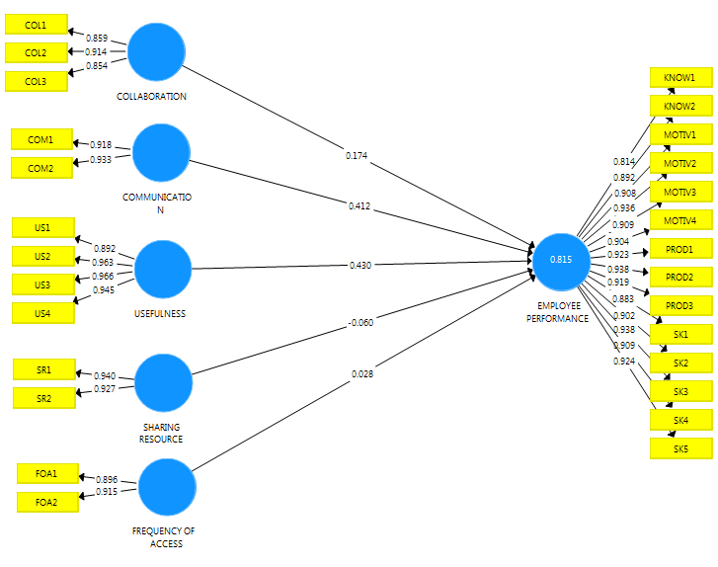

Based on the values ​​obtained by Collabooration on employee performance variables of 0.174 (<1.96). Communication to EP is 0.412 (<1.96), usefulness of EP is 0.430 (<1.96), resource sharing is EP of -0.060 (<1.96), frequency of access to EP is 0.028 (<1.96) The influence of variables Coll, com, use, SR, and FOA on the EP variable is not significant. This can be said to be Full mediation through the ST variable.
Based on the provisions of Cohen (1998) the value of the effect size: between 0.02-0.15 (weak). 0.15 - 0.35 (moderate), and> 0.35 strong. This mediation model has a moderate influence.

H1 Does Collaboration (COL) influence Use Social Technology (ST) significantly?
Based on the results of the structural analysis model, that is, especially on the value of the t-test as can be seen in Table 4 shows that H1 relationship COL → ST is accepted, so it can be interpreted that COL has a positive influence on ST. besides that it is supported by the result of the path coefficient (β) value of 0.319 which means that COL has a significant effect on ST, with the coefficient of determination (R2) where COL and ST have an influence of 0.743. This is in line with previous relevant research (Huda, 2015). Furthermore, based on direct observations made by researchers, it shows that collaboration affects users in the use of Social Technology. So it can be concluded that H1 was accepted in this study.

H2 Does Communication (COM) influence Use Social Technology (ST) significantly?
Based on the results of the structural analysis model, that is, especially on the t-test value as can be seen in table 4 shows that H2 COM → ST relationship is accepted, so it can be interpreted that COM has a positive influence on ST. besides that it is supported by the results of the path coefficient (β) value of 0.245 which means COM has a significant effect on ST, with the coefficient of determination (R2) value where COM and ST have an influence of 0.743. This is in line with previous relevant research (Huda, 2015). Furthermore, based on direct observations by researchers, it shows that communication affects users in the use of Social Technology. So it can be concluded that H2 is accepted in this study

H3 Does Frequency of Access (FOA) influence Use Social Technology (ST) significantly?
Based on the results of the structural analysis model, that is, especially on the t-test value as can be seen in table 4 shows that the H3 FOA relationship → ST is rejected, so that it can mean that FOA has a positive effect but not significant to ST. besides that, it is supported by the result of path coefficient (β) -0,020 which means FOA does not significantly influence ST, with the coefficient of determination (R2) value where COM and ST have an influence of 0.743. This is not in line with previous relevant research (Huda, 2015). Furthermore, based on direct observations made by researchers, it is shown that frequent access to Social Technology does not affect users in the use of Social Technology.
Based on the results of the questionnaire analysis showed that 65% of respondents agreed if the reason for frequency of access had no effect because employees of PT. The State Gas Company is given solid duties and responsibilities. According to Panjaitan and Prasetya (2017) if employees have solid duties and responsibilities from superiors, then they tend to focus more on how to complete their work. So that you don't have time to do other activities. These results are in line with previous studies according to Giannakos and Leftheriotis (2014) that frequent access to social media in this case the use of Social Technology for employees will increase Employee productivity and become Social Technology as a tool for communication. But the hedonic value and the value of the benefits coincide with each other and in the study according to Giannakos and Leftheriotis (2014) prove that the results of the value of benefits and hedonic values ​​keep on going. So it can be concluded that H3 was rejected in this study.

H4 Does Sharing Resource (SR) influence Use Social Technology (ST) significantly?
Based on the results of the structural analysis model, that is, especially on the t-test value as can be seen in table 4 shows that H2 relationship SR → ST is accepted, so it can be interpreted that SR has a positive influence on ST. besides that, it is supported by the result of path coefficient (β) 0.196 which means that SR has a significant effect on ST, with the coefficient of determination (R2) value where SR and ST have an influence of 0.743. This is in line with previous relevant research (Huda, 2015). Furthermore, based on direct observations made by researchers, it shows that sharing material or information affects users in the use of Social Technology. So it can be concluded that H4 is accepted in this study.

H5 Does Usefulness (USE) influence Use Social Technology (ST) significantly?
Based on the results of the structural analysis model, that is, especially on the t-test value as can be seen in table 4 shows that H2 USE → ST relationship is accepted, so it can be interpreted that USE has a positive influence on ST. besides that it is supported by the result of the path coefficient (β) 0.228 which means that USE has a significant effect on ST, with the coefficient of determination (R2) value where SR and ST have an influence of 0.743. This is in line with previous relevant research (Huda, 2015). Furthermore, based on direct observations made by researchers, shows that the use of Social Technology affects users in the use of Social Technology. So it can be concluded that H5 was accepted in this study.

H6 Does Social Technology Use (ST) influence Employee Performance (EP) significantly?
Based on the results of the structural analysis model, that is, especially on the value of the t-test as can be seen in table 4 shows that the relationship between ST → EP is accepted, so it can be interpreted that ST has a positive influence on EP. besides that it is supported by the result of path coefficient (β) 0.882 which means that ST has a significant effect on EP, with the coefficient of determination (R2) value where ST and EP have an effect of 0.778. This is in line with previous relevant research (Ashraf et al., 2014) that social networking influences performance on 4 aspects of motivation, knowledge, ability and productivity. Furthermore, based on direct observations made by researchers, shows that the use of Social Technology affects users in improving employee performance. So it can be concluded that H6 was accepted in this study.

- Conclusion
As empirical five of the six hypotheses in this study were accepted, namely:
- Collaboration has a positive and significant effect on the use of Social Technology.
- Communication has a positive and significant effect on the use of Social Technology.
- Resource sharing has a positive and significant effect on the use of Social Technology
- Usefulness has a positive and significant effect on the use of Social Technology.
- The use of Social Technology has a positive and significant effect on employee performance.
- The use of Social Technology is part of Full Mediation for the use of extended social technology models.

REFERENCES

- APJII. (2017). Penetrasi & Perilaku Pengguna Internet Indonesia 2017. Asosiasi
Penyelenggara Jasa Internet Indonesia, 1–39.
- Ashraf, Naheed, and Tasawar Javed. 2014. “Impact of Social Networking on Employee Performance.” Business Management and Strategy 5 (2): 139. https://doi.org/10.5296/bms.v5i2.5978.
- Bughin, J., A.H. Byers, and M. Chui. 2011. “How Social Technologies Are Extending the Organization.” McKinsey Quarterly 20 (11): 1–10.
- Beauchamp, Michelle Bednarz, and Middle Tennessee. 2001. “Facebook and Higher Education : Do College Students Prefer to Segment or Integrate Their Academic and Social Lives ?,” 172–74..
- Beauchamp, Michelle Bednarz, and Middle Tennessee. 2001. “Facebook and Higher Education : Do College Students Prefer to Segment or Integrate Their Academic and Social Lives ?,” 172–74.
- Chui, M, J Manyika, J Bughin, R Dobbs, C Roxburgh, H Sarrazin, G Sands, and M Westergren. 2012. “The Social Economy: Unlocking Value and Productivity through Social Technologies.” McKinsey Global Institute. https://doi.org/10.1007/s11002-013-9246-1..
- Huda, Muhammad Qomarul, and Nur Aeni Hidayah. n.d 2015. “A CONCEPTUAL MODEL OF SOCIAL TECHNOLOGY IMPLEMENTATION.”
- Preacher, K.J and Hayes, A.F..2004. SPSS and SAS Procdures for estimating Indirect effects in simple mediation models behavior research methods in simple mediation models. Behavior research methods, instrument & computers, 36 (4):717-731psychonomic society

