**Design and Analysis of Management Information System Qurban (SIMAQ)**

**at PKPU Human Initiative, East Jakarta**

**Oviani Viandari1), Qurrotul Aini2)**

1), 2)Information System Major, Faculty of Science and Technology,

Syarif Hidayatullah State Islamic University Jakarta, Indonesia

email: [oviani.viandari14@mhs.uinjkt.ac.id](mailto:oviani.viandari14@mhs.uinjkt.ac.id1)1), [qurrotul.aini@uinjkt.ac.id](mailto:qurrotul.aini@uinjkt.ac.id)2)

*The establishment of the Pos Keadilan Peduli Umat (PKPU) Human Initiative as one of the non-governmental institutions. Concentration on humanitarian issues should have a public service standard such as a SIM (Management Information System) the goal is to fulfill role processing needs in channel qurban with modern management where more days the number of donors is getting more increase so that requires management to improve service quality. Therefore the writer analyzed and designed the Qurban Management Information System at PKPU Jakarta East. The method used in Job Training (PKL) is Rapid Application Development (RAD) through the Requirement Planning and Workshop Design stages with modeling Unified Modeling Language (UML) so as to produce analysis and design of Information Systems Qurban Management (SIMAQ), from the results of street vendors the authors analyze and design include: integrate donor data management starting from collection transactions up to reporting on distribution or distribution of qurban animals, the author designs starting from the use case diagram that will explain the sequence of activities performed by actors and systems to achieve the system needed, such as identification of actors, identification of use cases , design of use cases and use case narratives , activity diagrams, sequence diagrams, and class diagrams . Display of the system user interface qurban management information based on the duties and authority of each actor.*

**Keywords:** Qurban *Management Information System*, SIMAQ, PKPU, *Rapid Application Development*, *Unified Modeling Language.*

1. **INTRODUCTION**

Nowdays, the need for information so fast, precise and accurate the higher. Thing this is also supported by technological developments which is increasing rapidly. Information often become the main key in sustainability an organization or company. One of company activities that require information that is fast, precise and accurate management of qurban data where more days the number of donors is increasing so require management for improve service quality.

PKPU has a management system qurban includes managing data from donors, distribution of sacrificial animals to remote areas archipelago, record, compile

and computerized report distribution, but still applying applications or *tools* which is not integrated between one and the others such as storing donor data, recording transaction gathering, distribution, and reporting of printed animal stocks in book form, so if you need it information about these data is not all data can be searched with documents stored in *Ms.office* the used. In addition, these data are has been printed in the book not *up to date*, there are old data that haven't updated and existing data refurbished is still separated storage which causes reporting not maximal so it will reduce efficient management of qurban management.

Field Work Practice (PKL) aims to produce analysis and design qurban management information system includes: integrating donor data management starting from collection transactions up to with reporting distribution or distribution of qurban animals.

System analysis and design this information will be the basis of making Sistem Informasi Manajemen Qurban (SIMAQ) PKPU Human Initiative to input qurban order data

application-based *software* that can be accessed through the company's *personal computer*. The application is operated by officer / admin who has been assigned with each work function is like an officer finance, CRM officers, distribution officers, cage management officer, officer

reporting.

1. **THEORETICAL BACKGROUND**

## System Analysis

System analysis is a process

collect and interpret the facts that exist, diagnose problem and use both forimprove the system[1]. System analysis is a decomposition of a system complete information into sections the component with the intention to identify and evaluate

problems, chance-opportunity, obstacles that occur and expected needs so that improvements can be proposed improvement[2].

## System Requirement

System requirement is a designing and determining ways

processing information systems from the results of analysis system so that it can meet needs from users including among us designing user interfaces, data and activities process[3].

## Management Information System (SIM)

Management Information System (SIM) is an information system already computerized that works because of it human and computer interaction. System Management information includes tasks which is very broad including decision analysis and as a tool for making decisions. To access information systems, users management information systems do division of tasks towards system resources management information, such as for example. The Data Base Management System (DBMS) used as a data storage media, models as a support tool for interpret stored data in the database and others. Information Systems management will produce output in the form of information that can be used as consideration (tool) to take or make a decision[4].

## Definition of Qurban

The language of the word Qurban comes from the word اًواَب َُ ْرق ـ اًب َُ ْرق ـ ُبُرْقَي ـ َب ََُرق which means approached him or approach him. Whereas according to the term *syara'* qurban is livestock slaughtered for draw closer to Allah SWT on the day Adha, the 10th of Dzulhijjah and the days Tasyriq (dated 11, 12, and 13 Dzulhijjah)[5].

## *Rapid Application Development* (RAD)

*Rapid Application Development* (RAD) is a model of the device development process soft which is classified as *incremental* technique (graded). RAD emphasizes cycles short, short and fast development. Short time is the limit important for this model. RAD uses method *iterative* (repeat) in developing a system, where is the work model the system is constructed at the beginning of the stage development with the aim of establishing user needs. Work model used only occasionally as a design base and final system implementation[6].

## Reason Use Method Development System *Rapid Application Development* (RAD)

The author chose the RAD model as system development method with reasons as follows:

1. The system is analyzed and designed is a simple system, if the system is applied or implemented using the model RAD in related institutions, no takes a long time.
2. Using the RAD model forgive restrictions on a system to avoid changes.
3. RAD can solve problems about obscurity about what users need the system must be done later because users can interact directly with the system at the beginning. This ambiguity also usually caused by difficulty for users to express what is desired to the designer system.

## Unified Modeling Language (UML)

Unified Modeling Language (UML) is a modeling language for systems or paradigmatic software 'object oriented'. Modeling really is used for simplification of problems complex in such a way that more easy to learn and understand [7].

1. **PKPU PROFILES**

[8]Starting from a sense of concern for humanitarian tragedy in 1997 to 1999, a group of young men took action social gives hope for the country. Follow up on their accompanying actions awareness of philanthropic potential at

Indonesia, as well as to optimize underprivileged people to be independent, born PKPU social institution at 10 December 1999. Then on October 8 2001, PKPU was designated as the Amil Institution National Zakat (LAZNAS) based on SK. Minister of Religion No. 441.

1. Vision

“Being a World Class Institution Trusted in Building Independence”.

1. Mission
2. Utilization: Use it emergency program, recovery, empowerment in improving quality Life and Build independence.
3. Partnership: Establish partnerships with community, business, government, media, world academic and civil society organizations ( *Civil Society Other CSOs* on the basis of harmony values that adopted institutions.
4. Research & Development: Doing study, research, development and relevant capacity building for increasing role effectiveness Civil Society Organizations.
5. Cooperation: Active role and encourage the formation of various forums cooperation and programsosial- other important humanity at the level national, regional and global.
6. **ANALYSIS AND DESIGN SIMAQ**

The following is an explanation of Information System analysis and design Qurban Management (SIMAQ) at PKPU Human Initiative with using the Rapid Application methodDevelopment (RAD), there are only two stages used by the author, namely through stage of Requirement Planning and Workshop Design with Unified Modeling modeling Language (UML).

1. Requirement Planning Phase

At this phase identification is carried out

problems and analysis for making plans solution to the problem. Then the writer describes the system analysis into three analysis phase, namely:

1. Problem Analysis:

* Analysis of the system running.
* The system narrative runs.
* Identification of system problems running.

1. Requirements Analysis:

* Proposal system
* Proposed system narrative

1. Decision Analysis

The results at this stage will be described

in the form of rich picture .

1. Workshop Design Phase

At this phase, the author designs and explain the design of the system that has been proposed. This stage consists of three stages design, namely:

1. Process design:

* Use case diagram
* Identification of actors
* Identification of use case
* Design of use cases
* Use case narration
* Activity diagram
* Sequence diagram

1. Database Design:

* Class diagram
* Database schema
* Database specifications

1. Interface design:

* Display of the user interface

System design is described in UML diagram forms include:

1. Use Case Diagram

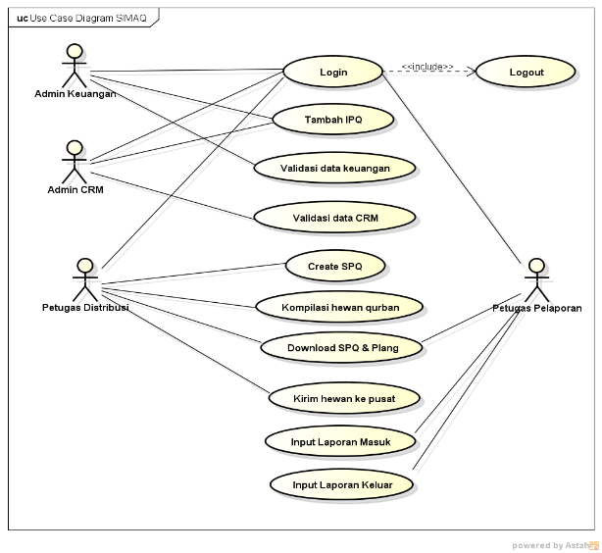**Figure 1.** Use Case Diagram

1. Activity Diagram

The following is an activity diagram for the qurban management information system. Figure 2. is an activity diagram for log in to the system (login).

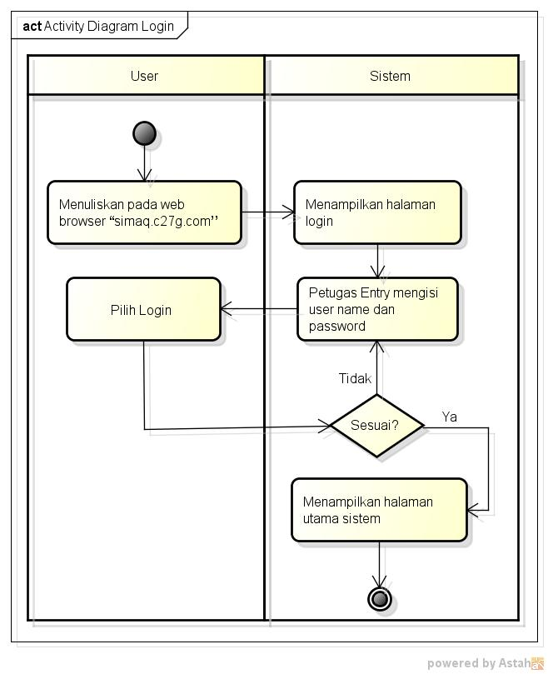**Figure 2.** Activity Diagram Login

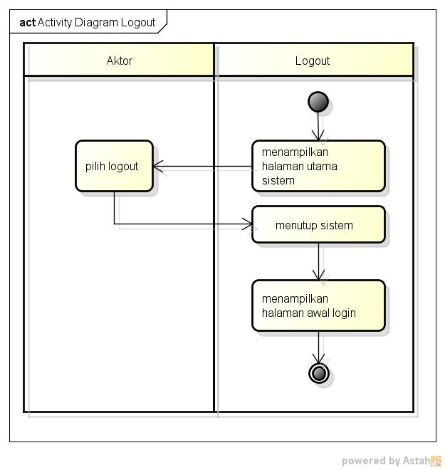Figure 3. An *activity diagram* for exit system (logout).

**Figure 3.** Activity Diagram Logout

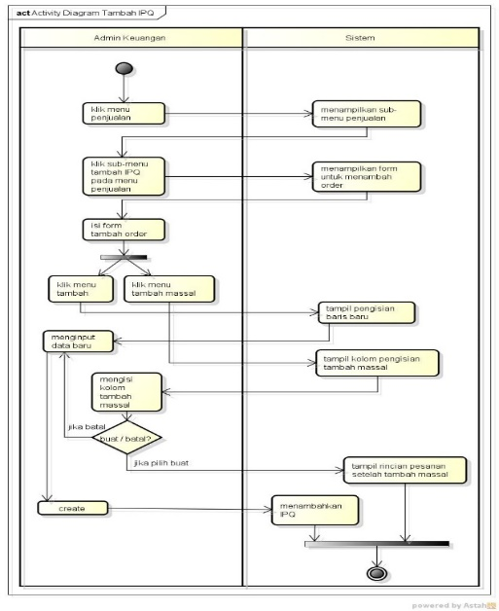Figure 4. An *activity diagram* for add IPQ (Input Perintah Qurban) via SIMAQ.

**Figure 4.** Activity Diagram Add IPQ

1. Sequence Diagram

The following is a sequence diagram for the qurban management information system. Figure 5. Is a sequence diagram for the user enters the system (login).

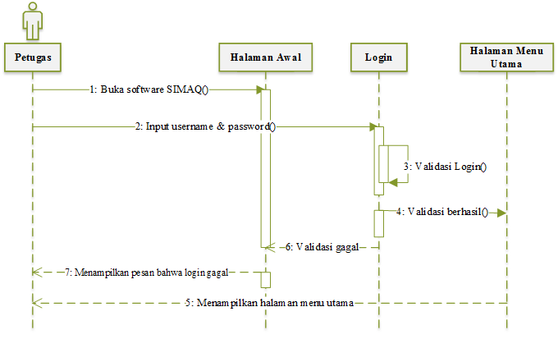

**Figure 5.** Sequence Diagram Login

Figure 6. Is a sequence diagram for user exits the system (logout).

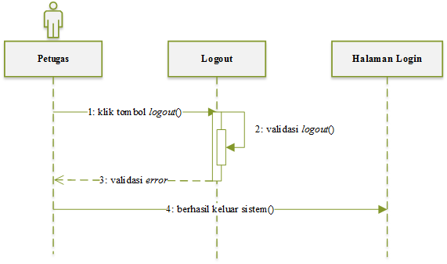

**Figure 6**. Sequence Diagram Logout

Figure 7. Is a sequence diagram for user adds IPQ (Input Perintah Qurban) via SIMAQ.

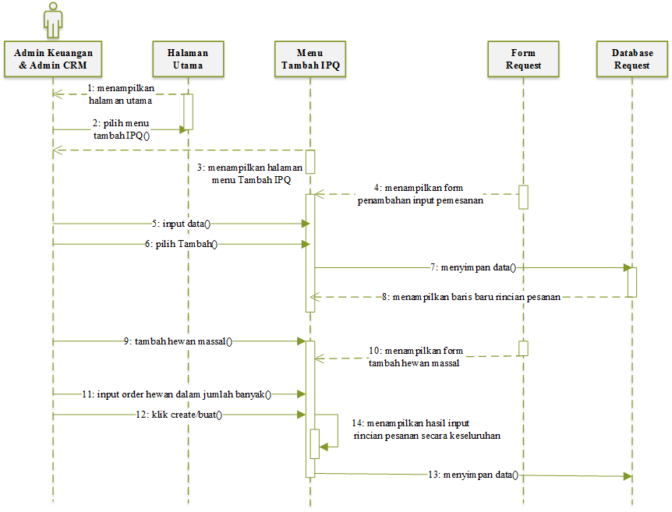**Figure 7.** Sequence Diagram Add IPQ

1. Database Design

Database design for the system qurban management is described by class diagram. Figure 8. is a class diagram to describe a collection of class and its relationship in the Information System Qurban Management (SIMAQ).

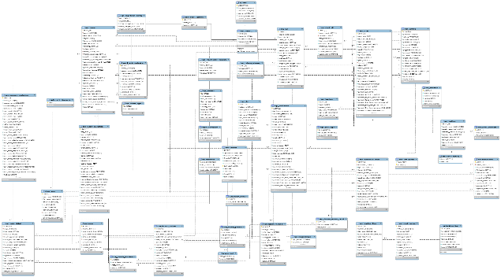

**Figure 8.** Class Diagram

1. User Interface

The following is the interface or interface of Management Information Systems

Qurban (SIMAQ).

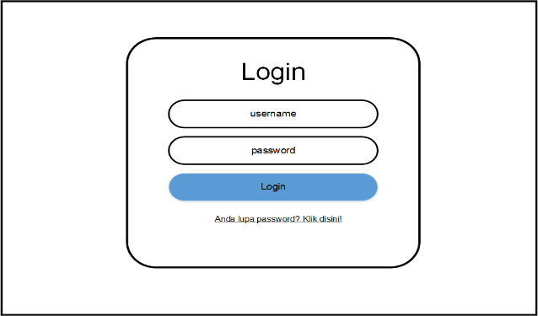

**Figure 9.** User Interface Login

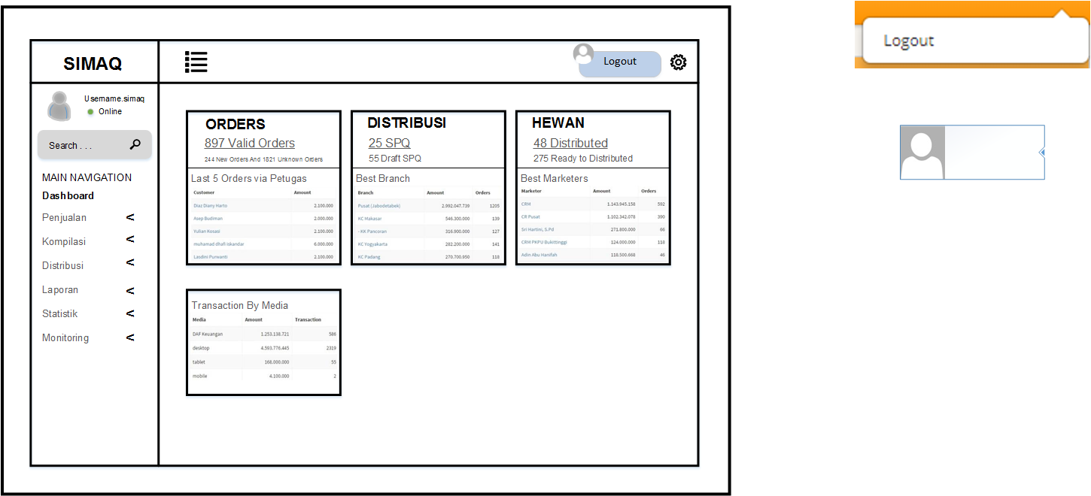**Figure 10.** User Interface Logout

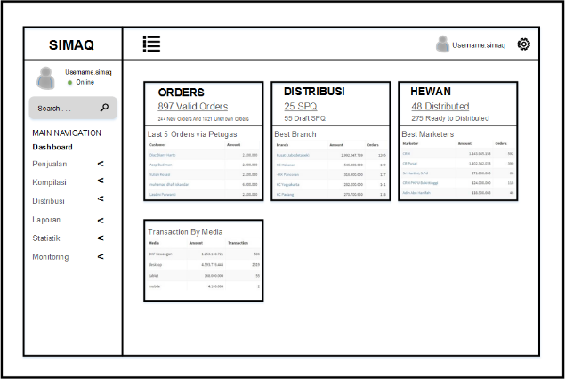**Figure 11.** User Interface Main Page

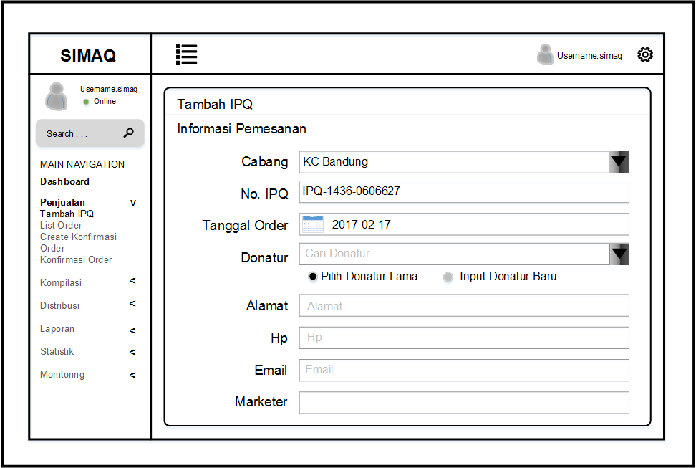

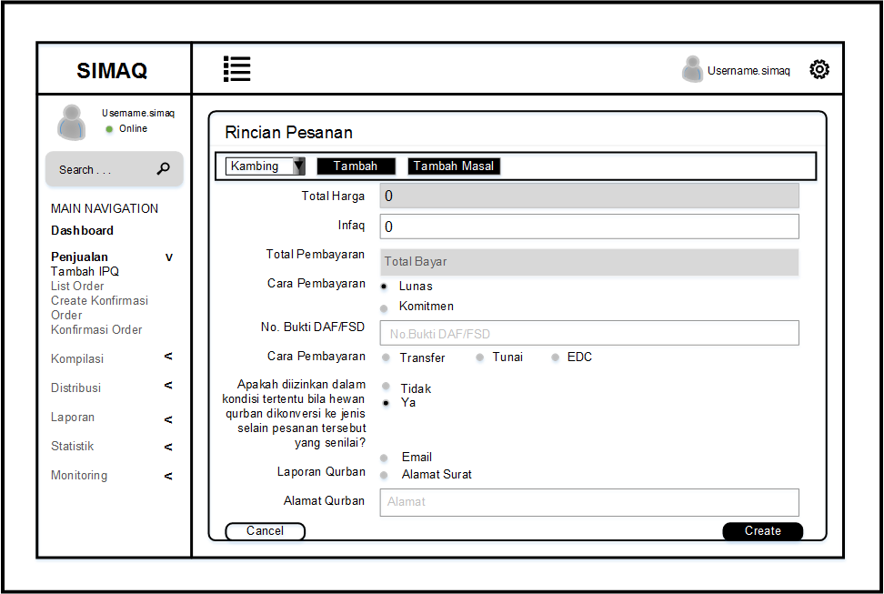**Figure 12**. User Interface Add IPQ

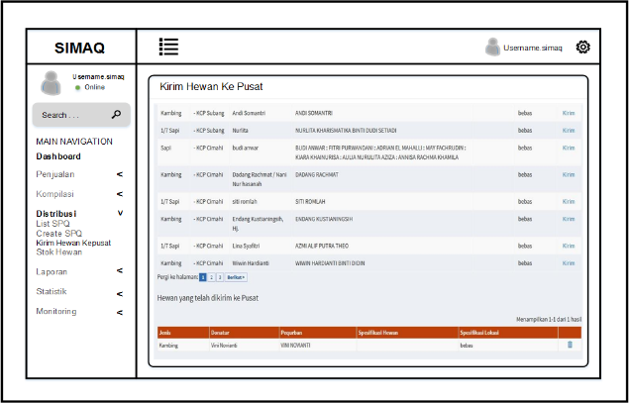

**Figure 13.** User Interface Send Animals Center

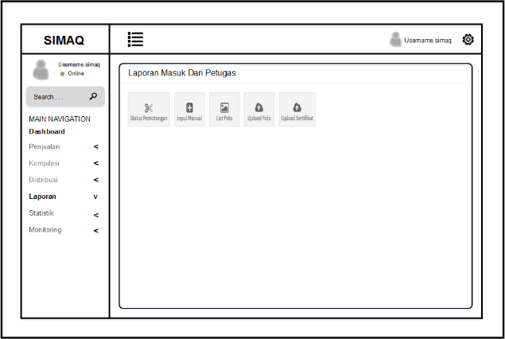**Figure 14.** User Interface Entry Report

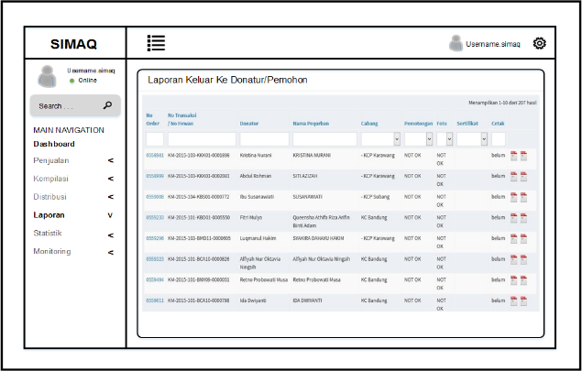**Figure 15.** User Interface Exit Report

1. **CLOSING**

The conclusions and suggestions from the results of the Practice This Field Work Practice (PKL) are as follows.

1. Conclusions

Based on the description and discussion in the previous chapters,conclusins can be taken as follows:

1. In analyzing and designing Sacrifice Management Information System (SIMAQ) based on this *desktop* application author use method *Rapid Application* Development *Development* (RAD) through phase *Requirement Planning* and *Workshop Design* with *Unified* modeling *Modeling Language* (UML).
2. In addition to providing solutions to ongoing problems, Qurban Management Information System (SIMAQ) This certainly also gives benefits to PKPU Human Initiative on its performance in the process management of donor data, transactions finance, recording out and in and out qurban animals, report animal stocks qurban, archive and report making automatically and put together in integrated system needed from starting to enter data until the output is a report desirable and can be used for the interests of PKPU and institutions others like public accountants, reduce risk of making mistakes report and do accumulation from data and funds used as well management that could accounted for.
3. Suggestions

Suggestions that can be submitted from the result of this Field Work Practice (PKL) are as follows:

1. Continuing analysis and design this qurban management system with make the design get up to implementation and *testing* stages.
2. PKPU Human Initiative Employees is often delegated to service to the cutting location and distribution of qurban animals to regions certain areas, then research can then design the system *mobile* based so employees don't need to delegate access rights.
3. For further research implement *e-* security system *commerce* for donors.

**BIBLIOGRAPHY**

[1] Kristanto, A. (2007). Perancangan Sistem Informasi dan Aplikasinya. *Klaten*.

[2] Jogiyanto, H. (2005). Analisis dan Desain: Sistem Informasi Pendekatan Terstruktur Teori dan Praktek Aplikasi Bisnis. Yogyakarta: Andi.

[3] O'Brien, J. A., & Marakas, G. M. (2009). *Management Information System 9th Edition.* New York: McGraw-Hill.

[4] Mulyani, S. (2016). *Metode Analisis dan Perancangan Sistem.* Bandung: Abdi Sistematika.

[5] Matdwan, M. N. (1993). *Kurban Dalam Syarat Islam.* Yogyakarta: Bina Mulya Usaha.

[6] Kendall, K. E., & Kendall, J.E. (2008). *Systems Analysis and Design 7th Edition.* New Jersey: Pearson Prentice Hall.

[7] Subhan, M. (2012). *Analisa Perancangan Sistem.* Jakarta: Lentera Ilmu Cendikia.

[8] PKPU. 2001. Sejarah. [Online]. Tersedia: http://www.pkpu.org/aboutus/history/. (Akses: 3 Februari 2017)